How to Create a Solidarity Enterprise
By Luis Razeto Migliaro

Luis Razeto Migliaro (2020). How to Create a Solidarity Enterprise: Unit I: A Theoretical-Practical Manual. Grassroots Economic Organizing (GEO). https://geo.coop/articles/how-create-solidarity-enterprise

PREFACE
After many years working and conducting research in the field of solidarity economy I have had the opportunity to see many successful businesses created, and others fail. Having participated in several projects, successful and unsuccessful, provided support and training to others, and studied and analyzed this type of business, I believe I have learned a fair amount about what makes for the success or failure of solidarity economy initiatives, or, as I call them here “solidarity enterprises.”
The theory of solidarity economy offered here, based on experience and practical application, is intended to help you in your own process of business creation by providing key elements for organizing and operating effective solidarity enterprises, relating to the market, managing resources and operations, and resolving problems, difficulties, and internal conflicts.
This manual presents in an ordered and simple manner the principal lessons I have learned from both practice and theory regarding how to create, organize, and develop solidarity enterprises, so that they can grow to their full potential and provide optimal benefits to their participants and the social environment in which they grow.
It is my hope that this manual will be of use to people and groups who want to create a solidarity enterprise in which to work, obtaining the means to live with dignity and progressing economically, socially, and culturally, as well as to those working in institutions or support organizations of some kind who are trying to facilitate the formation and development of solidarity initiatives of various types, scales, and characteristics.
– Luis Razeto Migliaro

Translator’s Introduction
hagamos profesión terrestre
toquemos tierra con el alma
- Pablo Neruda, Sonata con algunos pinos
Let our profession be an earthy one
Soul touching soil
- Pablo Neruda, Sonnet with a few pines
As soon as I started reading this manual I knew I wanted to translate it. I had just translated Luis Razeto’s Solidarity Economy Roads, an introduction to the theory and practice of solidarity economy in Latin America but this book was different.
I needed it and knew others who did too. Through conversations with social movement organizers and cooperative developers it had become clear that if cooperatives were to succeed and fulfill their promise a slower, deeper, and more deliberate approach to learning and organizing was needed. As the Japanese saying goes, “if you are in a hurry, take the long way” (急がば回れ).
And, as a long-time practitioner of worker education in academic and activist contexts – unions, union democracy and reform groups, community-based immigrant workers centers, university labor centers, etc. – I have always treasured manuals and handbooks in which practitioners share their ideas, experiences, and techniques. The practice of learning that is democratic, participatory, and incorporates social transformation through collective action – often called popular education – requires not just theory but practical technique. A well designed, usable manual is a treasure.
As a manual, How to Create a Solidarity Enterprise is unique. In many popular education handbooks, organizing is separated from learning, treated as something to be done at a later point, after the educational process is complete. In the best examples, organizing is understood to be central to the ongoing spiral of learning but, even then, the actual practice of organizing takes place in a different space than the one where learning happens. In this manual learning and organizing share the same space. Razeto assumes a group of people intending to create a solidarity enterprise – a business that will function in the real world – for whom he provides an educational and organizing framework for self-organization. There are no teachers here, the manual is designed for collective self-study. But it is not just a workbook or collection of forms to complete; it contains theoretical texts that address some of the most challenging problems of cooperative economic organizing. This is learning by doing, but also doing by learning, a form of economic practice that is simultaneously and self-consciously a learning process.
A summary of Luis Razeto Migliaro’s life and intellectual trajectory is available in Solidarity Economy Roads, so I won’t repeat it here. Let it suffice to say that as a leading figure in the history of solidarity economy in Latin America, author of numerous books and studies, and founder of educational institutions, he brings to this manual a unique combination of theoretical and practical experience bridging the 20th and 21st centuries.
I am grateful to Luis Razeto for agreeing to the English translation of this book which I am confident will be useful to cooperative and solidarity economy practitioners around the world. In the North American context, the manual’s radically peer-to-peer self-organizing approach and emphasis on the “solidarity group” as the starting point for enterprise development and the “C Factor” as the key to success are timely contributions to recent debates about best practices of cooperative development. The manual is also timely in a larger sense, insofar as the creation of cooperatives and other solidarity enterprises is an essential part of the larger project of creating the “New Civilization” – as Razeto calls it, following Gramsci – needed to address the economic, social, cultural and ecological crises of our time by transforming, through work, our relations to ourselves, each other, and our planet.
How to Create a Solidarity Enterprise will be published serially on the websites of the Cooperative Educators Network (https://ed.coop) and Grassroots Economic Organizing (https://geo.coop), followed by print and electronic versions.
I have added footnotes to suggest additional techniques, relevant references, and brief supplementary explanation of some terminology. In general, I have made an effort to keep the language familiar and non-academic, though some terminology from economics, cooperativism, and business administration is unavoidable. Sharing this terminology is a key element of Razeto’s strategy; each Unit includes a glossary.
– Matt Noyes
About the Translator
Matt Noyes is a social movement educator specializing in worker self-organization, living in Colorado Springs, Colorado. He has a Masters in Applied Social Economy and Cooperative Organization from Mondragón University and is a member of several cooperatives and collectives including Grassroots Economic Organizing (GEO.Coop). He translated Luis Razeto’s Solidarity Economy Roads and is collaborating on the translation of Joxe Azurmendi’s The Cooperative Man, about the life and work of Mondragón founder José María Arizmendiarrieta.

TABLE OF CONTENTS
How to Create a Solidarity Enterprise includes seven Units and two Final Projects. Each Unit covers a fundamental theme which is approached both theoretically and in its practical aspects.
- HOW TO USE THIS MANUAL
- Unit 1: WHERE TO BEGIN?
The solidarity group and the C Factor
Session 1
Session 2
Jornada 1
Unit 1 Glossary
Evaluation of Unit 1
- Unit 2: THE IDEA AND OBJECTIVE OF THE ENTERPRISE
Needs, market, profit
Session 3
Session 4
Jornada 2
Unit 2 Glossary
Evaluation of Unit 2
- Unit 3 – THE FACTORS OF A SOLIDARITY ENTERPRISE
The theorem of defined proportions
Session 5
Session 6
Jornada 3
Unit 3 Glossary
Evaluation of Unit 3
- Unit 4 – WHERE TO GET THE NECESSARY FACTORS
Member contributions and group development of factors
Session 7
Session 8
Jornada 4
Unit 4 Glossary
Evaluation of Unit 4
- Unit 5 – EXTERNAL FINANCING
Donations, subsidies, loans, and solidarity funds
Session 9
Session 10
Jornada 5
Unit 5 Glossary
Evaluation of Unit 5
- Unit 6 – ECONOMIC ORGANIZATION OF THE ENTERPRISE (1)
Forms of property, recruitment of members, and management structure
Session 11
Session 12
Jornada 6
Unit 6 Glossary
Evaluation of Unit 6
- Unit 7 – ECONOMIC ORGANIZATION OF THE ENTERPRISE (2)
Payment for labor and distribution of surplus.
Session 13
Session 14
Jornada 7
Unit 7 Glossary
Evaluation of Unity 7
- Final Project 1 – Write the Bylaws and Internal Rules for your enterprise
- Final Project 2 – Create your Business Plan
Each Unit is designed to be done in two sessions of group study, followed by a “jornada” or practicum in which participants organize and carry out a learning-organizing activity. Between the sessions and the Jornadas, readings, exercises, and activities have been provided for participants to do individually or in small groups.
Each Unit includes the following elements:
- The Plan for the Session
- Readings
- Questions for Reflection and Discussion
- Individual Tasks
- Group Tasks and Exercises
- Practical Activities (Jornadas)
- Evaluation
- A Glossary

HOW TO USE THIS MANUAL
How to Create a Solidarity Enterprise is designed for group work. It is intended for a group of people who not only want to learn ideas and get information, but also to create a solidarity enterprise. Using this manual you can learn what a solidarity enterprise is and begin to create one at the same time. The exercises, individual and group work, practical activities, and final projects all contribute directly to this goal.
But the manual is also useful for existing solidarity or associative enterprises whose members want to improve, reorganize, or make their organization more efficient.
It is possible to use the manual as an individual, in order to learn how solidarity enterprises are created, and may be helpful for people who work in organizations that train and support these types of enterprises or those who are thinking of and evaluating the possibility of organizing an enterprise in which they plan to participate. Nonetheless, the manual is primarily designed for collective learning and organizing and many of its exercises and practical activities can not be done individually.
Using this manual as a group requires a certain level of organization and planning, the instructions for which are as follows.
Materials
- Before working on each Unit, all participants should have the full text corresponding to the Unit, not just the readings. For this reason it is best if each participant has a copy of this manual.
- Each person should also have a notebook to be used only for work in this course.
- Some of the exercises and practical activities require participants to prepare materials to be used; instructions are provided in each case.
Plans
Each Unit includes:
- Two sessions for group work and study of about three hours each. Ideally these should be done in the same day. If the group is very large, or the participants need more time, it is possible to extend the indicated times. The group will have to plan the course based on their unique circumstances and characteristics, keeping in mind that all of the activities should be completed.
- Individual work and study are assigned after each session and can be done either at home or in another location. The individual assignments are important for various reasons: for understanding new ideas, deepening knowledge of the theme, developing one’s capacity for written and figurative communication, creating the habit of meeting assignments, and deploying one’s creativity. Individual assignments are indispensable for the learning process used in this manual and provide information and analysis that is later used in group sessions and practical activities. Each participant should do assignments in their notebook and present their work in the following session.
- Exercises, to be done in accordance with the instructions provided.
- A day-long practical activity (jornada) that requires planning, preparation, and the carrying out of various individual and group tasks.
Every session starts with a plan or agenda that has been designed for work with grassroots groups. Groups can adapt the plan to their particular characteristics or circumstances.
The language used in this manual is pretty simple. But some technical terms have to be used, along with other uncommon expressions. So, to make the text easier to understand, there is a glossary at the end of each Unit. It is best for members of a solidarity enterprise to use the same terminology when referring to certain themes and important aspects of their work as they develop their business activity. Study of the glossary can be helpful for this and for formulating and sharing one’s thoughts with precision.
The Facilitator
Each group should have a facilitator, who should follow these instructions:
- The facilitator should study the Unit and all material before each session and be available to participants in the course of the meeting.
- Nonetheless, the facilitator should not take any initiative, not even to get meetings started or form work groups. The manual should be used by the participants autonomously. Organizing the meeting, choosing a moderator, calling on people to speak, setting the sequence of activities – all of this is part of the learning process for creating a solidarity enterprise and should be done by the group.
- Facilitators should not intervene unless they are explicitly asked to speak. However, they should offer to help when disputes arise or the group is getting too far off the agenda.
- It will be useful for the group if facilitators take their own notes and record their observations as the meeting goes on. At the end, the facilitators can be asked to share their comments if the group feels it would be helpful.
- As a rule, in group sessions people should speak for no more than three minutes at a time, which is enough to explain most things if the speaker has a clear idea of what they want to say. Long speeches are not well suited to the management of solidarity enterprises. It is important that everyone participate, so before calling on a person a second time, the moderator should be sure that at least one third of the participants have already spoken. If the moderator is not attentive to this or fails to enforce it, a facilitator should remind the group of this recommendation.
Note: if the group determines that this procedure is too strict, they can modify it, but it should be noted that unlike many types of popular education and personal development approaches which use more open-ended methodologies, this manual includes content that requires formal learning. The objective is to create enterprises which can meet the requirements of economic reality, which include orderly and disciplined work, efficiency in decision-making, and execution of operations when time is limited and scarce. The learning process itself is designed to help prepare participants to work together in such conditions.

Unit I
WHERE TO BEGIN?
GROUP SOLIDARITY AND THE C FACTOR
Session 1
Plan
1. Gather, welcome, ice-breaker, form a circle, choose a moderator for the meeting.
2. Participants introduce themselves. (Briefly: name, job, main work or activity, other personal information that they wish to share. The activity should not take more than 20 minutes, so the moderator should calculate the time available to each participant accordingly.)
3. “Reading #1.” (One or two people read out loud as others follow along in the text.)
4. Break, snack.
5. Questions for review and discussion. (Participants volunteer to answer questions, raising their hands to speak. Other participants build on their answers but it is best if nobody speaks twice before others have had a chance to speak.)
6. Questions for the facilitator, exchange of ideas and free conversation on the theme.
7. Suggestions for the Individual Task. (The facilitator will explain the content and purpose of the individual task, clarifying any issues and answering questions that come up.)

READING #1
The point of departure is crucial, because it indicates the direction to be followed, the contours of the road, and the objectives pursued. Success or failure of the enterprise is at stake from the start. The first thing, then, is to be clear about where and how to begin to create a solidarity enterprise.
The creation of a capitalist enterprise begins with… capital. Only those with capital to invest, or with access to credit or other forms of financing, can think of creating a capitalist enterprise.
That’s not how it works in the solidarity economy. Capital is not the starting point for a solidarity enterprise and if you want to create a business that will be significantly different from a capitalist enterprise there are more important things to do before you start thinking about financing.
We have seen many initiatives claiming to be part of the solidarity economy in which micro-enterprises and popular economic organizations were formed on the basis of some source of financing, whether through a grant or some form of credit. In nearly all of the cases, after a short time the enterprises failed, usually because the financing ran out. Numerous Non-Governmental Organizations, public bodies, revolving loan funds and other systems that receive financing to promote popular economic organizations have believed that they could facilitate the development of solidarity micro-enterprises by offering a certain amount of money, on the basis of which they could assemble a target group to whom to propose projects. Motivated by the possibility of gaining access to resources, the groups throw themselves into elaborating projects, sometimes with the assistance of technical consultants. They nearly always fail and this has resulted in an unfair prejudice against the solidarity economy.
They failed because they started wrong. They didn’t start where an economy of labor and solidarity should. As we saw, in an economic context organized by capital and money people believe that when, and only when, you have enough financial resources is it possible to organize and launch economic initiatives. This is the first idea we have to abandon and replace with another:
YOU DON’T NEED CAPITAL TO START A SOLIDARITY ENTERPRISE
This does not mean that solidarity economy does not use financial resources or that we don’t need money. But those come later and we will see, when the time comes, how to get or create them in order to start a solidarity enterprise.
What we mean to say is that a solidarity economy enterprise does not begin with money or capital and that it is possible to begin to create an enterprise – with confidence that it will become a true business functioning efficiently in the market – without having money and even without any idea of where or how to get it. The solidarity economy is full of surprises for those who are willing to explore its paths.
The most important thing in a solidarity enterprise is the solidarity group that creates it.
The solidarity group can be made up of family members, a small circle of friends, a social organization, a community, or simply a group of workers who get together to create a business.
The fate of the enterprise – its chances of success or failure – depends on the people who create it and work in it, on their capacities, values, ideas, objectives, limitations and potential, qualities and defects.
For this reason, for a person who wants to create a solidarity enterprise the most important thing to focus on is the formation of a solidarity group, a collective of individuals who are united and capable of conceiving and undertaking a project that will be carried out in practice.
The collective that forms a solidarity enterprise has two main dimensions:
It is a work group, or a collective of workers; and it is a solidarity group, a community and association of people.
As a work group, the enterprise is made up of people whose various capacities and specializations, experience, knowledge, skills, and abilities complement each other. Everyone collaborates in the realization of a common project; but they do it by fulfilling different functions and tasks.
As a result, we can speak of a division of labor in a solidarity enterprise in the sense that different and complementary tasks are performed by different people. Everyone collaborates in the achievement of business objectives in accordance with their capacities and abilities and the responsibilities they are assigned and accept.
As a solidarity group, what is crucial is that the group of people forming the enterprise be united in a common project and that they all work together for shared benefit.
Solidarity implies commitment, investment, and the capacity to embrace a common project; but it also implies participating in the benefits and results of work done. Solidarity involves, then, a give and take, contribution and compensation. The internal relations of the enterprise must be as fair as possible, characterized by solidarity, as much with respect to the contributions each members makes as to the benefits they get.
A bit of theory will help us better understand why forming a solidarity group is so important and why creating a solidarity enterprise should begin with creating a solidarity group in the right way. First of all it is necessary to have a clear shared idea of what an enterprise or business is.

WHAT IS AN ENTERPRISE?
Economists say that an enterprise is an organization of economic factors whose objective is to generate wealth.
We can express the same concept less abstractly: an enterprise is made up of a combination of productive forces – natural, human, social – that an individual or group entrepreneur organizes and combines in such a way that they work together with efficiency. These productive forces, efficiently organized, are put to work making and distributing goods and services to satisfy the needs of people and society.
Economics refers to the productive forces, the energies that in one way or another contribute to generate wealth or economic value, as “factors.” The contribution that each factor makes to the generation of the economic product is its productivity.
The creation of a business consists of organizing, combining, and efficiently operating a set of productive factors in order to achieve economic objectives.
Further on, in another Unit, we will deepen this concept of the enterprise, its organization, its operation, and its modes of functioning. For the time being we are interested in the concept of productive factors, which deserve a closer look.
Usually people only talk about two factors: Capital and Labor. People think of Capital as the organizing factor, the factor that determines the objectives of the business and receives the profits from the wealth produced, while Labor is considered the subordinate factor, operating in the service of the business objectives, receiving for its contribution a fixed remuneration, a wage or salary.
But this is just the capitalist enterprise form, the mode of being of a capitalist business in which capital is the beginning and the end. When creating capitalist businesses, everything begins with an entrepreneur with a certain quantity of capital who invests in a space, machinery or equipment, raw materials and inputs, technology and labor power, in order to obtain in the end, as a result, an increase in their capital. This is why, when we think of creating a capitalist business, we have to start with the previous accumulation of a certain amount of capital to invest. People sometimes call this the originary accumulation of capital.
But capital and labor are not the only factors and there are other ways in which the factors can relate to each other and be organized, other ways for enterprises to exist. The enterprises that characterize the solidarity economy are such alternative forms and the C Factor is a productive force they use intensely.
THE C FACTOR
This is the most important concept and real force in the solidarity economy. What is it? Why is it so important?
We can define the C Factor as “solidarity converted into a force of production.” We should deepen this definition, though. First, why do we call it the “C” Factor?
Economists are accustomed to representing factors of production with a letter: capital is K, labor is L or W, technology is T. We represent solidarity with the letter C because it is the initial letter in a series of words that express its content: community, comradeship, communion, cooperation, communication, collaboration and many others that begin with the prefix “co” which signifies to be together or do something together.
It is a universal experience: every time that people become unified in their consciousness, will, and feeling around a common objective, it produces an energy that fortifies the action of each member and the group as a whole.
This social energy is manifest in every order of things and every type of human activity.
- The members of a family that is united progress much more than those from a family divided against itself. Children do better in school, parents are more successful and get more recognition for their work, the house looks better and is better maintained, everyone’s life is more pleasant, the neighbors’ respect for them increases.
- Is it well known that a soccer team in which all the members feel like comrades, are loyal to their jersey, and act as one, scores more goals than another in which each player tries to stand out above their teammates and show off their individual skill. If the coaches, fans, staff, and players are united, the outcomes (productivity) of the team are much better.
- History is full of examples that show how armies in which people on every level of the hierarchy are convinced of the justice of their cause and united in their objectives and operations can defeat much larger and better armed forces that are internally divided, lack conviction, or have less fluid relations between generals and troops.
- Political parties, religions, and social and cultural movements whose members are united in their consciousness, will, and feeling recruit more members, garner more support, and better achieve their goals than other, similar, groups that are divided into tendencies or shot through with internal conflicts.
- The same thing occurs in economic organizations and in businesses. The unity of the members increases productivity, causes costs to fall, and profits to rise. The company is better positioned in the market, management is easier, technological innovation is more dynamic.
There is nothing mysterious about these results, no esoteric explanation required. The facts mentioned have an objective explanation: the union of consciousness, will, and feeling around a shared objective generates a powerful energy with enormous practical effects.
It is this efficient energy, this unity converted into a productive force, that we call the C Factor, distinct from capital, labor, technology, and management.
Later on we will see how this factor operates in solidarity enterprises and the ways it affects productivity. For the moment it is enough to know that various studies have demonstrated that capitalist businesses – in themselves poorly suited to the development of the C Factor – achieve productivity gains of up to 30% when they improve their internal relations in various ways. In solidarity economy enterprises the contribution of the C Factor typically exceeds 50%. There is no doubt that we are dealing with a decisive factor, a principal determinant of the success or failure of an enterprise.
No solidarity enterprise can function without the C Factor: without it the internal social atmosphere deteriorates, human relations suffer due to internal conflicts that go on with no resolution, the group or community loses friendship and compassion among its members.
Because no solidarity enterprise can exist without a consistent C Factor, the creation of a solidarity enterprise must begin with the cultivation of this social energy.
A few years back, a famous North American economist – Albert O. Hirschman – traveled through Latin America to learn about cooperatives and other associative enterprises, hoping to understand their ways of being and the causes of their successes or failures. After studying numerous examples in many countries, his most important conclusion was that all of the enterprises had something in common: a previous history of social organization, of shared struggle for a cause, of living in community or association, motivated by objectives that were not strictly speaking economic. The enterprises arose after members had united and acquired mutual trust, be it through a religious community, a labor union, a social or political organization or a struggle over particular demands.
This led Hirschman to formulate what he called the “law of conservation and transformation of social energy” according to which each organization and collective undertaking generates a social energy. The essence of this energy is the trust built up among the participants in the group who act together based on certain objectives, whatever they may be: social, cultural, political, religious, etc. The energy is present and growing as long as the objectives are in the process of being won. Once they have been achieved or if they are not achieved, or abandoned, the social energy generated in the process is not lost, but conserved. It remains available, ready to be applied to other, new objectives. Social energy is conserved and transformed in the sense that it is oriented in a new direction. What Hirschman observed was that in successful associative economic experiences, social energy created in processes that were not directly economic had been conserved and transformed, re-oriented towards social-economic objectives.
Using our terminology, we see that the previous processes in which human relations of trust were generated constitute that originary accumulation of the C Factor that is so necessary for the creation of solidarity enterprises, as necessary for them as the previous accumulation of capital is for the creation of capitalist businesses.
THE C FACTOR CAN BE CREATED AND DEVELOPED
The collective that will become the solidarity group in an enterprise can be formed in one of two ways.
First, a preexisting social group or community, organized for other purposes, can decide at some point to create a solidarity enterprise. It could be a family group, a circle of friends, a “crew,” a youth group, a women’s collective, a local committee, a religious community, a cultural association, a labor union, etc.
Second, an institution or organizing group, or a person who hopes to be part of the enterprise to be created, looks for people to become future members of the solidarity group, and brings them together in the initiative to create an enterprise.
In both cases, the minimum requirement for creating a solidarity enterprise with a chance of success is that the people who form it start from mutual trust and shared interests, objectives, and aspirations with respect to what they want to do. It is also necessary to have a good match of skills as a work group; that is, the group needs to be able to find or develop among its members the skills and the willingness to work necessary in order to create an enterprise of a particular type. Some needs are permanent: the need for bonds of trust and mutual understanding, for a union of consciousness, will, and feeling around a common objective, and a shared desire to cooperate in its accomplishment, converting the group’s internal solidarity into a productive force, the C Factor.
The C Factor is not just friendship and comradeship but practical cooperation in the realization of a common task.
Before going on we should say something about the quality of the C Factor.
Like any economic factor, the C Factor can be of high, regular, or low quality, just as labor power, technology, management, or financing can be of high, regular, or low quality. The strength and efficiency of an enterprise depends to a large extent on the quality of the factors and how they are organized. For this reason it is critical to create a C Factor of the highest possible quality.
The quality of the C Factor depends on the degree or level of unity of consciousness, will, and feeling among the people who form the solidarity group, with respect to their common objective.
The greater the intensity of unity and solidarity, the more energy the collective generates.
This is a true “law” which applies as well in the field of material reality. The force fields established by the union of physical or chemical elements are more or less intense, and radiate and attract with greater or lesser intensity, depending on the cohesion or force holding the system together. Atomic reactions are more powerful than molecular and chemical reactions because the elements comprising an atom are much more strongly bonded to each other than those of a molecule or a chemical element.
To create a solidarity enterprise it is necessary first of all to develop a process of original accumulation of C Factor of high quality.
More than quantity, i.e. the size of the group, it is the intensity of the force uniting the members that counts.
A strongly cohesive human group is indestructible by normal means. A solidarity group, even a small one, if it is held together by an unshakable love and faith, can change the world. There are
many examples in history. A small group of disciples of Jesus of Nazareth, who formed a community in which everything was shared, created a civilization. A small group of faithful followers of Muhammed generated a movement that ended up founding a huge empire whose decadence was marked by a rupture in its internal unity. The great social, political, and cultural revolutions were initiated by small groups that started by creating a common consciousness, will, and feeling. The great experiment in self-management at Mondragón, in which now more than 60,000 people participate, was launched by six young people whose unity was capable of generating an immense, expanding social energy.
On the other hand, you may have seen or perhaps personally experienced the weakness, insecurity, lack of faith in one’s own abilities, loss of self-esteem, failure to follow through on what you have proposed, into which an individual can fall when they feel, or are in fact, alone. You may also have seen or experienced the power, security, and conviction that you can accomplish great things that people acquire when they love each other and feel loved, participating in groups that are united and well organized.
There are people who say things like “solidarity economy is a utopia,” or “solidarity enterprises are not viable companies.” The problem is they don’t know the C Factor, or they haven’t experienced it. It is true, however, that solidarity economy and solidarity enterprises are not viable in the absence of a real C Factor. How could there be solidarity economy or a solidarity enterprise without authentic solidarity?
What defines a solidarity enterprise is the presence of unity converted into an economic force, not just the mechanical adoption of a cooperative model of organization or some other specific type of association.
Once a cohesive solidarity group has been formed and the C Factor energy has been generated, the members immediately realize that there is no difficulty they can not overcome and that they are capable of creating an efficient solidarity enterprise even if they do not have money, power, social contacts or friends in high places.
We will repeat this phrase: unity of consciousness, unity of will, unity of feeling. The three elements are equally important because each contributes to the cohesion of a human group and generates human and social energy. Some people believe that solidarity is just something sentimental or emotional; others think it is only about conscience and ethical values; still others understand it as nothing more than the will to really do something. But it is the integrity of the three things combined that makes a human group indestructible and their initiatives viable and successful. These three aspects determine the quality of the C Factor.
Everything depends, then, on the people and the group they form. Now we know where to begin. The first and fundamental thing to do if you want to create a solidarity enterprise is to form a solidarity group whose members are strongly united.
That’s all for now. As for how to create and develop the C Factor, that is a task for each group to identify, and the best way to do that is to... do it. That is the objective of this Unit’s group work, exercises, and the first Jornada.
INDIVIDUAL TASK #1
To be done after the first session.
- Study the Glossary at the end of Unit 1.
- Answer the “Questions for Review and Discussion #1” in writing in your notebook.
- In your notebook, draw an image or figure that represents the C Factor.
- Think of a question you would like the group to discuss in the next session; write it in your notebook.
QUESTIONS FOR REVIEW AND DISCUSSION #1
Each participant should answer the following questions individually, in writing, in their course notebook. The answers will be shared during the group discussion, giving participants the chance to verify their understanding by comparing answers, hearing the discussion, and correcting and evaluating the answers given.
- Is it necessary to secure financing before starting to create a solidarity enterprise?
- What is an enterprise?
- Where do people begin when creating a capitalist business?
- Where do people begin when creating a solidarity enterprise?
- What are the two ways in which people can form a collective in a solidarity enterprise?
- Which two dimensions are present in every solidarity group in a solidarity enterprise?
- What characteristics should the solidarity group have as a work group?
- What are the minimum requirements that should be met by a collective or solidarity group in a solidarity enterprise?
- What are the factors of production?
- What is productivity?
- What is the C Factor?
- What determines the intensity of social energy converted into the C Factor?
- What determines the quality of the C Factor?
- What does Albert Hirschman mean by the “Law of Conservation and Transformation of Social Energy”?
- What three aspects or components combine in the formation of the C Factor?

Session 2
Plan
1. Gather, welcome, thematic game, form a circle, choose a moderator for the meeting.
2. Read the answers to the questions that participants came up with in Individual Task #1, free conversation about them.
3. Exercise #1. Getting to Know Each Other: Yesterday.
4. Reading and commentary on the answers to Questions for Review and Discussion #1. (If the group is large, each participant will read only one or two responses.)
5. Break, snack.
6. Exercise #2. Drawing Together: Picture the C Factor.
7. Reading and Organization for Jornada #1: “El Mitote.”

Exercise #1
Getting to Know Each Other – Reflections on the First Session.
Explanation
Mutual trust is the basis of the C Factor and it can not be established and developed unless the people forming the solidarity group get to know each other well. Developing mutual understanding is a process which never ends and can always grow richer. It begins in various ways and spreads in many forms. The people starting this process together may already know each other but even so they are probably far from constituting a solidarity group and reaching the levels of unity needed to create a C Factor of high quality.
For this reason the first exercise is an activity for getting to know each other. Many other activities to come will deepen this process of mutual understanding.
At the beginning of the first session the group members introduced themselves in a general way, but more is needed to establish trust. Nor is it particularly helpful for people to say general things about themselves, for example their strengths and weaknesses. Participants should know each other more specifically, concretely, in their daily lives, and know how they think and feel about their lives. So the first exercise refers to yesterday.
The Flow
1. Seated in a circle, one volunteer starts off, telling the group what they did yesterday, what they did at different times of the day, interesting things that happened, problems, joys, sorrows, meetings; whatever they like that they can tell in about five minutes.
2. The person facing the first speaker from the other side of the circle listens carefully and responds as they like, without any pressure of any type. If they like they can pass, explaining why (if they like).
3. The person facing the first speaker then takes their turn, telling the group about what they did yesterday. When they are finished, the person to the immediate left of the first speaker responds, asking the second speaker a question or making a comment.
4. Then the person who just asked a question takes a turn, and so on, until each has told the group about their yesterday and responded to the previous speaker.
This activity should not run longer than 40 minutes. Depending on the number of participants, the time is divided among them. The moderator must enforce the time limits to make sure there is space for all to participate.
Exercise #2
Drawing Together: Picture the C Factor.
Explanation
Drawing is used in all enterprises: for product design, logos, corporate images, and many other things.
Drawing can be used to develop our creativity. It is an activity that every human group, in every epoch, has used to express its identity, its aspirations and desires, its projects and objectives. In a drawing, ideas are represented and fixed, becoming more precise and easier to remember and communicate to others.
Drawing together is an activity that develops group integration while it permits each participant to express their ideas and demonstrate some of their creativity, skills, and capacities.

The Flow
1. Each participant shows the group the drawing of the C Factor they did after Session 1, giving a brief explanation. The drawings are then posted, gallery style, where all can be seen.
2. After all the drawings have been posted and people have had a chance to look at each one, the group discusses the drawings and chooses the image that bests represents the group’s idea of the C Factor. People then discuss how to improve the image, perhaps by integrating elements from other drawings.
3. The group chooses the best artist (not necessarily the person who drew the drawing they chose) to re-draw the selected image on a sheet of large drawing paper, incorporating some of the suggestions for improvements.
4. The group analyzes the new picture, comparing it to the original, and people propose corrections or modifications.

Jornada #1
“El Mitote”
What is a “mitote” and why do it?
A “mitote” is a type of community party held at home and comes from the name of a Toltec ritual dance.
In a traditional mitote the principal activity was a dance done in a circle with everyone holding hands, wearing their best party clothing. A banner or other symbol of identity was placed at the center of the group, with a basket of food and a jar of water. People danced to the sound of a drum, periodically taking food and drink.
The meaning of the mitote is obvious, in our terminology it is a gathering designed to develop the C Factor. The elements of the party are clear:
- Dressing up for the occasion. This expresses the fact that each person wants to present themselves at their best and bring the best they have to offer, without holding back on their personal preparation for the event.
- Dancing together, holding hands. This represents the unity of the group. The dance plays out at length, and with joy, reproducing and cultivating the feelings of friendship that hold the people together.
- The flag or symbol at the center. This represents the group’s collective identity. Dancing around it, constantly seeing it, reminds the group of belonging to the community it represents, and strengthens that feeling.
- Placing food and drinks next to the symbol of the unified community. This represents the contribution that each makes to the collective for the common good. Eating and drinking, not in one’s own place, but at the center next to the symbol signifies that it is the collective that is the source of satisfaction of one’s needs, aspirations, and desires.
The “mitote” that is the focus of our first Jornada does not have to be done in the same form used by the ancient American peoples, because that form corresponded to a different culture and context than our own. But it has the same profound meaning: to contribute to the formation and development of the C Factor in the group of people – the solidarity group – that proposes to create a solidarity enterprise. These ancient and wise cultures teach us the meaning of the activity and lend us elements to reconsider and re-elaborate in our own way.
At the same time, the organization and performance of the mitote constitutes a practical application of solidarity in organizing an economic activity. Organizing and holding a mitote is, in fact, a way to work together, a temporary, one-off solidarity enterprise that nonetheless shows how to organize a permanent solidarity enterprise, and helps us begin to prepare for that work.
How to organize a mitote?
- The mitote to be organized for the jornada in this Unit consists of a group or community get-together that the group organizes in accordance with its habits and customs, on a day, time, and place chosen by the group.
- Having explored the meaning of the C Factor and the symbolic elements of the ancient indigenous practice, the group will see how to adapt them to their particular circumstances and characteristics, giving the process as much time as they feel is possible and appropriate.
- During the get-together the participants should make an effort to bring their best spirit of collaboration and friendship. All the activities should be performed by the group as a whole, avoiding the formation of subgroups or circles that separate themselves and leave other people out.
- The mitote includes certain elements that must be included in order to completely fulfill the objectives.
Which activities are indispensable for the mitote?
- Before the mitote is held, a symbol should be created, something that represents the identity of the group and can be placed where all can see it. The gathering is held in front of the symbol or near it. (This symbol will be saved and used again.)
- There will be a shared meal (breakfast, lunch, dinner or other). Some of the food and drink can be prepared ahead of time by participants and some can be prepared where the mitote is held.
- There should be a simple ritual in which each participant makes an offering, writing on a piece of paper their promise to offer to the solidarity group those skills and abilities that they believe would be their best contribution to the solidarity enterprise that the group is proposing to create. Seated in a circle or semi-circle facing the symbol that represents the group’s identity, each person stands up, reads their promise, and places the piece of paper on or near the symbol.
- Immediately after doing this, the group will hold an open discussion in order to broaden and deepen the participants’ mutual understanding. The form for this conversation can be improvised (if the members already know each other for some time) or prepared ahead of time (if they feel it is necessary to facilitate the exchange in some way), using whatever group activity will best help the group achieve its purpose.
- In addition to the techniques already mentioned, the group could organize other activities: songs, dances, a campfire, skits, or other techniques that might help build a better, more complete unity and a joyful spirit of conviviality.
- During the mitote the participants should be reminded that each person will do an individual written evaluation of Unit 1. People should be encouraged to be as honest as possible and reminded to bring the evaluation to the next session where they will share it with the group.
How exactly should the mitote be organized and prepared?
- It is necessary that everyone participate in planning, organizing, and preparing the mitote in its various aspects. Individual responsibilities will be assigned and work teams will be formed for activities that require more than one person.
- The organization of the mitote should be optimal: careful, complete, and detailed. Keep in mind that the group is organizing this event as a kind of one-off business activity and in the process learning how to organize the long-term enterprise they are hoping to create.
- The organization of the mitote should be documented, with a written description of the activities, the names of the people and teams, the agenda and schedule, etc. This will aid in the preparation and execution of the event and serve as a basis for evaluation afterwards.
Why should people put effort into preparing their self introductions?
- The idea is not to stand out from their friends but to show that they are ready to give their best to the solidarity group. A good self introduction is a form of respect.
- A person who takes care of their hygiene, clothing, and presentation, without ostentation or excess, is more warmly received by others, and in this way acquires self-confidence and ease.
- The success of an enterprise depends to a large extent on its image. An enterprise should be careful to avoid giving the impression of poverty or neglect and this applies to each of its members as well.
What can be used for the symbol of unity that is placed at the center, for all to see, representing the identity of the solidarity group?
- Something designed and built by the solidarity group itself. It is important for it to be well made, to be joyful, to “speak” to those who see it.
- Everyone in the group should agree that the object or design adequately represents the spirit of the solidarity group.
- One option is to use the collective drawing of the C Factor drawn in Exercise 2; but re-drawn, with high quality materials and executed with all the care that a symbol representing the solidarity group merits.
What kinds of food and drink are good for the mitote?
- Healthy, nutritious, tasty, with variety. Food that everyone likes, nicely presented, prepared in accordance with strict hygienic standards.
- Enough for everyone, abundant food and drink, but it is wise to avoid excessive alcohol. That which can not be eaten should be divided up among the participants at the end.
How should the mitote be financed?
- As this Jornada will show, an excellent mitote – a successful solidarity enterprise – can be organized and carried out with very little money. Any solidarity group can hold a party by sharing what they have.
- The participants can set an amount of money that each member will pay, and commit to contributing needed items, for example a space to hold the get-together, food, music, utensils, etc.
- In the organization and execution of the get-together, the group should be careful not to spend any money on things they can obtain through group or individual work.
- A budget will be prepared showing income and expenses and there will be strict accounting, with receipts and other paperwork kept. Each member will note in their course notebook every expense they incurred in preparing for the mitote: money they spent for preparing food and drinks, transportation and other activities, or even costs incurred in preparing their self-introduction. Thorough and rigorous accounting is an indispensable and constant practice in any solidarity enterprise (later on we will see why in this case we are also interested in personal expenses).

UNIT 1 GLOSSARY
Associative enterprise
An associative enterprise is one formed by a group of people acting together, normally called “members,” who contribute money, labor, and management activity to the enterprise. An associative enterprise can take different legal forms and organize and function in various ways. Forms of associative enterprise include the various types of cooperatives, worker self-managed enterprises, social enterprises, community businesses, and mutuals.
The C Factor
The C Factor can be defined as “solidarity converted into an economic force.” It is the social energy generated in a solidarity group which pursues shared objectives through the combination of each person’s awareness, will, and feeling. The C Factor is manifested in cooperation, comradeship, amity, mutual aid, fluid collaboration and communication, and the sharing of sacrifice as well as benefit.
Capitalist business
Capitalist businesses are those created on the basis of an investment of capital with the objective of maximizing the profit on the capital invested. These enterprises take the form of juridical persons independent of the human beings who create them and assume a limited liability for the capital invested.
Cooperatives
Cooperatives are one of the most widespread forms of solidarity enterprise. In their organization and operation they are based on “cooperative principles” (e.g, one member one vote, open membership, limited interest on capital, distribution of surplus according to patronage or work, cooperative education, and religious and political pluralism).
A cooperative organization typically has a General or Membership Assembly (the highest body), an elected Board of Directors, an Administrative or Management Council, and an Auditing Committee.
Division of labor
Division of labor refers to the fact that in a company or other enterprise the distinct functions, tasks, and activities that need to be done are carried out by different people, each specializing in one area, with the different roles complementing each other.
Efficiency
In economics, “efficiency” refers to the means of extracting the greatest profit and benefit at the least sacrifice and cost. The efficiency of enterprises is achieved by the correct use and organization of productive factors such that all operate with maximum productivity.
Enterprise
An enterprise is an organization of people, resources, and activities for economic purposes. It is a unit of economic activity producing goods and services, in which profits or benefits are obtained through efficient organization of the human, material, and financial factors of production. An enterprise can take various organizational forms.
Entrepreneur
An entrepreneur creates and organizes an economic enterprise, taking the risks and getting the benefits that may be generated. An entrepreneur can be an individual or a group, community, or associative organization. The principal characteristic of an entrepreneur is their capacity for organization and innovation.
Factors of production
In economics, factors of production are all the elements – units of energy and information – that are brought together in an enterprise where they contribute to the process of production, each making a particular contribution which can be recognized, evaluated, quantified, and remunerated. The most important factors of production are: labor, technology, management, materials, financing, and the C Factor.
Micro-enterprise
A small market oriented unit of production, commercial activity, or service provision that operates with no more than five workers, with a minimal investment of capital, simple technology, and limited management. A micro-enterprise can be individual, familial, or associative.
Organizing factor
The organizing factor is that factor of production that constitutes the basis for the formation of an enterprise. It is provided by contributors – who themselves comprise an economic category – seeking to augment and improve their investment. The organizing factor assumes the risks and benefits of the enterprise, and takes the gains (as well as the losses). Any of the factors of production can play this role. Which one becomes the organizing factor distinguishes one type of enterprise from another, as each represents a characteristic economic rationality.
Originary accumulation of the C Factor
The social and cultural process which permits the development of a solidarity economy, in the broad sense. Applied to an enterprise, it consists of the formation of a solidarity group united around the objectives of the enterprise, based on a shared awareness, will, and feeling.
Originary accumulation of capital
The term “originary accumulation of capital” refers to the historical process by which capital was accumulated and made available for investment at the dawn of the capitalist system. When applied to an enterprise, it refers to the gathering of the initial capital to be invested in the creation and launch of a capitalist business.
Popular economic organizations
“Popular economic organizations” are various types of grassroots social organizations that carry out economic activities for the benefit of their members. They are associations of people with meager economic resources but great drive, capacity, and force, who join together in a spirit of self-help and solidarity in order to collectively address unmet needs and aspirations for a better quality of life for individuals and their barrios. In many countries in Latin America a variety of popular economic organizations have sprung up: jobs programs, buyers’ clubs, family kitchens, do-it-yourself construction, neighborhood committees, family and community boards that carry out activities for the community, popular education and skills training groups, alternative health groups, community collection and storage centers, etc.
Productive forces
The productive forces are energies of nature, people, and society that can be put to use in an organized way in the social production of goods and services.
Productivity
Productivity refers to the contribution that each factor of production – labor, capital, technology, management, the C Factor, etc. – makes to the production of wealth or economic value. The productivity of a given factor is measured by dividing the total value produced by the number of units of the given productive factor. An enterprise’s productivity is an indicator of the efficiency of each factor alone and in combination.
Rotating fund
A rotating fund or solidarity fund is a modality of solidarity financing in which an entity or organization makes a certain quantity of money available to provide credit or make low interest loans. People or groups of certain types, with specific characteristics, present their projects to the fund with the object of obtaining the necessary financial resources. The money “rotates” in the sense that the repayment of loans allows the fund to offer new credits or loans to the same or other beneficiaries.
Solidarity economy
A form of production, distribution, and consumption in which relations of solidarity and mutual cooperation form the basis of the organization of enterprises as well as of the circuits of economic distribution. The solidarity that is present and operating in the economy gives rise to a special economic rationality.
Solidarity enterprise
Solidarity enterprises are enterprises organized by a solidarity group, in which the C Factor is the principal economic factor, contributing in a decisive way to productivity and the generation of benefits part of which are shared by the members and part used for development of the organizing group and the community. These are enterprises whose organizers and owners are associated workers who constitute a community of work. The economic objective of these enterprises is to maximize benefits for the workers and the community or association they form.
Solidarity group
This is the name we give to a relatively small group of well organized people, united around a common project or purpose, who join their capacities, potential, and resources in order to carry out activities whose benefits will be shared among them and extended to the broader community in which they work.
Subordinated factor
Factors that play a dependent role in enterprises. Normally they are contracted by the entrepreneurial factor and used instrumentally to achieve specific economic objectives. Subordinated factors receive a fixed remuneration for the time during which they operate in the enterprise.
Utopia
Literally, that which is in no place. Utopia is a label typically used to suggest that a project is unrealistic, impossible to concretize. But the word also expresses the ideals and dreams of individuals and groups, or a model of social organization considered perfect or desirable that is postulated as an ideal or goal at which to aim even if it is never completely achievable.
Viable enterprise
An enterprise is considered viable if it manages to balance its income and expenses in a sustainable manner over time, generating enough surplus and reserves to meet the demands of future operation in the market.

EVALUATION OF UNIT ONE
This evaluation is to be done both individually and as a group.
Individual Evaluation
Each participant should answer the following questions in their notebook. Participants will share their responses at the beginning of the next session.
A. Circle the answer that best matches your experience.
1. My understanding of the contents covered is:
Weak – Good – Excellent
2. My performance of the individual assignments in this Unit was:
Weak – Satisfactory – Very good
3. I consider my contributions to the group exercises:
Poor – Adequate – Outstanding
4. My participation in the organization and execution of the mitote was:
Passive – Relatively active – Very active
5. I now know the group members:
A little – Somewhat – Very well
B. Reflect on the following questions and summarize your answers in writing.
1. Is the group sufficiently united? Do we have common interests and objectives? Is there mutual trust among us? Do we know each other well? Have we developed the C Factor we need in order to take on the creation of a solidarity enterprise?
2. What are the group’s strengths? What values or qualities stand out? What are some potential strengths that could be developed?
3. Which aspects of the group are weak? Can you foresee problems or conflicts that might arise? Which? Have you seen anything that could make it difficult for us to build a solidarity group? Is it possible for us to overcome those difficulties or conflicts?
4. How would you describe the dominant spirit and energy of the group? Is it shared by all?
C. Reflect on these questions about your individual participation in the solidarity group and write your responses:
1. Do I really want to participate in this group? Does it excite me? Am I prepared to make a commitment and contribute all I can to the group, to give it my best? Am I sure I want to belong to this group?
2. Is there anything that makes it hard for me to be a part of this group? Do I have any hesitations? Do I have enough trust in the group and all of its members? What prevents me from giving more of myself? Can I foresee problems that might make it impossible for me to continue participating? Do I know the group well enough to decide to make a deep commitment? What are the conditions I am placing on the group, or on myself, before I take a chance on it and on the project that we are thinking of undertaking? Have I clearly stated them so that others know what I am thinking and what they can expect of me, in terms of my participation?
3. How can I contribute to making this a real solidarity group and to strengthening the C Factor? In the activities we have done so far, have I given my best? Do I feel like there is more that I can give? What, specifically?
Group Evaluation
Seated in a circle, the whole group discusses the following questions. (Note: this discussion takes place at the beginning of the next session.)
1. Are we a solidarity group yet? Do we have enough unity to undertake together the creation of an associative enterprise? Is there a clear awareness of our shared objectives? Do we have the will and determination required to achieve them? Is there a feeling of friendship, comradeship, and mutual trust that makes us feel like this group is ours, that we belong to a stable solidarity group, and can commit ourselves to a long term shared project?
2. Are we aware of anything that makes is difficult to integrate members into the group? Are there any divisions or other latent problems that could generate conflicts in the future? What threats to our group integration and solidarity might arise in the future?
3. How can we cultivate, strengthen, and improve the quality of the C Factor in our group?

Unit II
THE IDEA AND OBJECTIVE OF THE ENTERPRISE
Session 3
Plan
- Gather, welcome, ice-breaker, form a circle, choose a moderator for the meeting.
- Evaluation of the first session.
  - Each participant reads aloud their answers to the individual evaluation form from Unit 1.
  - The group carries out the group evaluation as described in the group evaluation form from Unit 1.
- Break, snack.
- “Reading Two” (One or two people read out loud as others follow along in the text.)
- Questions for review and discussion. (Participants volunteer to answer one question each, raising their hands to speak. Other participants can add to their answers but it is best if nobody speaks twice before others have had a chance to speak.)
- Questions for the facilitator, exchange of ideas and free conversation on the theme.
- Suggestions for the Individual Task. (The facilitator will explain the content and purpose of the individual task, clarifying any issues and answering questions that come up.)

READING TWO
To create an associative or solidarity enterprise it is not enough to have a subject – the solidarity group – that plans to do it. The solidarity group needs to have a clear understanding of what it is they want to do. If you are thinking of creating a solidarity enterprise you need, as a point of departure, two complementary elements: the C Factor and a good idea of what you want to do. The two fundamental pillars of a solidarity enterprise are a group of people united in solidarity, the subject of the initiative, and the business idea to be expressed and developed in the project.
A solidarity group that has a good idea is well on the way to success.
In reality, one can begin the creation of an enterprise from either the idea or the group. If you start with the group the question is, “what is your idea?” If you start with the idea, the question is, “who are the people, where is the group that will make it happen?”
In the design of this manual we chose to start from the solidarity group, supposing that there already is a group, or one in formation, that wants to create a solidarity enterprise. But we could just as well have started from the idea, supposing that someone has an idea and that the task is to find and organize the solidarity group that can make it a reality.
In either case, what matters is that a group of people and an idea come together so they can start off with a solidarity group with a good idea.
But what do we mean by “an idea” in this context?
In reality the idea is a combination of ideas, carefully considered and coherent, about the enterprise you plan to create. It is the idea that motivates the solidarity group to go beyond good relations, friendship, and comradeship and pursue the collective creation of an enterprise.
The idea is the basis and focus of the plan. In any economic project there must be a key idea: the original and creative element around which the enterprise is to be built. The key idea is the premise and basic requirement for the formulation and elaboration of the project. It is the idea, combined with the will and power of the solidarity group, that makes the initiative being undertaken seem possible and potentially successful. A group without a clear, precise, original, and convincing idea of their projected enterprise can not create it. Without the idea there is nothing to which the group can apply its solidarity and no way to convert that solidarity into a productive and efficient C Factor.
This Unit is dedicated to working on the idea. The first point to make clear is:
It is not easy to have a good idea because a good idea has to meet various conditions.
There are two basic preconditions for a good idea.
- The idea is good if it is original and innovative.
The market is full of businesses producing innumerable goods and services that satisfy consumers’ needs and desires. It is practically impossible to enter the market doing what others do, in the same way, and under similar conditions. Those who are already there have many advantages over anyone who wants to copy what they do. They have learned how to produce, covered the initial costs, overcome the inherent difficulties in creating any type of enterprise, and they know the market and their competition. Thinking in terms of doing the same thing that others are already doing is a straight path to failure.
On the other hand, if your intent is to copy an existing business in order to displace it, appropriating “its ideas,” then your project is off to a bad start, because it begins with a decision that is petty, lacking in solidarity.
This is not to say that one can not create an enterprise in order to produce goods and services that already exist in the market. The fact that there are already bakeries doesn’t mean you can’t make bread. The point is that this is not the idea you need in order to create an enterprise. The idea has to be, for example, producing bread in a different way, or creating a bakery in collaboration with existing bakeries so that all can benefit. The idea is always something specific that implies some kind of innovation, something new that means your enterprise will be original, creative, and therefore capable of finding a space in the market and providing you the benefits for which you hope without harming others.
The idea is what distinguishes what you propose to do from what already exists.
As Goethe said: “One has to differentiate oneself in order to appear.”
For example, the idea could be:
- a new or innovative product or service that satisfies needs and demands not already met by that which exists in the market;
- an existing good or service done in a new or special way, simpler and at lower cost, that permits one to offer it at prices lower than those currently charged;
- an innovative technical process that enables the group to produce products of higher quality that they can offer at reasonable prices;
- an achievable “captive” market in which the group faces little serious competition;
- securing raw materials and inputs that are better and cheaper;
- a new, more efficient way of organizing production and/or marketing.
In sum:
The idea is always something that permits the enterprise to have a comparative advantage.
2. The idea is good if it is realistic.
Nothing comes of a “beautiful” idea that is unrealistic. Ideas are good when they are realistic, when it is realistic to think one can carry them out, that one can convert the idea into fact.
The idea is not just a flight of fancy. It is a flight of fancy with a foreseeable return to earth.
What makes an idea realistic and capable of being realized in practice?
The idea is realistic when all the elements and means needed to make it real in practice have been obtained and are in place.
This does not mean that the solidarity group needs to have the means and resources already in place from the moment it thinks up and defines an idea, just that you believe that it will be possible to secure them.
Some people are more optimistic, some more pessimistic. For this reason, groups have a better chance of being realistic than isolated individuals; the pessimists are balanced by the optimists, such that the group tends to arrive at a realistic position. Neither pessimism nor optimism alone is realistic: one is lacking, the other excessive. But when it comes to enterprises, which are creative initiatives, we have to keep the following in mind:
Entrepreneurial realism is closer to optimism, but takes the pessimists’ points seriously and carefully analyzes them, not in order to surrender to them, but to see how they can be overcome.
So, how do we determine if an idea is reasonable? This is one of the first and most important functions of a business plan. Designing and drafting the business plan, which starts with the initial idea, is a fundamental step in the creation of any type of associative or solidarity enterprise. In this process the idea is subjected to a rigorous feasibility study, an evaluation of its realism.

The Plan
Before being converted into a concrete reality, the initial idea needs to take the form of a plan. The basic sequence of steps to be followed in the process of creation of an enterprise is as follows:
Solidarity Group → Idea → Plan → Solidarity Enterprise
In essence, the plan consists of making an anticipatory depiction, an image, – mentally and on paper – of the idea you are going to organize and execute as an enterprise. Exactly how the solidarity group is going to design and create the enterprise is specified and detailed in the plan, which implies analysis and calculation as well as careful study of sequences of activities and estimates of the time required by each.
Further on we dedicate an entire Unit to the theme of the business plan and will learn how best to prepare so as to create a successful plan. We can not move to the plan until we understand several other aspects that we have not yet considered. But, for the moment, at the level of the idea which has not yet taken shape as a project, it is necessary to draw out a few initial elements which anticipate the first elements of a plan. These initial elements have to do with the analysis of the idea in terms of its realism, or, better, they help the group make the idea more realistic and concrete, in its embryonic stage and first formulation.
The idea should be related to and compatible with:
- Your objectives;
- The market, that is, the place or context in which you will make it happen;
- The community in which your activity takes place.
The first step is to examine the idea in relation to the objectives of the solidarity enterprise to be created. The idea is good if it helps you meet your objectives.
When you compare the idea to the objectives of the solidarity group, if it turns out that carrying it out would not lead directly and clearly to meeting those objectives, you have to reject the idea and find another one.
The Objective of the Plan
An enterprise is something that you create, organize, and develop in order to achieve an objective. The objective should foremost in your minds all through the process of imagining the enterprise and making it real.
The objective is that which the solidarity group aims to accomplish, that which you came together to do, that which leads to the creation of an enterprise. Your objective is the first criterion for evaluating the idea. Said another way, the idea is nothing other than a statement of the means, mode, and path to be taken to achieve a predetermined objective.
All rational activity – and economic activities have to be rational – has an objective and implies searching for the best possible way of achieving it. The solidarity group, then, needs a clear objective.
The objective of the solidarity group becomes the objective of the enterprise they create. The objective of the enterprise should match the objective of the solidarity group. If not, the actions of the group and the enterprise will be schizophrenic, irrational.
Thinking of the objective of the solidarity enterprise in this way is crucial. It is not a matter of having a predefined objective, as it is in other types of business. In a capitalist business the predefined objective is the maximization of profit. Those who participate in the business may or may not share and be aligned with the objective. Surely it is the objective of the capitalist, the one who invests the capital, but probably it is not shared by others who participate in the business. For this reason capitalist businesses are often the scene of clashes of irreconcilable interests. This can not occur in a solidarity enterprise, in which the enterprise is the means chosen by the group in order to realize its objectives, and the objectives of the enterprise correspond to the objectives of the group and all its members.
Determining the objective of the solidarity group and its enterprise.
What does the solidarity group propose to do? Why does the group exist? This is the question that the members of the group must ask themselves explicitly and clearly, and answer with total sincerity.
The objective of the solidarity group and its members may be to make money, the same as that of the people who create a capitalist business. There is nothing wrong with that. Still, the solidarity group should define the objective more clearly: why do the group and its members want to make money?
We ask “why?” because making money for the sake of making money is not a rational objective. Making money is a rational objective for people and the solidarity group they form only if they have clearly defined why they want to do it, for what purposes. For reasonable human beings and groups, money is not an end, an objective in itself.
If the only thought is to make money, and if the reason for making money is not clear, then creating a solidarity enterprise is probably an inappropriate and inefficient choice. If all you are after is making money, other forms of enterprise are better suited and will allow you to get there more quickly. If you are concerned about how you make money, respecting certain values, for example, or having a certain identity and other ends beyond money making, and see money as a means, a resource needed to reach objectives that transcend it, you have to define the “why.”
It is when you take these other objectives into account, the means by which you want to achieve them, and the values by which you want to live, that the great potential of a solidarity enterprise and its superior efficiency become clear.
The solidarity group should take time to consider these questions and its members should explicitly state before their fellow members what they want, that to which they aspire, and why they want to make money.
Those objectives might include, for example:
1. To survive, to meet the needs of individuals and their families.
2. To progress, to improve one’s situation, to extend one’s training and education.
3. To broaden and improve human and social relations.
4. To have fun, be entertained, to get access to certain goods and services.
5. To improve one’s quality of life.
6. To do something good for the community.
7. Maybe – why not? – to transform the world.
With one’s own objectives clearly defined and converted into the objectives of a solidarity enterprise it will be easy to see and understand why this form is more efficient that others, why organizing this way is more efficient than simply using and spending money to achieve the same objectives. The solidarity enterprise offers many ways to contribute directly to the accomplishment of our objectives while spending and employing less money. The need for money declines if the objectives for which money is needed can be accomplished without its use. Better yet, if in some way the objectives themselves can be accomplished within the enterprise, the money generated by the enterprise will remain available to serve other objectives and reach other goals that once seemed impossible.
To define your objectives and those of the enterprise you have to ask yourselves:
What are our needs? What are our aspirations and desires?
The next step is to find a way to relate the objectives of the enterprise you intend to create to reality, because the goal is to make them real. To make an idea real and to achieve any objective one has to act in and with reality.
Reality is the context in which we all act and live, the complex world of our relations, the various types of conditioning that limit us. Reality is made, fundamentally, by others, their activities, their realizations, and the things they have, desire, and offer.
More concretely, for an economic enterprise, acting in a world of economic reality and being conditioned by that world, the principal reality is the market. The market is the principal and most immediate point of contact between an enterprise and reality.
What is the Market?
There are many wrong, incomplete, and distorted ideas about the market. We begin then by specifying what the market is not for an enterprise, so that we can arrive at a better understanding of what a market really is.
- The market is not an enemy nor an adversary; it does not constitute a threat to our initiatives. The market is the world in which we live. It can be favorable and always offers opportunities.
- The market is not the negation of solidarity; nor is it in contradiction with solidarity economy. The market is a social reality that exists because we need each other and work for each other.
- Money is not the market’s principal reality. Human and social needs come first and labor and production are oriented to satisfy them.
- The market is not only the place where we go to sell our product; we do not enter the market with that goal alone. Before we enter the market to sell our goods or services, the market tells us what we should produce; it is the place where we identify the demands that we will try to satisfy through our production. We enter the market to make our labor and product useful.
- It is not necessary to be wary, egoistic, or cruel in order to win in the market; our goal is not to win at the expense of others. To win in the market we have to be generous, gaining the trust of others and making ourselves useful to them through the things we offer.
Understanding the market in this positive way, as the primary reality that both offers you opportunities and conditions your activity, you can choose the idea for your enterprise with the market in mind, not just your own objectives. You must see, understand, and study the market, to find the idea that you will convert into a plan.
It is the market that tells you if your idea is creative and original, and if it is realistic and feasible.
The third element to which the idea needs to be related and compared is the surrounding community. The solidarity group forms a part of the community which constitutes the immediate context of the activity of the future enterprise.
The effects produced by an enterprise on its environment are known as externalities. Externalities can be positive or negative.
Positive externalities are the positive effects that the enterprise has on its environment, the benefits it generates for the surrounding community. Negative externalities are the harm, the damage the enterprise causes to those around it.
When thinking about the idea and evaluating its realism, you need to take into account the positive and negative externalities it may generate. To some degree negative externalities may be inevitable but it is essential that the positive externalities be much more numerous, with more impact, than the negative ones.
If the negative effects of the creation and operation of an enterprise in a given place and social context are elevated and have high impact, the community will feel attacked and react by impeding its development or simply preventing the enterprise from being established or continuing to operate. We need to recognize that they are right to act this way.
If, on the other hand, the externalities are positive and the surrounding community feels that the enterprise is a positive influence, the latter will be welcome and may benefit from the support that the social context can provide. One must take into account the fact that solidarity enterprises are typically established within human networks, often in communities with strong social organization. For this reason, solidarity enterprises must be especially careful about externalities, since their viability and possibilities of development depend to a large extent on the local environment in which they are situated and operate.
Summing up: the objectives of the group and its members, the market, and the surrounding community are the three aspects that must be taken into account when identifying the idea at the center of the business plan to be elaborated.
What will this idea be? What idea will permit the solidarity group to create a successful business? It is the task of the solidarity group to answer this and the best way to find the answer is to start looking. The Group Work, Exercises, and Practical Activity that we propose for this Unit are designed to help you do this.
Questions for Review and Discussion #2
The following questions should be answered individually, in writing. Each participant will share their answers during the group work, allowing members to compare answers, correct errors and discuss the implications.
- Why is it impossible to create a successful enterprise by simply copying another one with which we are familiar?
- In what sense and in what ways can the business idea be innovative?
- What does it mean to say that an enterprise has “comparative advantages”?
- What comparative advantages do existing enterprises have in comparison with newly created ones?
- How can enterprises come to have comparative advantages?
- What makes an idea realistic and possible to carry out in practice?
- What is a feasibility study for a business plan?
- What are the three elements that an idea must have in order to be considered appropriate and realistic?
- Why must the objective of the enterprise be aligned with the objective of the solidarity group?
- How should the market be understood from the point of view of an enterprise?
- Why is it necessary for a solidarity enterprise to have positive impacts on the surrounding community and not just for the solidarity group itself?
- What is meant by “externalities”?
- What are positive and negative externalities?
INDIVIDUAL TASK #2
To be done after the second session.
- Study the Glossary at the end of Unit 2.
- Answer the “Questions for Review and Discussion #2” in writing in your notebook.
- Think of the objectives that you have and wish to achieve in the solidarity enterprise in which you plan to participate. Choose five objectives and write each one on a separate white index card, 10 by 15cm.

Session 4
Plan
1. Gather, welcome, thematic game, form a circle, choose a moderator for the meeting.
2. Reading and commentary on the answers to Questions for Review and Discussion #2. (If the group is large, each participant will read only one or two responses.)
3. Exercise #3. Identifying the Objectives of the Solidarity Group.
4. Break, snack.
5. Exercise #4. Brainstorm.
6. Reading and Organization of Jornada #2: “The Idea.”
Exercise #3
Identifying the Objectives of the Solidarity Group.
Explanation
When thinking about creating a solidarity enterprise the first step is for the members of the solidarity group to make clear exactly what it is they hope to accomplish. If the objectives of the enterprise are to coincide with those of the solidarity group, and be shared by its members, the identification of the objectives of the enterprise should begin with each member sharing their own objectives and seeing to what degree they are shared by the other members. Those objectives that are not shared can at least be balanced with other objectives, in a shared enterprise. This exercise should help the members identify with precision their objectives and those of the solidarity enterprise the group intends to create.
Go/no go?
Once the objectives of each member and of the group as a whole have been made clear, each person should be able to decide whether or not they wish to participate in the common project. So, what happens if, after each person’s objectives have been heard, it becomes clear that there is insufficient harmony, or there are incompatibilities? This is the moment to think about whether it makes sense to divide the project into more than one initiative, so that the different objectives can be better achieved. This does not signify splitting up the solidarity group, in the sense that the group can continue to be united, searching for forms and modes in which the different projects support, complement, and reinforce each other.
Before making any decision with regard to this question, the group should complete the two exercises and the practical activity in this Unit, or, better yet, the third Unit as well, for reasons that will become apparent as we go on.
The Flow
- Taking turns, each participant reads and briefly explains the items on the index cards they prepared in the Individual Task #2, posting them on the wall or canvas.
- Once they have all been read, the cards are reorganized, grouping them by the similarity or affinity between the objectives proposed. Cards that are substantially the same can be placed on top of one another. In this way the group can clearly see the objectives presented by each participant, the differences between them, and other patterns.
- The group does a round of discussion about the proposed objectives, identifying shared objectives. The group reflects about the similarities and differences, noting any points of alignment as well as incompatibilities.
- When the round of discussion is finished, each participant records the objectives on the canvas in their notebook, ranking them, according to the importance they have for the individual, from highest to lowest.
- Each participant then goes to the group canvas and writes a number on each objective, indicating the importance of the objective to them personally. When all have voted, the numbers are summed and the resulting list serves as a first approximation of the group’s collective priorities.
- A second round of discussion is opened concerning the priorities and the emphasis the solidarity group should give to the objectives the members have identified.
- The cards and the organized, prioritized list of the objectives should be saved as they will be used in the Practical Activity (Jornada) at the end of this Unit.
Exercise #4
Brainstorm
Explanation
It is up to the group itself to identify the idea for their solidarity enterprise. Finding a good idea for an enterprise may be accomplished quickly or may require a prolonged process. There are several steps involved in finding a good idea. The first is to identify the “comparative advantages” that the solidarity group has with respect to other enterprises with which they hope to coexist or compete in the market. Comparative advantages are determined in relation to particular business ideas.
The objective of this exercise is to help the solidarity group begin to find and formulate their idea, to identify the group’s comparative advantages for creating an enterprise, and explore them in relation to various business ideas that members of the group consider feasible. If the group already has a clear idea of the project it wants to carry out, the exercise will focus on testing the idea to see if the group has comparative advantages. In any case, the exercise will help broaden the range of possibilities or enrich the basic idea with other complementary elements.
The Flow
- Each participant is given several white index cards and one of another color, as well as a marker with which to write words that can be seen by the group when posted on the canvas.
- On the colored card, participants write an idea they think could be the basis for elaborating a business plan. On the white cards they write comparative advantages that they believe the solidarity group has in relation to that idea.
- Participants form a semi-circle facing the canvas or wall where the cards can be posted. Taking turns, the participants read aloud their colored cards, briefly explaining their business idea to the group, then posting the card in the column on the left of the canvas. Cards that are substantially similar can be combined or posted on top of each other.
- When all the ideas have been posted in the left column, they are labeled: A, B, C, etc. Participants then read and explain their (white) comparative advantage cards, posting them in a column on the right hand side of the canvas. Cards that are substantially similar can be combined or posted on top of each other.
- Once all the comparative advantage cards have been presented and posted, the group takes several minutes for silent reflection on the ideas and the comparative advantages presented.
- The next step is to determine if everyone in the group agrees that each comparative advantage is real and important. The moderator goes through the comparative advantage cards one by one asking the group, “Does our group really have this comparative advantage?” The participants raise their hands to signal “yes.” If there is not unanimous agreement, the moderator asks those in favor for their reasons, then those who disagree. After reflecting on the reasons given on each side, the question is asked again and decided by majority vote. If the majority vote, “no”, the card is removed from the canvas. If they vote “yes” the moderator posts the card in a row along the top of the canvas and goes on to the next card. When all the approved cards are posted, the moderator labels them 1, 2, 3, 4... (The result is a matrix with the colored A, B, C cards in a column on the y (vertical) axis and the white, numbered cards, in a row at the top on the x axis.)
- The next step is to see how each comparative advantage relates to each of the proposed ideas. The moderator again goes through the white cards one by one asking, “for which ideas could this comparative advantage be most useful?” If the comparative advantage applies, a check is written in the box formed by the appropriate row and column.
- In this way, a certain sense of the realism of the proposed ideas can be obtained. The ideas with the most check marks would appear to be those with the greatest possibility of success.
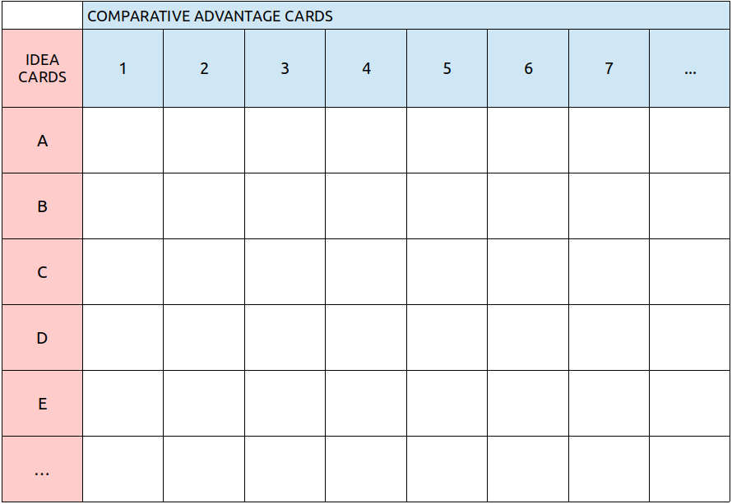INDIVIDUAL TASK #3
To be done after the fourth session.
Do the following activities as part of the preparation for Jornada #2.
Activity 1: Exploring the supply market. Use your notebook to record the information about the enterprise that you were assigned to visit, following this template.
Name of the Enterprise:
Address:
Phone:
Website:
Social Media:
Contact Person:
- How large is the enterprise?
- What does it produce?
- In what amounts?
- How is production done?
- How is the product sold?
- What are the enterprise’s comparative advantages and what enables them to be viable?
- Do they have plans for expansion?
- What is their evaluation of their own activities and business?
- How do they relate to their social environment?

Activity 2: Exploring the social environment and community. Use your notebook to record the information about the social environment and community in which you hope to create your solidarity enterprise.
General description of the community or social environment in which the enterprise is to be located:
- What are the problems and needs of the community?
- What are their forms of life, the relationships between neighbors, and the modes of social interaction?
- What are the conditions of safety and security?
- What cultural, religious, and political aspects characterize the community?
- What types of social organization exist?

Jornada #2
“The Idea”
What is this Jornada about?
In this jornada participants carry out an exploratory study of a business idea: examining it in enough detail and depth to evaluate if it is really a “good idea.”
Which aspects of the business idea should be examined in this jornada, in order to determine if the idea is good or if it should be rejected and a new idea explored?
The business idea should be examined according to the three main aspects or criteria we have studied. The goal is to create an idea that is original or innovative, and at the same time realistic or feasible. The criteria:
a) Carrying out this business idea will enable the solidarity group to meet their objectives.
b) The group has comparative advantages with respect to the idea in the market in which the plan will be carried out.
c) The idea is beneficial for the surrounding community, that is, it presents positive externalities for the community.
How to choose the idea to be explored in this activity?
The group should choose one idea for which the group had many comparative advantages from those presented by the participants in Exercise 3 (“Brainstorm”).
But it is not a question of mechanically going with the idea that had the most points. Other factors need to be considered. The group intuitively knows many things not considered in the exercise: whether or not the idea corresponds in its general line with what they want to do, if it seems realistic, if the group has or can develop the labor skills needed to do it, if they think it is possible to pull together the minimum resources needed to start it, etc.
You don’t have to have resolved all of these questions before doing this activity. The point is you should not waste time working on an idea that is clearly impossible for the group to carry out, or that members do not want to do, or that is bad for the environment, etc. The question of resources, including financing, will be examined in the next Unit.
Summing up: for this practical activity the group will choose the idea that seems best to them, taking into account all the information they have and what they have learned to this point.
What are the activities to be done in this jornada?
There are three steps for exploring the business idea:
a) Preparation and planning (this is to be done in the fourth session, if the group can not complete it, an additional session should be held).
b) Doing the assigned small group and individual tasks.
c) A day-long jornada of group work.
What needs to be done in the preparation and planning meeting?
a) Choose the business idea to be explored. The group should discuss this and come to a decision. In the event that the exercises about identifying objectives and brainstorming ideas ended up with the group proposing two or more enterprises, groups will be formed for each enterprise and each group will do the practical activity separately. However, as the jornada of group work is to be held with all members together, the subgroups will gather for the last part of the meeting in which the whole group will organize the jornada.
b) Plan for two tasks:
- Exploring the supply market.
- Exploring the community and social environment.
Exploring the supply market consists of collecting information about enterprises that produce goods or services similar to those which the solidarity group proposes to produce. The objective is clear: to learn as much as possible from the experiences of others and simultaneously evaluate if the solidarity group really has the comparative advantages needed to realize their idea.
Individually or in small teams, group members will visit enterprises that they have identified as relevant and to which they are able to gain access.
They will collect as much information as possible. See the handout for Activity 1 for questions to be asked.
Exploring the community and social environment consists of gathering information about the reality surrounding the solidarity group, or the place where they plan to establish the enterprise. See the Activity 2 handout for topics to be explored.
The group will organize itself to carry out both tasks, assigning responsibilities to individuals, pairs, or groups of three or four, according to the size of the group and what seems most efficient. Having distributed the tasks, the group will make an effort to take advantage of the skills that each person brings.
In carrying out both tasks, people will take detailed notes that, once organized and synthesized, they will present to the whole group in the jornada.
c) Prepare and organize the jornada of group work.
The group organizes and prepares the jornada in a participatory way, making sure that all the materials to be used are made ahead of time (tasks will be assigned to particular members), and that all the activities to be done have been planned in detail.
The jornada needs to be executed with precision, making the most of the time available and optimizing the results, this being part of learning how to create and operate an enterprise.
What should be brought to the jornada?
- The group symbol and logo design created in Unit 1, Exercise 2.
- All the index cards from Exercises 3 and 4.
- A big canvas, 2 x 3 meters, on which you can write and post cards, a large pad of paper with several sheets, markers, and a packet of index cards of different colors of the type used in the Exercises.
- A drawing that represents the Idea of the enterprise on which the group will work in the jornada.
- The notes that each person and group wrote during the exploring the market and exploring the social environment exercises.
- Each member’s personal notebook and the materials from Units 1 and 2 of the manual.
What kinds of materials are needed?
The canvas, the drawings, the cards, the symbol, etc. should be made with great care, using high quality materials and seeking perfection in their design.
The group should be conscious of doing everything well. The means of production used are the enterprise’s first “products” not to be neglected as they will be used in other exercises and activities in this manual.
There should also be careful accounting of the resources used and costs incurred in the preparation and execution of the jornada, as was done in the Mitote.
How should the jornada be carried out, what is the plan for group work?
This jornada is, essentially, a work session and can be done in about four hours, though the group may decide to add other fun activities that they think would be good to include.
The jornada follows this plan:
- Gathering, welcome, thematic game. Installation of the group symbol, used in the Mitote, in an appropriate place. Selection of a moderator for the meeting, as well as a “canvas manager” (to manage the bulletin board or display used in the activities), and a note-taker.
- Preparation of the canvas, using this layout:
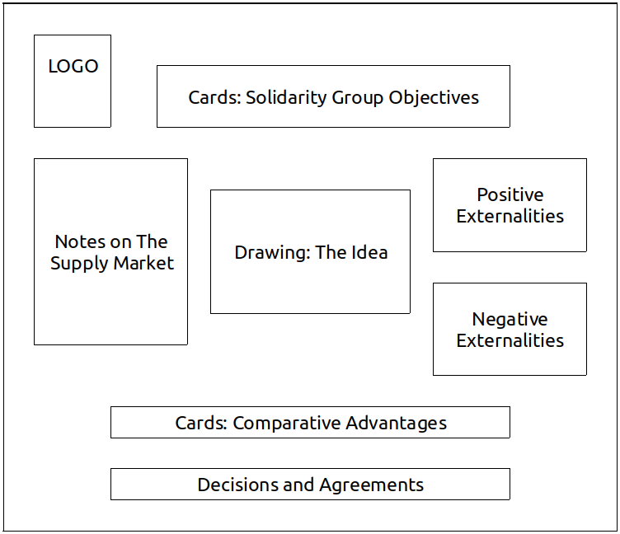
- Activity 1. Specifying the objectives of the enterprise.
- Break and Snacks
- Activity 2. Evaluation of comparative advantages.
- Activity 3. Evaluation of social externalities.
- Break
- Activity 4. Decision-Making.

Contents of Activity 1
The objective of this activity is to define more precisely the objectives of the solidarity group that is proposing to start a solidarity enterprise and determine if those objectives can be achieved through the business idea(s) that has been proposed.
In Exercise 3, members already took a first stab at this. The results are on the canvas.
The activity now unfolds in the form of a conversation in which everyone should give their opinions in response to the following questions:
Question 1. Are we in agreement about the objectives that were generated in Exercise 3? Do we all share these objectives?
Question 2. Are there any other objectives we would like to add?
Question 3. Should we change the ranking of the priorities we have set?
Question 4. Can we improve the wording of our objectives, to better express what we would like to achieve? (At this point proposals for edits are entertained until consensus is reached on the new wording and the old card is replaced with a new one.)
Question 5. Will our business idea enable us to achieve our objectives? In what way? (The objectives are analyzed one by one. For each objective that is clearly connected to an idea and is achievable, draw a solid line connecting the objective and the idea. For objectives that may or may not be achievable, draw a dotted line, and for objectives that seem unlikely to be achieved by this business idea, draw no line.)
Contents of Activity 2
The objective of this activity, in which members evaluate their group’s comparative advantages, is to assess the originality and realism of the group’s proposed business idea. Originality and realism are manifested in the group’s comparative advantages with respect to its idea and the advantages the enterprise has with relation to existing enterprises and the market which it intends to enter.
Exercise 4 involved an initial effort to define the comparative advantages of the solidarity group, and how they are related to the different business ideas that the group suggested, an effort that helped define the business Idea that we are now studying.
But that first identification of the group’s comparative advantages was still abstract and very subjective. They were identified by “looking inward” in the group, which is helpful for identifying the group’s strengths. But the idea is to compare those strengths to other enterprises, which requires “looking outward” and putting the group’s advantages in relation to other initiatives and experiences that resemble what the group intends to do.
As part of this activity and in preparation for the jornada, group members explored the “supply market” in which they too will operate, investigating other enterprises in the area that offer similar products or services to those of their proposed solidarity enterprise. It is on the basis of the knowledge and information gathered about these other enterprises that participants can make the comparisons called for in this activity. The activity follows these steps:
Step One: the people or teams that visited enterprises present a full and detailed report on the condition of those enterprises, sharing with the group all the information they obtained in regards to the research questions. After presenting, they respond to questions from the other participants.
Step Two: The comparative advantages of each enterprise that is presented, with respect to the group’s own solidarity enterprise, are to be noted in the space on the canvas set aside for “supply market,” under the name of each enterprise.
Step Three: Returning to the previously identified comparative advantages, written on index cards, the group will decide if they are still accurate, having compared them to the enterprises the teams researched.
Step Four: The originality and realism of the business idea for the proposed solidarity enterprise are evaluated by the whole group, based on the elements considered to this point.
Contents of Activity 3
The goals for this activity, in which social externalities are evaluated, are
a) to ensure that the enterprise that the group intends to create will be beneficial to the community and that the community will support its creation and development and be favorably disposed to buying its products and services, and
b) to identify those elements of the surrounding reality (organizations, groups, etc.) on which the solidarity group can count in creating and operating the enterprise, as well as the obstacles and resistance that might be encountered. The steps are as follows:
Step One: The people or small groups that explored the social and community context report back in detail on what they learned, answering questions from the rest of the group.
Step Two: The proposed enterprise’s positive externalities are identified (and written on the canvas). What will the enterprise bring to the social and community reality, what problems can it help address, how can it become a part of that reality so as to deploy all the contributions it can make.
Step Three: The proposed enterprise’s negative externalities are identified. Who might be harmed or affected, what problems might be created, etc.
Step Four: Open discussion of the impacts that the creation of the enterprise might have, with an effort to identify the elements of the environment that might motivate or stimulate support for its creation, as well as those that might pose obstacles or cause problems. The conversation is intended to explore how the group can broaden the positive externalities and eliminate or reduce the negative externalities.
Contents of Activity 4
The objective of “Decision-Making” is to extract from the preceding analyses and evaluations the appropriate conclusions regarding the business idea on which the group has worked. Such conclusions have to be translated into decisions adopted by the group and should lead the group to continue working on the business idea.
This activity is realized through an open conversation in which everyone should share their opinions and points of view so that the group can find where consensus and agreement are possible.
The decisions and agreements can be of various types, for example:
- dismiss and abandon the business idea developed to this point,
- approve it and continue improving it,
- explore other possibilities,
- correct initial conceptions, etc.
The decisions and agreements taken will be recorded on the canvas and in the notebooks of each participant.

Unit 2 GLOSSARY
Feasibility Study
A study that is conducted prior to submitting a business plan, in which you analyze the conditions of the market in which you intend to operate, the supply of factors and inputs, the fixed and variable costs of start up and operation, the quantities and prices of goods and services to be offered, the expected income and profit, the cash flow, and in general the elements that determine the possibility and economic suitability of the plan.
Quality of Life
Quality of life is determined by a wide range of conditions, factors, and elements that influence the way people and social groups live. The satisfaction of needs, the development of skills, the achievement of objectives, the fulfillment of desired and aspirations, are essential aspects of the quality of life as it is experienced by individuals and groups. In large part determined by participation in the economy and its fruits, quality of life is not just an economic outcome. It is also influenced substantially by the forms of coexistence and social relations, participation of residents, education and knowledge, access to and appreciation of culture and its works, and spiritual and moral development.
Externalities
Externalities are the combined impacts and effects that the establishment and operation of enterprises and economic activities in general have on the local environment, community, and social context in which they take place.
Positive Externalities
Those beneficial and useful impacts and effects that the enterprise has on its environment which contribute in some way to the quality of life of those who, at different levels, are related actively or passively to the enterprise or economic activity.
Negative Externalities
The harmful impacts and effects that the enterprise has on its environment which corrode in some way the quality of life of those who are affected by the enterprise or economic activity.
Business Idea
We understand “business idea” to mean the precise identification of one or more innovative or original elements that make it possible to create an enterprise or unit of economic activity that is viable and optimal. The business idea implies a creative act that leads to the conception of something new, different in some way from what already exists.
Captive Market
A “captive” market is one in which the aggregate demand for goods and services can only be satisfied by one particular enterprise.
Needs
The concept of needs used in solidarity economy is very broad. Needs are not just “lacks” or overwhelming needs that must be met in order for the individual to survive. Rather, they include all the motivations and impulses, forces and capacities, that lead to the performance of economic activities, be they in the form of consumption, production, or distribution. Needs are at once individual and collective, personal, communitarian, and social. Needs are not only of the body but also of the spirit. Some bodily needs are also cultural and concern coexistence. There are needs to have (things, goods), to do (work, know), to be (live, roam), and to exist (personal and social development). Manfred Max-Neef proposes a distinction between nine different human needs: subsistence, protection, affection, understanding, participation, leisure, creation, identity, and liberty.
Business Plan
A business plan is the mental prefiguration and written description of the enterprise one intends to create, including all the details and elements implied by its realization. To elaborate a business plan is to precisely identify: the economic objectives sought, who will organize them, who will produce what and in what quantities, the demand and the market to which production will be oriented, how production will be carried out (the factors, inputs, technologies used, etc.), where it will happen, when and with what planning, the results to be expected in specific time periods, how one expects the enterprise to grow and develop, etc. (See Unit 7)
Entrepreneurial Realism
We use this term to describe the creative and constructive attitude needed by a subject (individual or group) who intends to create an enterprise, or grow or transform it. Entrepreneurial realism assumes that one is aware of the organization’s capacities and potential as much as its limitation, that one appreciates the opportunities that reality offers as well as the obstacles and difficulties it can pose. Based on this appreciation of oneself and the real context, the most objective possible, it is crucial that one not be held back by fear or pessimism, but instead act constructively, be ready to take risks and take responsibility for the results, knowing that reality is modified positively through action itself. One learns by doing, developing relations with others, establishing and cultivating bonds, overcoming difficulties by expanding one’s own capacities and securing the support of others, etc. Hence, we see entrepreneurial realism as something that is not only sober but optimistic, hopeful, positive.
Comparative Advantage
Comparative advantages are all the conditions, qualities, circumstances, and factors that an entrepreneurial subject or enterprise possesses that give it a better position than other similar enterprises operating in the same market. People sometimes speak of “competitive advantages” referring to the fact that the enterprise can offer products and services for a better price, quality, or convenience that those offered by “the competition.”

EVALUATION OF UNIT TWO
This evaluation include both individual and group evaluations.
Individual Evaluation
Each participant should answer the following questions in their notebook:

A. Circle the answer that best matches your experience.
- My understanding of the contents covered in Unit 2 is:
Weak – Good – Excellent
- My performance of the individual assignments in this Unit was:
Weak – Satisfactory – Very good
- I consider my contributions to the group exercises to be:
Poor – Adequate – Outstanding
- My participation in the organization and execution of the practical activity (jornada) was:
Passive – Relatively active – Very active
- I think my overall contribution to the group was:
Very little – Could have been better – Ample
B. Reflect on the following questions and summarize your answers in writing.
About the group’s objectives:
- Do I feel that the group has set the correct objectives? Do I share those objectives personally?
- Do I believe our business idea will effectively help us achieve those objectives?
- Am I ready to give my all to achieve these objectives? In what areas or ways can I do more?
About the business plan:
- Did we develop the business idea with sufficient depth and seriousness? Do we have all the information we need in order to make a definitive decision? What else do we need to find out?
- Am I convinced by the agreements we reached? Are they realistic? Can we really carry them out?
- What are the comparative advantages of our group with respect to our business idea? What are the disadvantages? Can we develop additional comparative advantages? Can we overcome the obstacles we face?
- Would the enterprise we are thinking of creating really be good and useful for our community and social environment?
- Do I have another business idea that I think I should propose for the group to study together?
Group Evaluation (to be done in the next session)
Seated in a circle, the whole group discusses the following questions.
- What happened to the C Factor during the exercise where we identified the objectives of our solidarity group?
- Does our business idea inspire a unity of consciousness, will, and feeling in our shared objectives?
- What do you think our group still needs in order to make our business idea real?

Unit III

THE FACTORS OF A SOLIDARITY ENTERPRISE
The Theorem of Defined Proportions
Session 5
Plan
- Gather, welcome, ice-breaker, form a circle, choose a moderator for the meeting.
- Evaluation of Unit II.
  - Each participant reads aloud their answers to the Unit II individual evaluation form.
  - Carry out the group evaluation as described in the Unit II group evaluation form.
- Break, snack.
- “Reading Three.” (One or two people read out loud as others follow along in the text.)
- Questions for review and discussion. (Participants volunteer to answer one question each, raising their hands to speak. Other participants can add to their answers but it is best if nobody speaks twice before others have had a chance to speak.)
- Questions for the facilitator, exchange of ideas and free conversation on the theme.
- Suggestions for the Individual Task. (The facilitator will explain the content and purpose of the individual task, clarifying any issues and answering questions that come up.)
READING THREE
In the first two Units, we identified and elaborated the two main pillars on which the creation of a solidarity enterprise is based: the solidarity group and the business idea. This third reading assumes that the solidarity group has been formed and has come up with a specific business idea, although both remain provisional and require constant improvement. The theme that we address in this reading will add new elements to both the solidarity group and the business idea, modifying, and, we hope, improving them.
On one hand, we said that the group of people that wants to form an enterprise should organize itself as a work unit, something that is addressed in this Unit. On the other hand, we saw that the business idea should be developed with realism, and we will examine here what is needed in order to form an enterprise, which will enable us to see which elements the group already has and which are needed for the enterprise that we propose to create.
What is needed in order to form an enterprise? The economic factors.
We have seen that an enterprise is an organization that produces goods or services through the combination and joint operation of various factors of production (or economic factors). We will now examine the different economic factors that make production possible and must be present in any enterprise.
1. Labor Power
The first factor of production is labor power. Labor power is the human capacity of doing and implies an effort that is sustained in time. It is the exercise of physical and mental energies, the deployment of skills and abilities in the realization of tasks that have been assigned and for the completion of which a deadline has been established.
Labor power is individual and collective: each person has a certain capacity for labor, but labor is typically realized by combining the energies and capacities of a group of workers.
Each person’s labor power has different characteristics, different levels and types of qualification. There is a general, or standard, labor power which is possessed by any person of normal age and health, which permits the performance of certain simple activities. There is also specialized labor power, which is the capacity to perform activities that require certain skills and abilities, or the possession of specific knowledge and competencies that make it possible for the person to carry out more complex tasks (for example, the practice of a trade or profession).
Collective labor power is the capacity to do something through the combination of the skills and abilities of various people working together. When each person performs a partial or particular task that contributes to the execution of a larger task or activity, we speak of a technical division of labor.
Labor power, whether personal or collective, can have greater or lesser productivity, as measured by the quantity and quality of the tasks and works performed in a given period of time. The productivity of labor power depends on the levels and quality of the specialization of each person and of the group, but also on their dedication and effort, on their concentration on what they are doing, and on the constancy and strength of will they apply to the assigned task.
Normally, a person’s labor power is greater than that applied while they are working: there are unused skills, capacities that are inactive, will that is not applied, spaces of time that are unoccupied. So we can say that the potential productivity of labor power is greater than the real productivity shown in the execution of work.
Now, labor power alone cannot produce anything nor demonstrate its productivity. In the enterprise labor power acts in concert with a second factor.
2. The material means of production
The material means of production are the physical objects employed in the production process: the workplace itself, the tools and machinery used, the inputs and raw materials used to create products, the implements used in performing services, the locations where products are stored, the electric energy used, and other indispensable facilities.
The material means have something in common with labor power: that they have different levels of productivity depending on their specialization, their quality, and the time during which they can operate. Some means of production are more efficient than others, producing more while others produce less. There are means of production that have a long productive life, depreciating slowly, and others that deteriorate rapidly or are used up completely in the production process.
It is important to take this into account because the quantity and quality of production depends as much on the quality and productivity of the means of production used as on the skill and productivity of the labor power employed.
But to have an enterprise and undertake production, we need more than labor power and material means of production. It is a common error to think that no more is needed, but a third factor is required.
3. Technology
Technology is the practical knowledge, the know-how used to produce things, the combination of information necessary for production. Technology is not the same as machinery; machines “contain” technology in that they embody applied and objectified knowledge that determines beforehand the activities they are capable of executing.
However, inasmuch as technology is knowledge, learning, and information, it is a human factor. Technology objectifies itself not only in machines and material instruments, but also in people: the knowledge of the engineer, the mechanic, the artisan. Technology is also expressed in the design of products, in the formulas and calculations related to the production process, in the procedures and organizing systems, in the rational order of processes and operations.
But all technology, before taking the form of instruments and machines, or designs and systems, is born in the mind of humans. Technology is always the fruit of human creativity.
With respect to technology it is important to know that just like the other factors it has a differential productivity, manifesting different levels and degrees of productivity. The productivity of technology depends on the breadth, complexity, and precision of the knowledge applied. On the other hand, technology is not eternal: all technology has a period of validity after which it becomes obsolete. Thus it is crucial for any enterprise to engage in a constant process of creation and technological innovation. The development of new knowledge and applications allows the enterprise to maintain and increase its productivity.
Yet another factor is needed, in addition to labor power, means of production, and technology, without which an enterprise can not produce economically.
4. Management
Management means making decisions. The operation of an enterprise requires constant decision-making with respect to multiple functions and aspects, determining which are best suited to the objectives, and adopting them opportunely with agility.
The decisions that have to be made are on different levels: some are about the general functioning and organization of the enterprise, others about very specific operational questions. Some involve long term commitments and processes, others may only be valid for a day, hour, or even minute. The system of management should be such that demands on each of these levels are met. General decisions and those with long term implications should be adopted as part of a strategic plan; those that are medium term and affect specific functions (production, marketing, financing, etc.), should be part of the work plan or road map. Day to day decisions and those affecting particular activities can be matters of executive management.
As with the other factors, there can be different levels of quality when it comes to management, which determine its productivity or the contribution it makes to the achievement of the economic objectives of the enterprise. The quality of management depends on various aspects among them:
- knowledge of the real conditions of the enterprise, both internal and external,
- the skills of those carrying out the economic activities,
- the coordination and coherence between the decisions adopted at various levels of the organization,
- the capacity for meeting the changes occurring in the external or internal context,
- the agility of the processes generated by agreements,
- the reduction of time between the moment a decision is made and the moment it is carried out,
- the flows of communication between those who make decisions and those who carry them out,
- the exercise of rational and efficient leadership, and
- the disposition to correct errors, processes of evaluation.
Management is not the final factor needed. Two more remain.
5. Financing
Financing is necessary because the enterprise is not an isolated entity, self-sufficient, producing only for itself. The enterprise must establish economic relations with third parties: suppliers, providers of factors, clients and customers, etc. The enterprise needs what others have to offer, and produces goods and services for others. Relations with others are normally conducted in the market, where the factors of production, inputs, raw materials, etc. are offered by those who possess them and where the goods and services produced by the enterprise are demanded by consumers. These economic transfers, flows of assets entering and leaving the enterprise, are typically effected through exchanges: purchases, sales, contracts, agreements, promises to pay, etc., in which money is used as the means of exchange.
The financing of an enterprise is the money that it can use to buy or hire the necessary factors of production, to buy inputs, pay for services, pay workers, and in general assure the fulfillment of obligations and commitments to pay made in its creation and operation. Like all factors, the financing used to pay for expenses itself needs to be remunerated, that is those who provide it for the time during which it is at the disposition of the enterprise need to be compensated.
If financing typically takes the form of money (in Unit V we will examine other forms), it can nonetheless present different levels of quality. The quality of financing is made manifest in the time for which it is available to the enterprise and in the interest rate that must be paid. This quality depends basically on the credibility and trust that the enterprise is able to inspire in those who offer financing, whether they are members of the enterprise itself or outside investors who offer financing in the form of credit or loans. The more trustworthy the enterprise, the more money those financing it will be ready to provide, for longer periods, at a lower interest rate.
The sixth and last factor is our old friend, The C Factor.
6. The C Factor
As we already studied the C Factor in Unit I, we will limit ourselves here to recalling that the C Factor is solidarity converted into a productive force; that it is created through the union of consciousnesses, wills, and feelings around a shared objective; and that its quality – the force, consistency, and permanency of the ties that integrate the enterprise as a community or human group – determines its productivity.
We can now consider the relations among the factors, which are present to one degree or another, in any enterprise. As they operate together and are only productive in their joint operation they must be combined and organized for production to take place. The enterprise is precisely this: an organization of labor power, material means of production, technologies, management, financing, and the C Factor. We can represent it as a hexagon in which each factor is connected to the others:
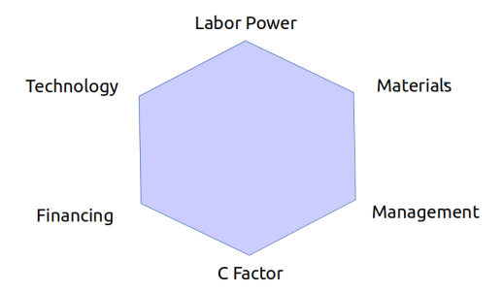
Six Factors of Production
The productive efficiency of the enterprise hinges on the combination and organization of the six factors, and the productivity of each factor depends on how it is combined with the others. We can say that just as an artist combines colors in their work, the entrepreneurial art consists of combining factors in a way that is harmonious and efficient. To combine the factors adequately there are some important things we need to know. The most important is the following:
The Theorem of Defined Proportions
This theorem states that in combining the productive factors certain proportions must be respected and the correct correspondence among them must be sought. The proportions are the quantities of each factor to be combined; correspondence alludes to the relation between their characteristics and qualities. Let us illustrate this with a few examples of each term, beginning with proportions.
Imagine a textile enterprise whose workplace is a 5x4 meters room with two looms each of which can be efficiently operated by two people. There are thirty workers. Is this an adequate proportion of labor power to means of production? Obviously not, since many workers would be inactive; and as there would remain little space for movement, it is to be expected that the people would talk and generate distractions of all kinds, leading to less production than could be produced by the four workers alone.
If, in the same textile enterprise, the workers can process 20 kilos of wool a day would it make sense for this enterprise to have 10,000 kilos of wool in storage, enough for 500 days of work? Clearly no, since in addition to generating problems of storage, the enterprise would have a great quantity of raw material immobilized which implies money invested that spends a lot of time unproductively. Of course, it would also be a mistake to operate with only enough wool for one or two days of production as any delay in supply would lead to a halt in production and a corresponding fall in productivity.
Now, imagine that in the same enterprise, in addition to the four machine operators, there were five other people working (in purchasing and sales, in design and product development, etc.), would the proportions be correct if there were a bureaucratic structure with six levels of hierarchy and eight departments or sections, represented in a complex organizational chart?
Assuming the enterprise has a cash flow that oscillates between 10 and 12 thousand dollars a month, would the financing be proportional if the enterprise kept 80 thousand dollars on hand, enough to cover all the costs for several months? The excessive amount of cash on hand is not helpful to the enterprise: the money will likely be spent unwisely, on unnecessary expenses, with poor profitability, and much of it would remain unproductive, which means it would be losing value. Workers, knowing there was so much money available, might reduce their efforts on the job, vendors might feel less pressure to accomplish their tasks with efficiency, etc.
We can multiply the examples; but at this level of abstraction the idea of defined proportions is clear: the different factors should be combined in the enterprise in the right quantities, permitting all the factors to be kept active and highly productive. If one factor is lacking, it becomes a “bottleneck” for the enterprise; as all the rest, which operate jointly with that factor, become excessive and remain largely unused. If one factor is in excess, there will be friction with the others, interfering with their functioning, and not only will that factor remain largely unused, it will drag down the productivity of the others.
Now, the efficient combination of factors is not only a question of quantities but also of the quality and characteristics of the factors combined. Each factor has special characteristics and its productivity is not “general” but particular. To operate looms you need weavers, not mechanics. To do the books for a small enterprise is it better to have an accountant than a business administrator because while the latter is quite able to do accounting, the rest of their technical knowledge will remain unused and their productivity will be lower than if they worked at their own profession. For an enterprise that will obtain revenue in the medium term, short term financing will not do. To manage a small enterprise operating in a local market a manager with experience in large enterprises that operate on the international market is not much use. Better to find someone who knows the reality that is relevant for the proper functioning of this small enterprise. And so on.
Thus we find that the “defined proportionality” between factors is as much qualitative as quantitative and when organizing an enterprise one should search for that combination of factors that will assure the best use of each available factor as well as the maximum productivity of their joint operation.
We said that there are “defined” proportions in which the factors of every enterprise must be combined in order to operate efficiently. Nonetheless, there is not one single proportion that is efficient, all others being inefficient. In reality, for any given production process there exists more than one proportion of factors that can be efficient. To understand this we need to introduce another concept:
The reciprocal substitution of factors.
In production, some factors can replace or be substituted for others. The most obvious case is the substitution of machinery for workers and vice versa. When a new type of machine manages to produce the same or greater quantity of goods or services with the same number of or fewer workers, it is said that the productivity of labor has risen (because the total production rose with fewer workers); but in reality it was the productivity of the machinery that increased. The rise in productivity of one factor signifies that the specific contribution of that factor to production has grown; thus, the productivity of labor rises when the product of labor is greater, which normally occurs when workers specialize or gains skills, or when improvements in the organization of labor make them more efficient.
Any factor can be partially replaced by another that makes a greater contribution to productivity. For example, improvements in information systems (technological factor) can facilitate management and make the decision-making system simpler, de-bureaucratizing it and reducing its footprint in the enterprise.
In this sense it is important to take time to carefully consider what occurs with the C Factor, which is so important for solidarity enterprises. This factor has the very special quality of being highly substitutable for other factors: it can replace them easily and in great proportion, and can itself be replaced by other factors. Let’s look at how this happens and what it implies for the organization of enterprises.
What happens when a group of people is integrated and united, with each member conscious of their common objectives and giving their all to achieve them? When the C Factor has this quality its contribution to production takes two forms: raising the productivity of each of the other factors and adding value to products itself, thus allowing the enterprise to obtain profits operating with a lower provision of the other factors. We will see how a strong C Factor allows the enterprise to partially replace the need for each of the other factors.
In well integrated group with a good working atmosphere, workers help each other in their tasks and teach each other the best ways to do them, making work more pleasant and reducing the fatigue that the activity causes, allowing for greater output per worker and a greater intensity and duration of activity. In this way the same activity can be satisfactorily carried out with fewer workers, and less labor power, than would be needed in the absence of a strong C Factor.
A good C Factor also implies less need for material means of production because they will be better maintained and cared for, depreciating more slowly, and more intensively employed, increasing their productivity. It may even be possible to forgo those means of production whose function is to improve working conditions inasmuch as the strong C Factor may better meet those needs.
A consistent C Factor also makes it possible to spend less on necessary technology as the spontaneous exchange of practical knowledge and the creativity of the group in finding solutions to technical problems reduces the need to obtain information and technology on the market.
The C Factor also simplifies management by facilitating communication, incorporating everyone in decision-making, and reducing the lag between decision-making and execution. A strong C Factor allows for simpler coordination of activities, eliminating many bureaucratic practices of control and accountability that are necessary where there is mistrust, and can be the source of significant costs for the enterprise.
Given the foregoing, the presence of a strong C Factor in an enterprise leads to reduced financial needs, allowing it to operate with less disposable cash. If the management is collective, it is not necessary to hire expensive managers and executives; if the people who do the work are members of the enterprise it will not be necessary to pay the legal costs associated with labor relations and conflicts, and the enterprise can operate on the assumption that the workers themselves will provide credit needed to cover any back pay that is owed, etc.
In this and other ways, the C Factor reduces the need for the other factors. Inversely, if the C Factor is lacking, its contributions and functions need to be substituted by other factors: a more complex information system, expensive bureaucratic and hierarchical management structures, a greater quantity of materials which will deteriorate and depreciate more quickly, more labor time for a given amount of production, etc.
Enterprises with various combinations of factors have different cost structures.
Thanks to the reciprocal substitution of factors, it is possible for the factors to be combined in different proportions. As we noted, for any given type and volume of production different theorems of defined proportions are possible. This is seen in the fact that enterprises can be intensive in one or another factor. There are enterprises with a high proportion of labor power, others in which the material means of production predominate, or financing, technology, management, or the C Factor.
As the productive factors have different values in the market and their integration in the enterprise implies greater or lesser costs, enterprises with more or less of a given factor will have different cost structures.
Generally speaking, capitalist enterprises in which it is more difficult to establish a C Factor (given the different interests of those participating), the financial costs tend to be very high. These enterprises also tend to function with less labor power, replacing it with machinery or technology, as the costs per worker tend to be high even if workers are paid little. Enterprises tend to incur costs associated with labor conflict and workers themselves don’t give their all, normally working with little commitment to the enterprise, slowing down, and forcing the enterprise to implement costly systems of monitoring and control.
Inversely, enterprises with a high proportion of the C Factor have decidedly lower financial costs, and tend to function with a higher proportion of labor power, capable of replacing certain portions of the materials, technology, and management factors. In solidarity enterprises the workers are committed to the achievement of the objectives of the enterprise, the profits of which will benefit them directly, so the productivity of workers tends to be higher (reinforced by the C Factor) making it more efficient for the enterprise to pay workers than to pay for other factors that might otherwise be substituted.
The quantity and quality of products and services depends on the combination of factors employed in their production.
When we say that factors are “productive” what we mean is that they contribute to the generation of products, whether tangible products or intangible services. The contribution made by each factor is seen and reflected in the product: in production something from each factor passes into the product and is “trapped” there. Thus the quantity and quality of the products depend on the quantity and quality of the factors employed in their production. Let’s consider some examples:
A ceramic cup, or a piece of fabric, made “by hand,” that is employing a high proportion of labor power and a minimal amount of machinery, is quite different from the same item produced by machinery with a reduced amount of labor power. In both cases, the quality of the product depends on the quality of the factors employed – the labor power and the machinery – according to the proportion of their participation in production. The quality and quantity of the technology and the knowledge used are also reflected in the products. It is easy to understand how the quality of the raw materials influences the quality of the product. It is less obvious, but equally true, that the quality of the product depends on the quality of management. Each factor leaves a part of itself in the product. The C Factor as well: goods and services produced with love and solidarity, turn out to be different and superior to those products made with nothing but a cold financial calculus. From this point of view, the “theorem” of factors is also important and enables us to see that it is best to “solve” it by considering not just the criterion of cost structure but also the quality of the product that is to be brought to market.
Internal and External Factors
Finally, we should bear in mind that the various factors can be present in the enterprise in two ways: as factors proper to the enterprise, or internal factors, and as external factors.
Internal factors are those that belong to the enterprise, or that its owners or proprietors contribute directly to the enterprise. External factors are those factors necessary for production that are not already part of the enterprise’s assets, so they must be contracted on the market. External factors imply direct costs for the enterprise as payment must be made for the time during which their productive services are employed in the enterprise. On the other hand, the enterprise does not pay for its own factors, their contributors are recompensed through participation in the profits or surplus obtained in the fiscal year. Any of the six factors, or portions of them, can be internal or external to the enterprise, resulting in different cost structures and different forms of distribution of surplus.
Cost structure and surplus distribution are quite different in capitalist and solidarity enterprises. In solidarity enterprises, it is normal for labor power to be internal, given that workers comprise the organization; in capitalist firms this is not the case, labor power is typically an external, contracted factor. Moreover, in solidarity enterprises the C Factor is always internal, while in capitalist enterprises it must be considered an external factor, even though it is not remunerated. Technology and management, too, are internal to the solidarity enterprise insofar as they are provided by the members (in the form of the creativity and knowledge of members, their self-management or participation in decision-making). Thus on this front too solidarity enterprises have lower direct costs (and needs for financing) than capitalist enterprises which have to pay for all the human factors they employ.
In accordance with the theorem of defined proportions and the reciprocal substitutability of factors, each enterprise should find the combination of factors that suits it best, taking into account the factors already in its possession, the access it has to other factors, and the cost structure that could support and enable maximization of gains.
INDIVIDUAL TASK #3
To be done after the fifth session.
- Study the Glossary at the end of Unit III.
- Answer the “Questions for Review and Discussion #3” in writing in your notebook.
- Write your curriculum vitae or resume.
Questions for Review and Discussion #3
The following questions should be answered individually, in writing. Each participant will later share their answers during the group work, allowing for evaluation and correction of the answers by comparing them with the answers of other members and ensuing discussion.
- What are the six factors of production needed in any enterprise?
- What is technology? What forms does it take in an enterprise?
- What is the factor known as management? What elements influence its productivity?
- What are the functions of financing in an enterprise?
- What is the Theorem of Defined Proportions?
- What is the reciprocal substitutability of factors?
- Why do solidarity enterprises have less need for financing than capitalist enterprises?
- How are the costs structures of capitalist enterprises different from those of solidarity enterprises?
- Based on the theorem of defined proportions, can you explain the differences between artisanal and industrial production?
- Can you give an example of each of the six factors of production?
- Why do we say that the theorem of defined proportions is the “basic equation” that the solidarity group must solve if it wishes to create an enterprise?

How to make a curriculum vitae (C.V.) or resume.
A C.V. is a personal introduction that is normally prepared for job applications. The idea is to tell the reader about your skills and the contributions you can be expected to make to the enterprise if you are hired. In our case, the C.V. should be written for the solidarity group, based on the type of enterprise the group has decided to create.
C.V. Contents:
  - Full name:
  - I.D. type and number:
  - Address:
  - Date of Birth:
  - Family Status:
  - Family Members:
  - Formal Education:
  - Other Education:
  - Training Courses, Certificates:
  - Current Position or Profession:
  - Other positions or professions:
  - Other skills or abilities:
  - Other knowledge or expertise:
  - Work Experience:
  - Freelance or Self-Employed work:
  - Participation in social movement and/or community organizations:
  - Positions held in social/community organizations:

Session 6
Plan
1. Gather, welcome, thematic game, form a circle, choose a moderator for the meeting.
4. Reading and commentary on the answers to Questions for Review and Discussion #3. (If the group is large, each participant will read only one or two responses.)
3. Exercise #5. Recognizing the Human Factors that Each Member Brings.
5. Break, snack.
6. Exercise #6. Recognizing the other Factors of the Solidarity Group.
7. Reading and Organization of Jornada #2: “The Theorem.”

Exercise #5
Recognizing the Human Factors that Each Member Brings.
Explanation
The objective of this exercise is for the group to recognize the human factors (labor power, technology, management, and C Factor) that each member brings to the solidarity enterprise to be created. We are speaking only of a preliminary recognition since the more complete identification of factors and the effective possibility of integrating them in an enterprise where they play a useful role, are more complex questions that we will examine in Unit IV.
As the human factors are acquired and developed to a large extent in the labor process, in study, and in participation in the organization, each member’s curriculum vitae can be a useful tool for documenting the skills, experience, and capacities available to the group.
The Flow
- This exercise is carried out using a flip chart or board on which are drawn four columns with the following titles:
- Participants take turns reading to the group the C.V.s they prepared in the individual task from the previous session.
- After each C.V. is read, the moderator or note-taker records the relevant data for each factor on the chart. The person who read their C.V. adds additional information to make sure the notes reflect more exactly what that person can do/contribute.
  - Labor Power: positions and professions, skills and talents, and other labor abilities developed in previous work experiences.
  - Technology: knowledge and practical know-how gained from formal study, training courses, and other apprenticeship-type activities.
  - Management: organizing and coordination skills developed through work experience, and participation and positions held in social and community organizations.
  - C Factor: participation in social movement and community organizations.
- When all have read their C.V.s and the factors they bring have been noted, an open conversation is held in which the group assesses and evaluates the human factors on which the solidarity group will be able to draw. While analyzing in this way the information provided by each person, the note-taker will highlight on the board or flipchart the factors that are clearly useful to the enterprise the group plans to create.
Exercise #6
Recognizing the Other Factors Present in the Solidarity Group.
Explanation
It is not always easy to get a complete picture of the productive factors available in a solidarity group because people and groups often possess many more factors than they know. Sometimes it is difficult to recognize the factors present in a group because they are inactive, or have not been productively used, or have not been considered economically useful. On the other hand, we are so habituated to thinking that the only productive factors are labor and capital that we pay little attention to many other human and social factors. When one has the idea or project for an enterprise, the desire itself to realize it enables people to discover all the elements with which they can contribute which are neither seen nor appreciated when there is not a concrete initiative. The sense of this exercise is, then, to broaden the recognition of those factors which the solidarity group already possesses and will be able to put to use in the enterprise they will create.
The Flow
- Draw a hexagonal figure linking the six factors, leaving space in which to write the elements of each factor as they are added to the diagram. The chart from Exercise 5 should be posted nearby, to avoid repetition.
- The exercise consists of identifying all of the constitutive elements of the productive factors, additional or minor, not defined in Exercise 5, that the group members bring to the enterprise. All the elements should be identified, even if they don’t seem useful to employ in the enterprise and even if the members are not thinking of offering them to the group. The group proceeds factor by factor, starting with Labor Power, then Technology, Management, and the C Factor, ending with Materials and Financing.
- For each factor group members take turns indicating elements that they believe members of the group possess. The other members ask questions and make suggestions, such that each person ends up describing everything that could eventually turn out to be productive.
- Once the elements have been identified, they are added to the diagram.
- When every factor and each group member has been considered, the exercise ends with a group reflection on the results.
Jornada #3
“The Theorem”
What is this practical activity about?
The purpose of this jornada is to solve the basic equation of the enterprise, that is, to design the combination of factors that will enable the enterprise to function efficiently making the most of each factor and its potential productivity. The idea is to make the exercise as realistic as possible, taking into account the restrictions and limits to the availability of the factors that the group obtains through the contributions of members or from external sources. The purpose of designing a theorem for the enterprise the group wishes to create is to identify the specific proportionality among the six factors which will assure that all factors are used efficiently.
Solving the “theorem” of the enterprise is a technical question, the complexity of which can be greater or lesser depending on the scale of the enterprise, the number of members, the type of goods and services that one wishes to produce, the size of the market to which one has access, etc.
But although it is a technical question, and even though we called the Theorem the “basic equation” of the enterprise, solving it is not a matter of mathematics, nor something to be done by simply following a predetermined procedure. In reality, the multiple and varied understandings members bring have to be combined “artfully.” So this jornada should unfold very freely with the group defining the best way to reach their goal, guided by their business idea and a sober consideration of the factors available to the group. It is crucial that the group accomplish the objective: identifying as precisely as possible the factors needed to create the enterprise and defining the best combination of factors in order for each factor and all of them together to generate the highest and best productivity.
Which aspects of the Factors should be included in the jornada, in order to define the best possible combination of factors?
The six factors should be examined one by one, specifying a) which elements are necessary for the operation of the enterprise; b) the quantity of each element that is required; c) the quality they should have; d) the productivity that they should reach; e) the specific contribution they will make to the products; and f) the proportions in which each factor can best be combined with the other factors for greater overall efficiency.
What are the activities to be done in this jornada?
The Theorem has three steps:
a) Preparation and planning (this is to be done in the sixth session, if the group can not complete it, an additional session should be held).
b) Doing the assigned small group and individual tasks.
c) A day of group work.
What is the individual assignment?
Each member of the group will make a serious effort to gather information and ideas to contribute to the design of the enterprise theorem. We can not offer a more specific process to follow since the knowledge needed differs so much with the type of product or service to be produced and the group’s business Idea. We can, however, say that all information that helps the group specify the following elements will be useful:
- the goods and services the group intends to produce, including quantities and quality;
- the supply market for factors, including information about quality and price;
- the market for the goods and services that will be produced, including estimates of quantity, quality, and price;
- the productivity of the factors, in various combinations;
- the combination of factors in similar businesses;
- all other pertinent information.
What should members bring to the jornada?
- Each person will bring their Curriculum Vitae and their notebooks with all the information they obtained in the “individual assignment” above.
- The group symbol and logo design created in Unit I, Exercise 2.
- All the materials from Exercises 5 and 6.
- The large canvas used in jornada #2.
- Plenty of index cards (10cm x 20cm) in six colors.
- The notes that each person and group wrote during the “exploring the market” and “exploring the social environment” exercises.
- Updated account information (personal and group).
How should the jornada be done, what is the plan for group work?
This jornada is essentially a work session that can be done in about four hours, though the group may decide to add other activities that they think would be good to include.
The jornada follows this plan:
- Gathering, welcome, thematic game. Installation of the group symbol, used in the Mitote, in an appropriate place. Selection of a moderator for the union, as well as a “canvas manager” (person who manages the bulletin board or display used in the activities), and a note-taker.
- Preparation of the Factor Canvas, using the layout below.
- Activity 1. Imagining the enterprise on day one.
- Activity 2. Recognizing useful factors.
- Break and Snacks
- Activity 3. Identifying indispensable factors.
- Activity 4. Maximizing the productivity of the factors identified.
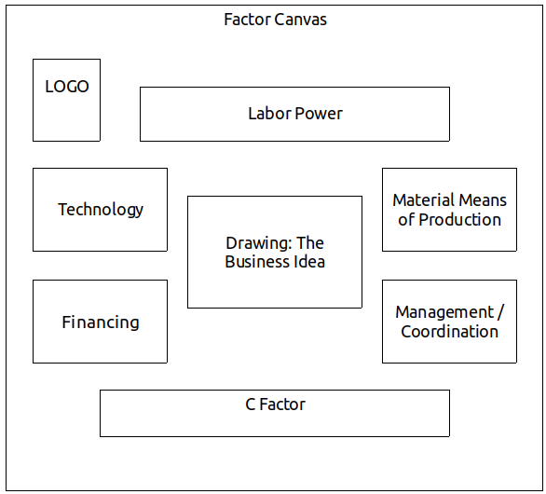
Contents of Activity 1 – Imagining the enterprise on day one.
The group already has an idea of the enterprise it wants to create and the task now is to begin to pin down the structure of factors with which it can operate. This is a complex technical task that needs to be realized over the course of several iterations. We will begin with a creative exercise in which the group creates for itself an image or prefiguration of the enterprise that is as detailed as possible, with all the necessary factors identified.
With the group seated in a semi-circle facing the board, the moderator invites all the participants to close their eyes and be silent, imagining the enterprise as it would be on the first day of its operation, if it were ideally organized.
After a few minutes, there is a round of comments in which each participant describes the group as they imagine it.
Open conversation follows in which people discuss the prefigurations offered by their fellow members. The idea is to assemble a full image of the enterprise they wish to create, as it would appear on its first day. To this end, the participants should methodically consider the six factors, with an emphasis on their efficiency and productivity.
Having identified the necessary elements for the operation of the enterprise on its first day, participants record them on index cards (one color per factor).
Contents of Activity 2
Taking turns, the group members share the results of their individual work: the information they gathered that can help the group design the factor theorem for the enterprise.
Based on all of the information gathered, the group identifies all the factors that could be useful for the creation of their proposed enterprise. Each element corresponding to one of the six factors, it is written on an index card of the appropriate color and attached to the canvas, alongside those from the previous activity. In this phase all the elements that could have some utility should be noted, even if they seem minor or dispensable.
Contents of Activity 3
The third phase of the jornada consists of selecting those factors that the group considers to be indispensable for the proper functioning of the enterprise, and those which are most important due to their greater productivity.
Analyzing each factor, the group removes from the canvas those cards that mention elements that are dispensable, either because they contribute little to the accomplishment of the objectives of the enterprise, or because they have a very high cost relative to the productivity that could be expected from them. Naturally, it is permissible to combine or replace cards if the analysis suggests such changes.
Finally, the cards are re-ordered according to the importance and indispensability of the factors they mention.
Contents of Activity 4
The fourth phase consists of analyzing the proportions in which the factors should be combined in order for the enterprise to be most productive. Considering that some factors will be harder to obtain and integrate into the enterprise than others, it must be asked if the specific contributions they make might be substituted by other, more readily available, factors. Keeping in mind that the factors have to be combined in defined proportions, and that they must correspond to each other qualitatively, the group specifies the necessary quantities of each factor and the qualitative features they should have. This data is noted on corresponding index cards.
The jornada is finished when the group believes it has successfully defined and properly solved the factor theorem for the enterprise.

UNIT 3 GLOSSARY
Efficient Combination of Factors
A combination of factors is considered efficient when its joint operation manifests high productivity, generating profits and revenues greater than the costs incurred to obtain them.
Executive Management
We understand the role of executive management in an enterprise to be the system and procedures for making short term decisions. Placing those decisions in the context of more general plans and strategies which orient them, executive management responds and adapts to conditions and circumstances that are changing daily.
Technical Division of Labor
The technical division of labor is the differentiation and complementarity of the various activities and tasks executed by a collective labor force, organized according to technical criteria with the goal of maximizing productivity.
Technological Innovation
Any change in production process that results in the incorporation of new practical approaches, information, or technical systems.
Cost Structure
The composition of the payments an enterprise must make to the people or enterprises that supply the various factors employed in its economic operations. Cost structure also takes into account the time periods within which payments must be made.
Technological Obsolescence
Technological obsolescence is the loss of productivity of a technological element or understanding resulting from the development of new understandings or technological elements that are more productive or efficient. Any technological understanding or element has a determinate “shelf life,” inevitably becoming obsolete; thus the importance of constant technological innovation and updating of understandings.
Functional Organization Chart (Organigram)
The functional organization chart is a design that represents, on vertical and horizontal axes, the different levels of hierarchy and the subdivision of functions and units of labor and their organization within an enterprise or economic unit.
Strategic Plan
The strategic plan is a systematic combination of decisions with long term consequences (usually covering several years) that addresses the most important or structural aspects of an enterprise or organization. The decisions are organized in a plan and adopted simultaneously in view of increased development and greater fulfillment of the enterprise’s general objectives. Typically, in a strategic plan the objectives and the goals to be met in a given period are set, as well as the main means to be used to achieve them, the investments to be made, the internal organizational forms that will be adopted, and the strategic lines that will be followed.
Potential Productivity
The potential productivity of a factor is the maximum contribution to production or creation of economic value that the factor can make in a specific period.

Real Productivity
Real productivity is the contribution that the factor actually makes to production.
Work Programs
Work programs are collections of medium-term decisions made simultaneously to be carried out in a specified period of time, referring to relevant aspects of the operation of an enterprise or organization, or its sections or departments. Work programs make the more generally defined long-term strategic plans specific and concrete.
Reciprocal Substitutability of Factors
The capacity of factors to replace each other in the specific contribution they make to production.
Interest Rate
The interest rate is the remuneration demanded by the possessor of a certain sum of money or financing in return for putting it at the disposal of another economic subject, in the form or a loan, for a specific period of time. The interest rate is typically set as a percentage of the sum of money lent. When a loan is made, the parties agree to an interest rate as well as a time period within which the amount of money borrowed must be paid back to the lender (also known as amortization).
Economic Transfer
Any flow of economic assets between subjects implying a transfer of ownership.

EVALUATION OF UNIT III
This evaluation is to be done both individually and as a group.
Individual Evaluation
Each participant should answer the following questions in their notebook:
A. Circle the answer that best matches your experience.
- My understanding of the contents covered in Unit III is:
Weak – Good – Excellent
- My performance of the individual assignments in this Unit was:
Weak – Satisfactory – Very good
- I consider my contributions to the group exercises to be:
Poor – Adequate – Outstanding
- My participation in the organization and execution of the practical activity (jornada) was:
Passive – Relatively active – Very active
- I think my overall contribution to the group was:
Very little – Could have been better – Ample
B. Reflect on the following questions and summarize your answers in writing.
- Did I create a Curriculum Vitae that was properly structured, true, and complete? Did it help me discover and value the human factors I possess?
- Do I feel that the factors I possess can be useful to the solidarity enterprise we are hoping to create?
- Do I believe that the factor theorem that we designed in the group is the most appropriate? Do I have suggestions for changes?
- Am I ready to give my all to achieve these objectives? In what areas or ways can I do more?
Group Evaluation (to be done in the next session)
Seated in a circle, the whole group discusses the following questions.
- Did we come up with a good design for the factor theorem for the enterprise that we plan to create?
- Can we reach our objectives by creating an enterprise that has this factor structure?
- What comparative advantages will our enterprise have as a result of being organized with this factor structure?

Unit IV
WHERE TO GET THE NECESSARY FACTORS
Member contributions and development by the group
Session 7
Plan
- Gather, welcome, ice-breaker, form a circle, choose a moderator for the meeting.
- Evaluation of Unit III.
  - Each participant reads aloud their answers to the individual evaluation form from Unit III.
  - Carry out the group evaluation as described in the group evaluation form from Unit III.
- Break, snack.
- “Reading Four.” (One or two people read out loud as others follow along in the text.)
- Questions for review and discussion. (Participants volunteer to answer one question each, raising their hands to speak. Other participants can add to their answers but it is best if nobody speaks twice before others have had a chance to speak.)
- Questions for the facilitator, exchange of ideas and free conversation on the theme.
- Suggestions for the Individual Task. (The facilitator will explain the content and purpose of the individual task, clarifying any issues and answering questions that come up.)
READING FOUR
Having created a solidarity group and identified a business idea, the members turn to the most important step in creating a solidarity enterprise: designing the basic equation of the enterprise – the “theorem” – on which achieving the efficiency needed for success depends.
Naturally, to define the theorem of an enterprise it is essential to know the quantity and quality of the factors that a group can realistically hope to possess. We must, then, look at how solidarity enterprises obtain the factors they need. The distinction we made between internal and external factors leads us to two basic paths forward; the required factors can be acquired:
- By means of contributions from members of the enterprise themselves.
- By means of outside contributions, that is, from other people or organizations that decide to “place” factors in this enterprise.
But this distinction should be made more specific, in two senses.
On the one hand, it is possible for members, too, to provide factors to the enterprise “from outside” as it were, not as contributions to equity but as investments made in expectation of a return. If a member contributes a sum of money to the enterprise as a capital contribution it constitutes an “internal” factor, but if the money is provided as a loan that the enterprise must repay with interest in a specified time it is an “external” factor. In the same way, a physical space that a member provides, transferring ownership to the enterprise, becomes an internal factor. But if the member leases the space to the enterprise, it remains an external factor. Labor power itself can be integrated into the enterprise as a contribution or contracted externally in return for a wage or salary.
On the other hand, contributions made by third parties can be integrated into the equity of the enterprise, if they are made in the form of donations. But, if they are provided to the enterprise for a limited time, in return for periodic remuneration, they are considered external factors. If those external factors are amortized by the enterprise, they will gradually cease to be external and will in this way come to be internal. For example, financing obtained via a loan, or materials obtained through a lease cease to be external if the debt is canceled or the leasing contract is fully paid off by the enterprise.
The exact understanding of which factors are internal and which are external, of the distinct forms in which factors provided to the enterprise by members of the solidarity group and/or third parties are integrated, and the implications that these different possibilities have for the functioning of the enterprise is of vital importance for the creation and success of a solidarity enterprise. We must then take the necessary time to examine this question deeply, considering all the alternatives.
The associative enterprise based exclusively on external factors.
Theoretically, an associative and solidarity enterprise can be created exclusively with external factors. In fact such solidarity enterprises exist, and there are even authors who have recommended this model as the most suitable, under certain conditions. So, we should consider this possibility carefully.
Naturally, in order to create a solidarity enterprise of this type it is necessary that someone be willing to make the required investment. It could be the State, or a private entity or non-profit foundation that provides the resources. Certainly, creating a solidarity enterprise this way can enable the solidarity group to get access to resources; nonetheless there are certain problems to be considered.
If it is a matter of a loan on which interest will have to be paid the problem lies in the large portion of revenue that will have to be set aside for that purpose. Unless the enterprise can count on its own, internally sourced, factors, it will have to pay for all its factors directly or indirectly (servicing the loan) at normal market prices (or standard interest rates). As a result the enterprise is obliged to operate with a strict logic of maximization of monetary profits, risking the loss of its rationality of solidarity. And if, in order to obtain credit, the enterprise has had to provide guarantees that compromise the equity or the incomes of the members, the risk involved is terribly high. If the enterprise functions successfully, it means that the solidarity group is working with high efficiency… for the benefit of the person or entity that provided the financing. For this reason, this alternative, having been considered, should be discarded.
If the contribution of factors is made as a kind of grant, subject to the achievement of determined objectives established by the party making the contribution, with the enterprise retaining ownership of the resources donated (for which it does not pay), the obvious problem is that the solidarity group might fall into a relation of dependence with respect to the patron or funder of the enterprise, which will certainly exercise close control and oversight. Moreover, as the enterprise is not really owned by the solidarity group and its members it is unlikely that the members will be willing to invest money from their earnings in order to expand the factors available to an enterprise that does not really belong to them. The Yugoslav model of self-management faced this problem; it was the State that made the initial investment and provided the necessary factors for production and growth. The workers self-managed with some solidarity, but with very relative autonomy, and, lacking the right incentives to develop the enterprise, low levels of efficiency. This alternative, too, should be discarded.
There do exist experiences in which a solidarity enterprise is created with funds contributed by a “not-for-profit” entity which transfers ownership of the enterprise to the members when they have demonstrated the capacity to manage and develop it successfully. In this case, the solidarity group has a large incentive to contribute as much as possible to the enterprise and to manage it with high efficiency. Nonetheless, in fact, donations made to promote the creation of solidarity enterprises are often used in a different way: the contributions are oriented towards already existing solidarity enterprises or those in formation, in which the members have already made all the contributions they can. The donation is made to supplement the provision of the necessary factors.
Whether or not the enterprise has access to donations or credit, we can draw this conclusion:
It is essential that the largest and best contributions of factors to the solidarity enterprise be made by members investing their own resources.
The advantages to the enterprise are clear: direct costs are reduced, as are the risks, autonomy in management and operations is increased, and the possibility of operating with a coherent solidarity rationality is better assured.
So, in the case of solidarity enterprises, we can say that in order to assure the success of the initiative, members must generously contribute all the factors they possess that can enhance the productivity of the enterprise.
Each person possess multiple and various factors, of the six types: labor power; tools, equipment and other useful materials; knowledge, know-how, skills and creativity (the technology factor); their capacity for organization and leadership (management); payment of dues, savings, ability to get loans, to loan money themselves or to forgo collection of remuneration (finance); and their spirit of solidarity, their capacity to generate trust, fellowship and group integration (C Factor). All of these can be brought to the enterprise from within, as it were, providing it with as many of the necessary factors as possible.
Determining which factors members can provide is the first task to be done, before thinking about obtaining loans or donations. The possibility of the latter is strongly conditioned by, and often proportional to the former. When someone makes a donation or decides to make a loan to a solidarity group, it is because that group inspires sufficient confidence and seems likely to generate good results. It makes sense: why should an external person or entity put their trust in an initiative whose members themselves have not demonstrated their own commitment by making contributions, in which they do not have “skin in the game,” in which members have not made the contributions they alone can make?
Having clarified all this, we should still be aware that the decision of each member to contribute factors to the enterprise should be an economically rational decision. This basically means that the member can reasonably expect the contributions they make to the enterprise to benefit them, that is that the expected benefit exceeds the sacrifice implied by giving up that which they contribute to the shared enterprise. We should never forget that in the solidarity economy enterprises exist and work for people, and not the reverse as in the capitalist economy.
It is necessary, then, to evaluate as exactly as possible the sacrifices implied in the contribution of factors each member makes, as well as the benefits they might obtain. To this end we need to know and be comfortable with some key concepts.
Opportunity Costs and Lost Earnings
One often hears economists speak of opportunity cost, the sacrifice of income that can occur when a person or institution contributes to an enterprise some factor in their possession which is then no longer available to be used by the individual. For the person making the contribution, the opportunity cost can be measured by the income they would have obtained if, instead of contributing the factor they possess to the solidarity enterprise, they had offered it on the market and it had been employed in some other enterprise in exchange for money. The opportunity cost is the sacrifice of those earnings, which can’t be obtained because you contributed the resources to the enterprise. So, for example, the remuneration that you forgo, having decided to leave your job to work in the solidarity enterprise, is an opportunity cost. Likewise, the interest on money invested for a fixed term which is lost when those funds are used to finance the solidarity enterprise, or the rent on a property that one ceases to receive having turned it over to the solidarity enterprise.
But it should be noted that the opportunity costs can differ from the income that the factor could generate in the market, since there are usually costs associated with use of the factor and the acquisition of that income, which should be discounted when quantifying the opportunity cost. For example, from the remuneration of labor one should discount the cost of transportation, if this is no longer needed when working at the solidarity enterprise. The same applies to taxes paid on rental income and so on. On the other hand, there are also benefits that are lost when removing a factor from its current use. Those too should be quantified and in that case added to the income as their loss also implies an opportunity cost.
It is very important to make the most exact evaluation possible of the opportunity costs incurred when moving factors from their current use to use in the solidarity enterprise since the enterprise should provide net benefits to those who make contributions. For the individual member it only makes sense to contribute factors that they possess to the enterprise when the opportunity costs are lower than the productivity to be gained by the enterprise, from which the member can benefit in proportion to their contributions. It is the job of the enterprise to reach sufficient efficiency in the use of the factors contributed by members that its productivity exceeds the opportunity costs implied in moving the factors from their previous use.
It is important, now, to distinguish the actual and effective income which the contributor ceases to receive when a factor that is removed from its previous use or investment and placed in the enterprise, from lost earnings. Lost earnings consist of income that might possibly be obtained if a factor currently unused, and thus not generating income, were to be employed. From this point of view, the productive occupation of factors that the members are not using should be beneficial for them.
That said, it is important to add that the decision to contribute a factor to the solidarity enterprise should not be based purely on a monetary calculation of opportunity cost and lost earnings. The solidarity enterprise offers other benefits to its members that are not to be evaluated in monetary terms. In Unit 2, we spoke of the fulfillment of objectives that transcend the strictly economic, such as the community meeting the shared needs, aspirations, and desires of its members; these considerations should also be taken into account when making this decision.
Nor should the economic calculation of costs and benefits stand in the way of personal generosity, or group solidarity. Knowing they are part of a common project in which benefits will be shared, members may make generous contributions to the enterprise, even if they involve short-term sacrifices of income or profit. They do this because they know that in the long run the gains they share in the spirit of solidarity, not all of which can be measured in money, can be enormous.
Still, and even if people are ready to make contributions for which the opportunity cost is higher than the expected personal benefit, it is important that the opportunity costs be rigorously calculated. On the one hand, because it is always helpful to know – and for everyone to know – what each member’s participation implies. On the other hand, it is important for the enterprise to have all the information necessary to allow members to evaluate its true economic efficiency. As we will see in Unit 6 where we examine the economic organization of the enterprise (its ownership structure and the distribution of surplus), it is essential to have an exact valuation of the contributions made by each member.
Five ways factors can be contributed to the enterprise.
There are different ways in which members can make factor contributions to the enterprise, with significant impacts on ownership structure, cost composition, operational efficiency, use and distribution of surplus, strength of group cohesion, and more. Just as participation in the enterprise is a free and voluntary decision that each member makes, so the contributions they make and the way they make them depend on the sovereign decision of each member. To make appropriate decisions, it is important to know the difference and distinguish between the five principal ways in which members can contribute factors to the enterprise:
- Donations
Members of a solidarity group can give or donate to a solidarity enterprise from factors in their personal possession. They donate their labor power when they do voluntary or unpaid work; materials when they contribute tools, furniture, the use of a locale, etc. without compensation; technology when they contribute and share their knowledge and teach others in the group; management when they bring their organizing, administrative, and leadership capacity, without expectation of recompense; financing when they offer no-interest loans or access to credit; and the C Factor when they contribute everything that favors group integration, conflict resolution, relations with the community and other organizations, etc.
- Contributions to Equity
Members of a solidarity group can contribute factors by transferring their property, so that it becomes part of the equity of the enterprise; but these contributions are not made as gifts or donations. They have a specific monetary value that is recorded in a member contribution account. In this way, the contributing members come to be owners of the enterprise in proportion to the sum of the values of the contributions each of them makes. Based on, and in proportion to, these contributions the members acquire certain rights with respect to the enterprise, basically the right to participate in the distribution of profits in proportion to the contributions made and to recover the value of their contributions if in the future they decide to withdraw from the enterprise. Money dues and capital contributions, materials transferred to the enterprise, rights to patents and inventions, are all of this type. Their value is calculated at market prices.
- Non-Equity Contributions of Use and Usufruct
Members of the solidarity group can also contribute factors without transferring ownership to the enterprise, offering only their productive use. The contributed factor remains the property of the member but is used by the enterprise, which benefits from its usufruct. These contributions can be made in two ways:
  - as donations members make to the enterprise which can use and benefit from them for a specified or unspecified period of time (normally in this type of contribution the contributing member is guaranteed the maintenance, repair, or compensation for damage, loss, or other costs implied by use of the factor);
  - as non-equity contributions reported in the member’s account, entitling the member to a proportion of equity and profits. In this case, what is valued and recorded as a contribution is not the factor itself but the time during which it is used by the enterprise. For example, if a locale, a machine, or a fixed amount of labor is contributed, it is valued as a contribution equivalent to the rent or salary that would be paid, and this amount is entered into the books as a member contribution, with corresponding rights to a proportion of equity and profits.
- Compensated Contributions
Members of the solidarity group can make factor contributions without those contributions being recorded in their capital accounts and without being paid as external factors, but in return for some compensation from the enterprise, the solidarity group, or other members. Such contributions are made according to an agreement between both parties and can take various forms and characteristics. For example, a contribution of factors can be compensated through certain services, such as child care, training, certain honorific titles, the right to use certain of the enterprise’s resources, etc. A very interesting way to stimulate compensated contributions, especially effective in the case of large groups, is through the circulation of solidarity units of account, or the emission of alternative currencies internal to the enterprise.
- Contribution of Paid External Factors
Members of the solidarity group can contribute factors to the enterprise for a given period of time on the basis of contractual terms or at market rates, those contributions being remunerated at pre-established prices. Using this form, members can provide the enterprise with credit, rentals, sales, leasing, etc. For the enterprise that needs to seek external factors, it may be more convenient to rely on external factors provided by members than by third parties, assuming that, naturally, they are provided at the lowest cost for which they might be obtained on the market.
As we have seen, members of the solidarity group have various options when it comes to contributing factors to the enterprise. But some factors that are better offered in one form than another. The C Factor, to be sure, should always be contributed as a gift or donation.
Technology and management factors are also especially suited to donation, with members sharing know-how and organizing capacities with all the members. Nonetheless, management and technological development can require special dedication of some people who contribute their skills professionally, making that their primary function in the enterprise. In such cases, it is appropriate that their contributions be made in the same form as other contributions of labor power, which we shall examine momentarily.
As for the finance factor, the most appropriate form seems to be an equity contribution. This is also true for contributions of material means of production, although in this case the non-equity contribution of use and usufruct may also be appropriate.
Contributions of the factor labor power in solidarity and associative enterprises deserve special analysis.

Treatment of labor power.
Labor power is inseparable from the people who do the work. As a factor that is always personal in this way, it can not, strictly speaking, be considered a factor belonging to the enterprise. Nonetheless, in the case of solidarity enterprises in which the members are the workers, the organizing subject of the enterprise – the solidarity group – constitutes the principal source of labor power on which the enterprise relies. As the enterprise belongs to the solidarity group, the group identifies itself with the enterprise in which it works, and in this sense the labor power becomes a factor belonging to the enterprise. Said another way, workers invest their labor power in their enterprise which then becomes one of their principal assets.
But there are various ways for workers in a solidarity group to incorporate their labor power into the enterprise, each resulting in a different way of treating the factor, economically speaking.
The choice is basically the following. If the workers set for themselves a fixed compensation, monthly or with another periodicity, that the enterprise is obligated to provide them, the effect is the same as if their labor power were an external factor. For the enterprise, labor compensation constitutes a fixed cost. This is not the best way to proceed because the enterprise can find itself obligated to make payments that exceed its capacity and may perhaps even fail.
The other way to compensate labor, which treats labor power as an internal factor, is through distribution of surplus generated by the enterprise in its operations. In that case, the compensation is not a fixed quantity but a percentage of the surplus. If the enterprise has good results, the compensation is greater, and if the results are poor, the workers have to settle for what their enterprise is able to generate.
This seems to be the most coherent way to make and compensate for labor contributions. But there is a problem: workers need regular income in periods that are much shorter than the usual period used to calculate income and loss, typically the fiscal year. This can be resolved through monthly payments to workers that are considered to be anticipated earnings, distributions made in anticipation of the annual results that can be fixed or variable according to the perception of the condition of the enterprise. These anticipated earnings can also be partially fixed, with a guaranteed indispensable minimum, and a portion that increases incrementally in relation to the performance of the enterprise, in anticipation of a larger amount of surplus, for example.
Creation and development of factors by the solidarity group.
Once all of the factors that can be provided by individual members of the solidarity group have been identified and the contributions have been made, the enterprise may still lack some factors. How to obtain them? In Unit V we will examine how the solidarity group can obtain and integrate external factors contributed by third parties. But before that we must see how, in addition to individual contributions, the solidarity group as such can also provide its own factors, creating and developing factors through an active process.
In effect, there are elements and factors that the solidarity group can create or obtain through its own effort. For the success of the enterprise the group should explore this possibility in depth and make every effort in this direction, because the more factors available to the group when it begins to function, the lower will be its costs and the greater the surplus and profits produced. Which factors can the group create and develop for itself, and how?
Any of the six factors can be developed in this way. The labor power of the group’s members can be improved and upgraded, increasing its productivity, through training and a kind of apprenticeship in which members teach each other. The technology factor can be developed with study, application of group creativity and innovation, and reciprocal exchange of know-how. Some furniture, tools, instruments and other material means of production can be fabricated by group members and work teams. Management and administrative capacity can be developed through better group organization, improving internal communication, joint execution of administrative tasks, leadership and management training, etc. Some amount of financing can be secured by carrying out fund-raising activities like raffles, campaigns, community events, etc. And of course, the group can always expand its C Factor, growing in solidarity and cooperation and deploying active processes to broaden its social relations with the community and surrounding social environment.
Since we are thinking about creating a solidarity enterprise, it is decisive that the group make an effort to create and develop to the maximum its own collective resources and capacities, before resorting to external sources. This is as important as the personal contributions made by each member, or more so, since it favors the integration of the group, reducing costs and deepening the commitment each and all make to the common work.
INDIVIDUAL TASK #4
To be done after the seventh session.
- Study the Glossary at the end of Unit IV.
- Answer the “Questions for Review and Discussion #4” in writing in your notebook.
- Write your “personal balance sheet.”
Questions for Review and Discussion #4
The following questions should be answered individually, in writing. Each participant will later share their answers during the group work, allowing for evaluation and correction of the answers by comparing them with the answers of other members and ensuing discussion.
- What are the principal ways a solidarity enterprise can obtain the necessary factors of production?
- Is it possible to create a solidarity enterprise solely with external factors?
- Why is that not a good idea?
- Why is it better for the members of the enterprise themselves to contribute most of the factors?
- What is meant by “opportunity cost”?
- In the reading, what is meant by “lost earnings”?
- What are the five main ways members can contribute factors to the solidarity enterprise?
- What is a member contributions account? What is it important to calculate and record this information?
- What are the ways in which members of a solidarity enterprise can contribute their labor power?
- What is the most appropriate way to treat contributions of labor power in a solidarity enterprise?
- Why is it important that the solidarity group itself do as much as possible to create and develop needed factors through group activities and shared effort?

How to make a “personal balance sheet.”
The purpose of this task is to determine exactly which factors each person possesses, their possible utility and productivity in the solidarity enterprise, and the member’s willingness to contribute the factors they possess, taking into account potential opportunity costs and lost earnings.
We call the analysis produced in this task a “personal balance sheet” because it resembles the information banks often demand of potential borrowers in order to evaluate their credit worthiness. In our case, the “personal balance sheet” deals with more than the usual aspects and is produced using a form that is structured differently. Each person should complete the following form:
Personal Balance Sheet
A. Personal information:
  - Full name:
  - I.D. type and number:
  - Mailing Address:
  - Work Address:
  - Email Address:
  - Telephone:
  - Birthdate:
  - Nationality:
  - Highest level of education completed:
  - Marriage status:
  - Number of dependents:
  - Full name of spouse or partner:
B. Labor Power
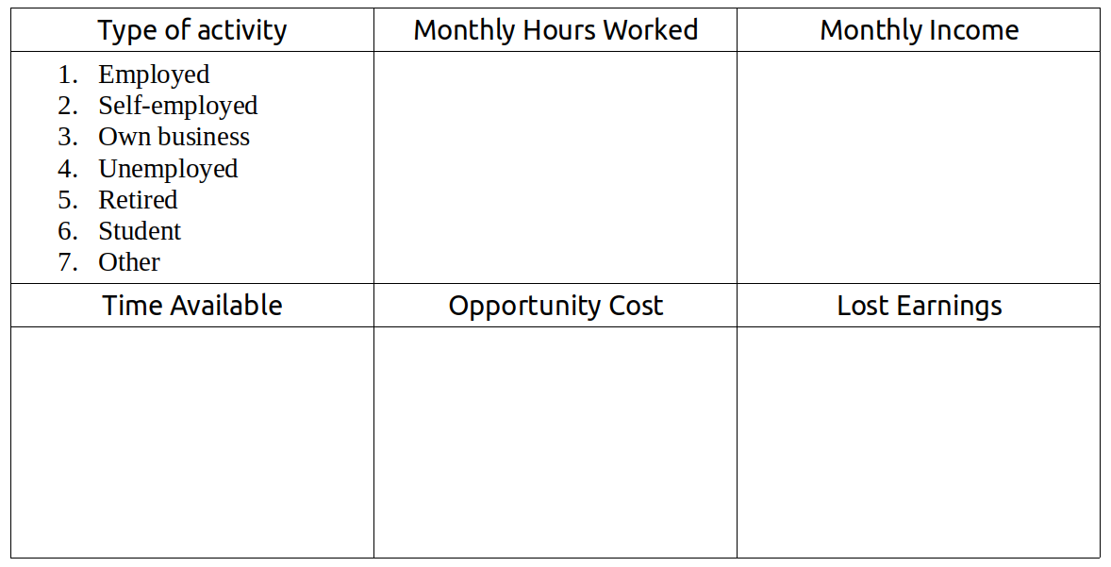

C. Material Means of Production
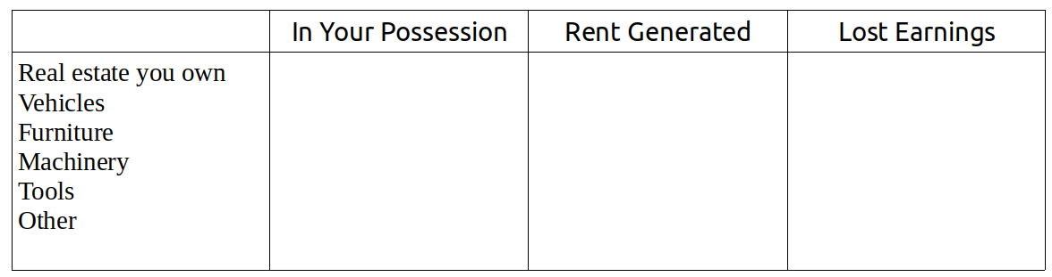
D. Finance
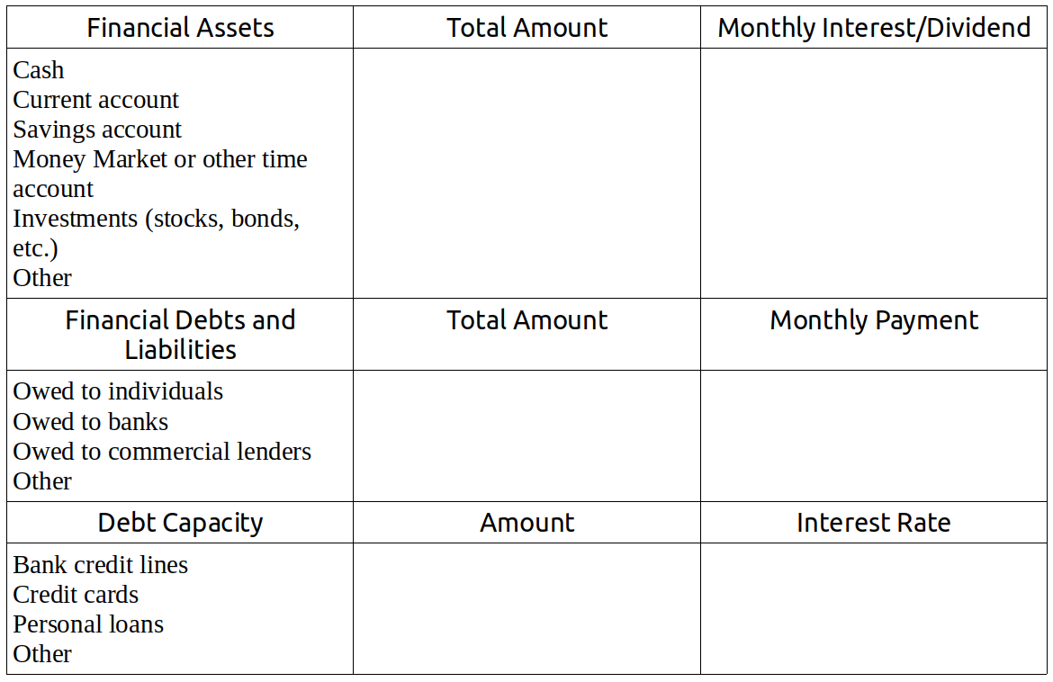
E. Technology
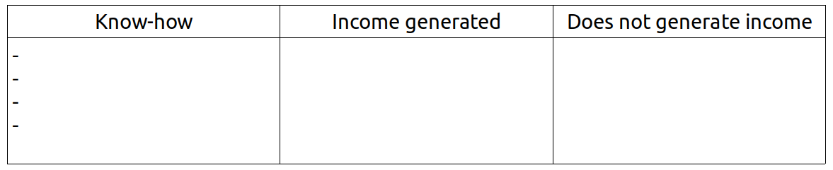

F. Management
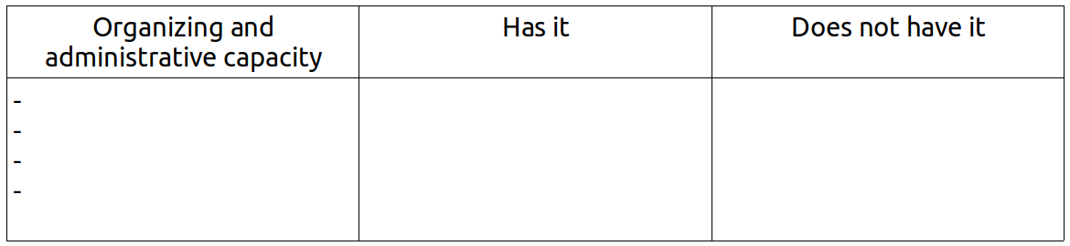
G. The C Factor
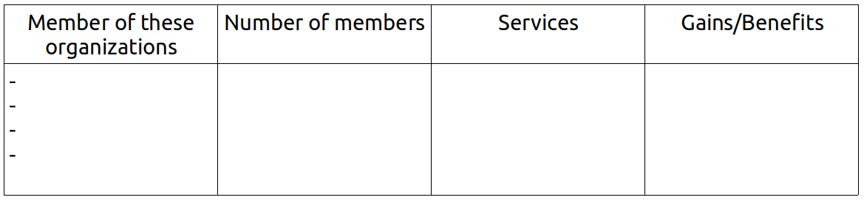

Session 8
Plan
- Gather, welcome, thematic game, form a circle, choose a moderator for the meeting.
- Reading and commentary on the answers to Questions for Review and Discussion #3. (If the group is large, each participant will read only one or two responses.)
- Exercise #7. Sharing Personal Balance Sheets.
- Break, snack.
- Exercise #8. Planning the Development of Internal Factors.
- Assignment of Individual Task
- Reading and Organization of Jornada #4: “Deciding to Contribute.”

Exercise #7
Sharing Personal Balance Sheets
Explanation
In the creation of a solidarity enterprise it is important that all members understand as clearly as possible the economic situation of their fellow members. This mutual knowledge has various meanings. On the one hand, it favors the concrete development of the C Factor, facilitating communication, increasing mutual trust and enabling transparent human and economic relations. On the other hand, knowledge of each person’s situation leads to awareness of the needs that the solidarity enterprise should help meet. And finally, it helps the group identify the contributions that each member can make to the enterprise and what the solidarity group can expect of each person. This exercise is designed to help build this awareness.
The Flow
- Taking turns, group members read aloud their respective personal balance sheets and explain with some detail (as much as is needed to understand the point) each of the different elements.
- After each presentation, the other group members can ask questions about points that were not sufficiently clear. It is important not to interrogate people about their personal situations in a way that violates their privacy or intimacy. The level of detail of the answers should be determined by the member who is presenting, without any group pressure.
- Once all the personal presentations have been made, the moderator can open a discussion with the purpose of analyzing the economic situation of the group as a whole, the skills, potential, limits, etc. of the solidarity group.
Exercise #8
Planning the Development of Internal Factors
Explanation
The solidarity group already knows which factors it needs to create the enterprise. They also know that the more factors contributed by the group itself, the greater the chances of success. Creating a solidarity enterprise implies planning the development of all the factors that the group itself can create or enhance through its own efforts, work, and study. In this exercise members identify as specifically as possible the factors that the group can develop internally, prior to launching the enterprise, and create a concrete plan of activities to do so.
The Flow
- Post the “Factor Theorem” canvas created in the previous jornada (with the index cards indicating all the indispensable elements for creating the enterprise) somewhere where it is visible to all.
- Discussion proceeds factor by factor, in the following order: labor power, materials, technology, management, financing, and the C Factor. The group reflects on each factor and discusses the possible ways to develop it and the means needed to do so.
- After general discussion of how the group can develop a factor, the next steps are to see if it is possible, and how to contribute to the creation or development of each elements identified on the corresponding cards.
- On a flipchart or board, the group plans the development of factors, identifying for each element of a factor (noted on cards): the goal to be met, the means to used in meeting it, the relevant activities, the deadlines for completion, and the people to whom it is assigned. In this way, for each factor a planning table is drawn up:
- After completing the analysis of the six factors and all the cards, the planning tables are revised and a “development plan” summarizing the combined factors is made, in which the goals are integrate, realistic means, activities, and dates are determined, and personal responsibilities are fairly distributed.
- Each participant records in their notebook the “Development Plan for Internal Factors” highlighting their personal responsibilities. The fulfillment of this plan will be evaluated in the next session of the manual at which point necessary adjustments can be made.

Jornada #4
“Deciding to Contribute”
What is this practical activity about?
Having studied Reading 4, everyone now knows the importance of individual member contributions of factors to the solidarity enterprise as well as the way in which these contributions can be received by the enterprise.
The objective of this jornada is to identify in concrete terms which of the factors considered necessary for the enterprise will be contributed by members of the solidarity group.
In order for a necessary factor or element to be contributed by a member two decisions must be made: first, the person who possesses the factor decides whether to contribute it, under what conditions and in which of the forms we have considered; second, the solidarity group decides whether to accept the contribution in the form and under the conditions proposed.
In this jornada both decisions must be considered and when they match or agreement is reached, it is understood that the member will actually contribute the factor to the enterprise.
Which aspects should be taken into account, by the group and by each member, when deciding whether to offer/accept contributions of personal factors?
In the creation of the Curriculum Vitae and the Personal Balance Sheet, and in exercises 5, 6, and 7, the members of the solidarity group carried out a thorough assessment of the factors they possess. They also identified the combination of factors needed by the enterprise they hope to create, in the jornada “The Theorem,” including an estimate of the quantity and quality each factor needed, as well as the desired level of productivity.
All of this is fundamental information when it comes to making decisions with respect to the factor contributions to be made by members of the solidarity group. Not all the factors in members’ possession are necessary or useful for the enterprise and members may not be willing to contribute all the needed factors that they possess.
It is possible that members will want to contribute factors or elements that the solidarity group does not need, or that the group is not ready to accept them on the terms on which the member offers them. It can happen, for example, that a member owns a factor that they wish to contribute as equity, but values it at a level that that the group feels is excessive or is not viable for the enterprise. Inversely, it can happen that the enterprise needs a factor that a member has but is not willing to contribute, due to the excessive opportunity cost it implies.
The process of identifying possible member contributions to the enterprise is delicate, because the desires and interests of each person need to be taken into account along with the needs and interests of the group and the solidarity enterprise. This process, then, has to be carried out with great transparency and the best C Factor, comradeship, and mutual trust that the group can muster. Nonetheless the theorem of defined proportions, which guarantees efficiency, must not be ignored. (Here we should caution that like other factors it is possible for an enterprise to have an excess of the C Factor, which unbalances the other factors. Such would be the case, for example, if the group, motivated by the desire to help a member, accepted their contribution of certain factors in a greater quantity than needed or accepted factors of insufficient quality.)
It may also happen that various members have and wish to contribute the same factor and that the resulting quantity is too much for the enterprise to handle. For example, the enterprise could need fewer hours of work that those that members are offering, or various members might offer as equity contributions multiple tools of a certain type when the enterprise needs only one. In these cases the question is which factors to accept and which to decline, based on what seems best for the enterprise, but keeping in mind that it is important to maintain a good balance among the contributions made by each member.
What are the activities to be done in this jornada?
Deciding to Contribute is a three part process:
a) Preparation and planning (this is to be done in the seventh session).
b) Doing the assigned individual task.
c) A day (jornada) of group work.
What is the individual assignment?
Each member of the group should come to the jornada with a clear understanding of the factors they possess, those they are willing to contribute to the group, and under what forms and conditions they are prepared to make the contribution(s). The individual task consists of writing a detailed proposal of the factor contributions they would like to make to the enterprise. During the jornada each person will present this information to the group so that the group can make collective decisions about whether to accept the contributions that each member proposes.
To write the proposal for individual contributions, each person should review their C.V. and their Personal Balance Sheet and complete the following form.
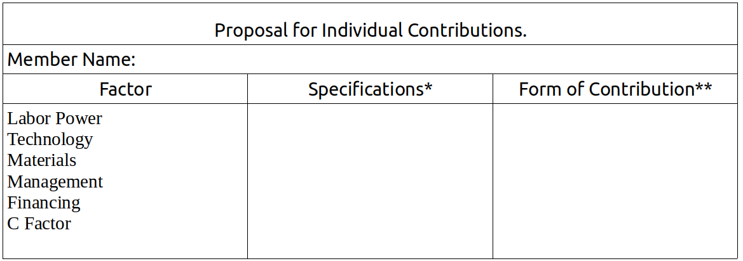
* The specifications are quantitative and qualitative. Specify age, brand, features, length of time it is available, and in general all the data that will help the group understand the value and productivity of the factor.
** The form of contribution should specify the conditions under which the factor is being offered to the enterprise. The alternatives are: a) donation; b) equity contribution; c) compensated contribution; d) non-equity contribution with right to use and usufruct; e) contribution for fixed compensation. (Indicate the conditions using the corresponding letter and provide details about the conditions, estimated value, etc.)
What should members bring to the jornada?
- Each person will bring their Curriculum Vitae, their Personal Balance Sheet, and their Proposal for Individual Contributions.
- The group symbol and logo design.
- All the materials from Exercises 5, 6, 7 and 8 in addition to the materials from Jornada #3, The Theorem.
- A flipchart.
- A large blackboard or other board for the canvas.
- Plenty of index cards (10cm x 20cm) in six colors.
- Updated account information (personal and group).
How should the jornada be done, what is the plan for group work?
This jornada is essentially a work session that can be done in about four hours, though the group may decide to add other activities that they think would be good to include.
The jornada follows this plan:
- Gathering, welcome, thematic game. Installation of the group symbol in an appropriate place. Selection of a moderator for the meeting, as well as a “canvas manager” (person who manages the bulletin board or display used in the activities), and a note-taker.
- Set up the materials from Exercises 5, 6, 7, and 8, in addition to the materials from Jornada #3, The Theorem.
- Prepare the canvas, using this layout:
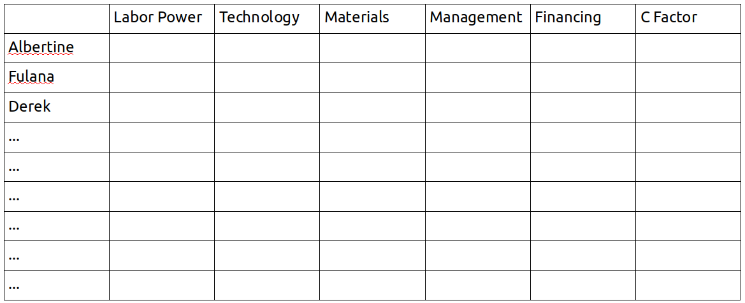
- Activity 1. Offering contributions.
- Break and Snacks
- Activity 2. Accepting contributions.
- Activity 3. Making Decisions.

Contents of Activity 1
All members take a short time to write down each factor they wish to contribute on an index card of the color corresponding to one of the six factors, as well as a second card of the same color describing the form and conditions of the contribution.
Taking turns, each participant presents their Proposal for Individual Contributions to the group and affixes their cards to the canvas.
Contents of Activity 2
Once all the participants have presented their proposed contributions, the group examines the usefulness and suitability of each for the enterprise, given the conditions and forms offered in each case. This analysis will enable the group to decide which factors to accept with an idea of how to integrate them into the solidarity enterprise.
This is a very delicate activity which should be undertaken with focus and careful attention. The analysis of each offer, about which a decision will later be made, should be done with transparency and maximum clarity, keeping in mind the enterprise and the common good of the group as well as the needs and interests of each member. In this sense, the group should be extremely careful in its analysis, and each member should offer their opinion with total sincerity and responsibility, for the good of the group and success of the enterprise. It is possible that differences of opinion will emerge at this phase, due to different judgments of the needs of the enterprise and the quality and productivity of the factors offered. Treating each opinion seriously and with respect, the conversation should focus on being as objective as possible, being careful to maintain the C Factor that should exist in the solidarity group.
The “Theorem” canvas made in the previous jornada , which has a detailed categorization of the factors needed by the enterprise, is an important element that will help participants maintain the objectivity of their analysis. Referring to the “Theorem” canvas each person can see if their desired contribution or that of another fits with the group’s priorities. The canvas should be displayed somewhere where everyone can see it and use it to compare the factors offered to the factors already determined to be necessary.
In this analytical activity the group can propose changes to the conditions and modes in which members desire to make contributions, and each member will determine if the group’s proposals are acceptable or not. This can give rise to a kind of “bargaining” between the group and the individual members. Obviously, it is important to guarantee all members equality of opportunities and equity in treatment by the group.
Contents of Activity 3
Once the analysis of the offers has been made and the group has determined the utility and suitability of each, the time has come to decide whether to accept or reject them.
In this phase, and keeping in mind the analysis of the totality of factors offered by members and those needed by the enterprise, decisions will be made.
Each decision about the contribution of a factor and its integration in the enterprise requires the explicit enunciation of two converging decisions: that of the group, which decides whether to accept or reject a factor, and the individual, who decides whether or not to make the contribution. For each case (specific element), the group decision will be announced first, detailing the conditions, specifications and form of contribution that they feel are necessary, followed by the announcement of the individual’s decision to agree or disagree with the group’s decision.
All the decisions should be recorded carefully, in detail, on the canvas and by each member in their notebook.
The jornada is complete when each person and the group have defined exactly which factor contributions each member will make, and on what terms, when the time comes for the group to establish the enterprise.

UNIT 4 GLOSSARY
Alternative currencies
Money or credit issued by associated economic subjects that circulates within groups conducting exchanges and barter on the basis of mutual trust.
Capital contributions
Member contributions in the form of money, materials, or any other factor of monetary value, that form part of the equity of the enterprise.
Cost-benefit analysis
The quantitative and qualitative estimation or evaluation of the costs and benefits expected from an economic activity over a determined period of time.
Leasing
A lease is a contract for the right to use an economic asset in exchange for a periodic fixed payment, implying the final transfer of the property upon completion of the payments. If the payments are not completed, the asset remains the property of the person making the contribution.
Lost earnings
The income or economic benefit that an economic asset could generate but is not being obtained because the asset is not being used.
Net profits
The global sum of economic profits generated in a given period minus all the costs and payments that must be made to third parties.
Opportunity cost
A term normally used to designate the sacrifice of income and other benefits implied by the application of an economic asset to a new use.
Rational economic decision
A decision is considered economically rational when it is made with the criterion of maximizing and optimizing income or profits in relation to costs or sacrifices.
Self-management
The system of management in an economic unit in which the workers collectively assume responsibility for management and administration.
Solidarity accounts
Quantitative registers of economic values transferred by some subjects to others within solidarity groups or circuits.
Usufruct
The right that an economic subject has to use an economic asset for their benefit and appropriate to themselves the benefits generated through its utilization.

EVALUATION OF UNIT IV
This evaluation is to be done both individually and as a group.
Individual Evaluation
Each participant should answer the following questions in their notebook:

A. Circle the answer that best matches your experience.
- My understanding of the contents covered in Unit IV is:
Weak – Good – Excellent
- My performance of the individual assignments in this Unit was:
Weak – Satisfactory – Very good
- I consider my contributions to the group exercises to be:
Poor – Adequate – Outstanding
- My participation in the organization and execution of the practical activity (jornada) was:
Passive – Relatively active – Very active
- I think my overall contribution to the group was:
Very little – Could have been better – Ample

B. Reflect on the following questions and summarize your answers in writing.
- Did I create a Personal Balance Sheet that was properly structured, true, and complete? Did it help me discover and value the productive factors in my possession?
- Do I feel that the factors I possess can be useful to the solidarity enterprise we are hoping to create? Am I comfortable with the contributions I offered to the enterprise and those which the solidarity group accepted?
- Do the agreements on the development of factors that we came up with in the solidarity group make sense? Are there other elements that we could develop as a group?
Group Evaluation (to be done in the next session)
Seated in a circle, the whole group discusses the following questions.
- Did we know how to motivate members to contribute factors? Were we fair and efficient in our analysis of the offers made by the different members?
- Have we come up with a good plan for developing our own factors as a group? Are there other elements we can develop?
- Considering the member contributions and the development of factors by the group, do we have enough of our own factors? Can we say, realistically, that we will be able to acquire those factors that are still missing in order to create the enterprise?

Unit V
EXTERNAL FINANCING
Loans, Grants, Donations, and Solidarity Funding
Session 9
Plan
- Gather, welcome, ice-breaker, form a circle, choose a moderator for the meeting.
- Evaluation of Unit IV.
  - Each participant reads aloud their answers to the individual evaluation form from Unit IV.
  - Carry out the group evaluation as described in the group evaluation form from Unit IV.
- Break, snack.
- “Reading Five.” (One or two people read out loud as others follow along in the text.)
- Questions for review and discussion. (Participants volunteer to answer one question each, raising their hands to speak. Other participants can add to their answers but it is best if nobody speaks twice before others have had a chance to speak.)
- Questions for the facilitator, exchange of ideas and free conversation on the theme.
- Suggestions for the Individual Task. (The facilitator will explain the content and purpose of the individual task, clarifying any issues and answering questions that come up.)

READING FIVE
Where do we stand? A group of people are united around clear objectives, ready to create an enterprise, based on a very precise and well-defined business idea.
They have precisely identified the factors needed for its creation and efficient operation.
They know which of the necessary factors will be contributed by members and which they can develop together as a group.
What we need to study and analyze now is how to obtain the remaining factors of production. This brings us to the important question of financing and its different forms and modalities.
Factors we do not have and can not create ourselves have to be obtained from third parties, people or economic agents who have them. Now, we saw in Reading Three that of the six factors of production it is through financing that the enterprise establishes economic relations with others, including with providers of the inputs we still need. In other words, in order for the enterprise to obtain the other factors it needs it must secure financing, which is indispensable. Like other factors, finance has to be obtained from others if the enterprise does not have it in sufficient quantity. We need, then, to examine the ways to obtain external financing for a solidarity enterprise.
Obtaining Financing in the Market
It is commonly said that in addition to the capital provided by their founders, there are three ways for enterprises to obtain financing in the market: 1) issuing shares which represent a defined proportion of the enterprise; 2) issuing bonds, or promises to pay a certain amount at a defined date in the future, to be purchased by third parties at a lower price than the nominal value; and 3) securing loans from banks or other financial firms.
It is necessary to carefully examine what these three forms of financing mean to a solidarity enterprise, to see how and to what degree each is possible for the enterprise the group means to create, and to analyze each in order to determine if it is appropriate or not.
1. Issuance and Placement of Shares
Given that capitalist businesses typically take the form of corporations owned by shareholders, many people believe that it is impermissible for solidarity enterprises to issue shares or adopt any kind of stock-holding system. This is based on a misunderstanding. In reality, shares are only a mode of representation of the value of an enterprise divided into smaller units which are assigned to the various members in proportion to the contributions they have made to the enterprise.
A corporation or joint-stock company is “capitalist” if the only contributions that are valued and confer on their owners a degree of ownership of the enterprise are financial contributions, and if, moreover, the percentages of ownership represented by shares are bought and sold in the market, such that ownership of the enterprise is separated from those who work and participate in it.
But a company that issues shares is not capitalist when the shares that represent the value of the enterprise also recognize the other factor contributions made by members, for example, labor, technology, management, etc., and if the shares are not sold on the market, thus ensuring that ownership of the enterprise remains in the hands of the solidarity group that created and organized it.
This being the case, it is clear that if the enterprise issued shares in order to finance its efforts through the contributions of third parties, that is to obtain external financing, it would be running the risk of converting itself into a capitalist enterprise, because it would in fact be transferring part of the ownership to parties outside the solidarity group; and, as ownership of the enterprise confers rights to the profits it generates, the workers and group members would begin to work for those external financiers and owners.
2. Issuance and Sale of Bonds
The second usual way of obtaining external financing consists of the enterprise issuing and selling bonds, that is, documents representing a specific quantity of money that the enterprise promises to redeem on specific dates and which are offered and sold at a discount, that is at a price lower than that which the enterprise promises to pay on the maturity date.
The issuance of bonds does not affect the ownership of the enterprise, and in that sense does not open the possibility of the solidarity enterprise assuming a capitalist form. Nonetheless, bonds compromise future profits since the obligations assumed by the enterprise have to be paid out of the revenue generated by its operations; and in the event that the enterprise is not in a position to redeem the bonds, it would have to declare bankruptcy and use its equity to meet its financial obligations.
The other problem is that bonds constitute a very expensive form of financing that impinges on the enterprise’s ability to operate with a coherent logic of solidarity. This is because bonds do not confer rights over property or management of the enterprise, so those who buy them are only inclined to do so if the discount on the face value of the bonds is great enough to outweigh the cost of immobilizing the funds and risking their loss. In practice, this normally means that the cost paid for financing obtained in this way is greater than the contribution the financing makes to the profits of the enterprise, that is greater than its factor productivity. Thus it is highly probable that the workers in the solidarity group will end up working for the bondholders rather than for themselves and be forced to to operate in a way that maximizes monetary returns, which implies a deviation from the proper rationality of the solidarity economy.
3. Loans and Credit
Taking out loans is a normal way to obtain money through the market, with the money being offered for a specified time in exchange for payment of interest. Giving and receiving loans is a process of exchange, similar to any other contract or purchase and sale: an asset is paid for and received. But there are important differences to keep in mind that are crucial when it comes to evaluating the appropriateness of soliciting financing through loans and assessing opportunities when they arise.
The first difference is that in the case of loans the moment of exchange is split up: the provider of credit gives money to the borrower who does not pay at that moment but instead promises to pay at a future date. This poses an obvious risk: the borrower might not repay the lender. It is for this reason that the provider of credit requires the borrower to provide certain guarantees, which fulfill two functions: on the one hand they encourage the borrower to do all they can to make sure they can pay the money back. On the other hand, guarantees provide the lender with security: even if the borrower does not pay, the lender can recuperate their money.
The second difference is that when it comes to loans we are dealing with an exchange of money for money and what is bought and sold is really the time during which this economic asset can be used (the time that transpires between the moment when the loan is made and the moment when the money needs to be repaid). The enterprise that obtains loans will use the money as a factor of production in order to generate, in combination with the other factors, value and wealth. This productivity is what makes it possible to repay the loan with interest that is charged. It is important then for the enterprise to ensure that the productivity of the finance factor obtained through a loan is high enough to justify the borrowing. If the productivity of the factor is insufficient to cover its cost the workers and members of the enterprise will be working on behalf of the external creditor, redirecting to the creditor part of the value generated by their labor and the other factors.
So credit implies risk for both sides, those who provide credit and those who receive it. The risks can be greater or lesser depending on the solvency and efficiency the borrower demonstrates, the lapse of time between the making of the loan and its repayment, and the amount of guarantees provided by the borrower. The risk is greater, naturally, when a loan is made to small firms than when it is made to large businesses, greater still if it is made to a new enterprise, and greatest of all when the guarantees they can offer are meager.
Now, the greater the risk that the person providing the finance incurs, the higher the interest rate they will charge for the loan and the greater the guarantees they will require. For this reason, new enterprises, small and with little equity, have a hard time getting loans and when they do must pay high interest rates for short terms.
In theory, there is no contradiction between external financing through loans and the economic rationality of the solidarity economy. But this does not mean there are no problems involved. There are. Because while it is true that the provider of credit runs a risk, it is no less certain that the borrower also is taking a big risk, a risk that rises directly with the interest rate and inversely with the duration of the loan.
An enterprise that obtains a large part of its financial resources and equity through loans from third parties can find itself obliged to operate according to the capitalist logic of profit maximization in order to pay back the money borrowed. In this way the enterprise will stray from the path leading to its objectives of benefiting the workers, the solidarity group, and the community, which are the objectives of an enterprise centered on solidarity.
So what conclusions can we draw about the three forms of obtaining financing on the market?
We can rule out the sale of shares in the enterprise, due to a lack of coherence with our principles and objectives.
We can also exclude the issuance of bonds, for reasons of inefficiency.
We can explore the possibility of obtaining loans if the conditions are reasonable, opportune, and appropriate.
But we have to place this way of obtaining financing in a broader context: in the framework of a general analysis of ways to obtain factors and financing that are reasonable, opportune, and appropriate for a solidarity enterprise. This leads us to look beyond the market, to think less of how capitalist businesses do it and more in terms of ways of operating that match the nature of the solidarity economy and may offer solidarity enterprises unique opportunities to assemble the necessary factors.
Alternative Means of Obtaining Factors: the Solidarity Economy Way
Let us return to the problem: the solidarity group has explored the abilities of the members to contribute factors in their possession and the capacity of the group to develop other necessary factors by its own efforts, but still lacks factors. How to obtain them?
Obviously, the factors that members do not have and the group can not create on its own have to be obtained from others, from the people or economic agents who do have them. So it is a question of convincing some of these people or organizations to place factors in their possession at the disposal of the solidarity enterprise we wish to create.
In Unit I we learned that the solidarity economy presents new opportunities that are lacking in the capitalist economy. In the production process, for example, a solidarity economy can draw on a special factor of production, the C Factor (solidarity converted into a productive force), a factor that also supplements the other factors present in any enterprise: labor, technology, management, and the material means of production. We will now see that the solidarity economy also offers new ways to obtain the necessary factors of production. Relations with third parties are not limited to transfers based on market exchange. Solidarity economy includes other ways to relate to third parties in order to obtain factors: donations, reciprocity, commensality, and cooperation.
We will now analyze how these relations of solidarity can serve as suitable means for obtaining at least some of the factors our enterprise still requires.
To discover the possibilities it is important to be aware of one essential fact:
Our solidarity group is not alone, nor are we the only people and organizations whose relations are based on solidarity. There is a potential for solidarity in every person, every organization, and every society. The solidarity economy counts on this basic essential fact.
The people, organizations, and societies around us possess factors of production. They are among the “third parties” who we have said might be able to provide our enterprise the factors we need. It is time to see to what extent and in what forms they might permit us to acquire them.
Donations, reciprocity, comensality, and cooperation each have potential and limits, advantages and disadvantages. It is important for us first to understand them theoretically. Later, we will consider them in concrete terms in the exercises and practical activities, putting our theoretical understanding to use in the process of creating the enterprise we desire.
1. Donations
Donations are transfers of assets – goods, services, or productive factors – that some subjects make to others in order to benefit the latter or to obtain in them some desired effect.
Donations imply two decisions: the donor’s decision to give something, and the recipient or beneficiary’s decision to accept or reject the offer. Both decisions are based on certain objectives and purposes.
The donors have an interest in knowing how the gifts they make will be used so it is important to them to understand the objectives and purposes of the beneficiaries. For the recipients, on the other hand, it is important to know the objectives and purposes of the donors because their intentions are not always good and may not coincide with their own. For example, it may happen that upon receiving a donation that carries certain conditions on its use, the receiving group ends up doing things that they do not want to do, pursuing objectives that do not interest them, in order to satisfy the donor.
It rarely occurs that the donors themselves take the initiative to make a donation. In most cases, the decision of the donors is motivated by the beneficiaries, who present their needs, objectives, ideas, and projects, and ask the donor to support them by making a donation.
This shows that obtaining donations requires an active process, an organized force, the deployment of initiative, creativity, and labor. Donations are not obtained by the presentation of weakness and poverty but by demonstrating capacity, high motivation, and realistic projects. As the Gospel says, “Whoever has will be given more, and they will have an abundance. Whoever does not have, even what they have will be taken from them.” If the solidarity group aspires to obtain certain factors in the form of donations, they will get them not by showing they have nothing and lack everything, buy by demonstrating that they have already achieved much on their own and are seeking a complement, something they still need after having made all the effort that they can to obtain it on their own, individually and as a group.
It is helpful to know that any of the six productive factors can be obtained through a donation. Voluntary labor is a donation of labor power. Technical training and leadership education are a donation of technological and management factors. Organizational support, collaborative assistance, recruitment of people into groups and larger organizations, are all donations of the C Factor. Donations of money, or loans that are subsidized or made with generous conditions, are donations of the finance factor.
Of course, in addition to the possibility of soliciting donations from individuals, enterprises, and other entities, the group can turn to organized systems of donations: institutions that make donations in pursuit of social aims, or dedicate themselves to providing micro-enterprises with needed factors of production. These organized donations may come from the public sector, through municipal agencies or offices that provide support for certain activities, granted on the basis of applications. Or they can come from private not for profit, non-governmental foundations that are accustomed to receiving proposals and supporting their realization through various means.
Ethical commitments implied by the receipt of donations
Finally, when we think of potential donations we should keep in mind that the receipt of factors in a spirit of solidarity implies a series of ethical commitments. These surge from the group’s own disposition to solidarity and the framework of solidarity economy in which the donations are made and received.
There are three moral commitments to be made: the commitment to using well and efficiently that which one receives; the moral commitment to give back what one has received, or offer it to others, when the need for that which is donated has been satisfied or the group has reached self-sufficiency, or to “pay it forward” making donations which extend the effect of the donation received, such that more people and/or groups are helped (for example, teaching others what one has learned); and the commitment to respect and honor the agreements one has made with the donor.
Experience teaches us that donations received in a spirit that does not correspond to this ethic of solidarity end up doing more harm than good to the enterprise and the receiving group. What is easily gotten is easily lost, almost always because being casually received is not valued and not used with efficiency. And, inevitably, failure to meet one’s obligations and use donations wisely reduces the chance of obtaining solidarity donations in the future.
2. Reciprocity and Barter
Another way to obtain factors and integrate them into the enterprise is through reciprocity and barter.
These transfers suppose relations of mutual trust between the solidarity group (or one its members) and people and organizations outside the group. Based on this relationship, the solidarity group and its external counterparts assume commitments, make agreements, or sign contracts, according to which the enterprise receives certain factors to be used productively, without having to pay for them, in return for something that benefits the owner of those factors, whether provided immediately or at a later date. The enterprise can, for example, use a space or part of it, taking responsibility for maintaining it and adding to its value through some improvement or expansion; make use of a machine in exchange for giving the owner part of the product produced with it; make use of labor power that will be recompensed through services, training, products, or some other asset that interests the workers; or receive money in the form of a no interest loan. All of these are forms of reciprocity and barter established on the basis of mutual trust springing from the desire to collaborate with each other in their propositions and projects.
The greater the network of social relations the solidarity group and its members have developed, the more opportunities for reciprocity they will find. Barter, commitments to future compensation, mutual aid agreements, reciprocal benefit agreements, all constitute forms of solidarity that extend beyond the immediate solidarity group, and can be understood as broader expressions of the C Factor.
3. Commensality
Another mode of solidarity in the procurement or utilization of productive factors is commensality that is the shared use of factors by various subjects. Each “sharer” uses the factors in accordance with their needs and requirements and contributes to its sustainability to the degree they can. There are material goods – spaces, machinery, equipment, etc. – that can be used by various enterprises: labor power that can transfer temporarily from one to the other to support them in moments of greater need; technology and knowledge that can be shared and developed jointly; aspects of management and administration that can be used jointly by various economic units; capacity for credit that can be multiplied through systems of shared security and guarantees and operate as rotating funds.
Solidarity enterprises have an advantage here. Unlike capitalist businesses which compete against each other in the same market and therefore do their best to avoid commensality in the employment of productive factors; solidarity economy enterprises do not have to assume the full costs of factors of production individually. They can take advantage of numerous opportunities to share factors and benefit from their joint use, resulting in more extensive productivity. Naturally, commensality supposes the existence of multiple and diverse solidarity enterprises capable of relating to each other and establishing forms of mutual collaboration.5
4. Cooperation
Cooperation among solidarity enterprises and organizations for the procurement of needed factors is similar to commensality with the difference that the rights of use of the factors that are available on a cooperative basis are proportional to the contributions that each cooperator has made to gather them. Cooperation supposes a greater degree of formalization and more rigorous accounting in operations.
The most wide-spread form of cooperation in the procurement of factors is that which gives rise to savings and loan cooperatives or credit unions, in which the finance factor is made up of members’ dues and savings, with the members acquiring rights to obtain loans in proportion to the contributions and savings made. But cooperation can also occur with respect to the other factors of production, through modes of inter-cooperation in which various enterprises make complementary contributions of factors, putting them at the disposal of member enterprises in quantities they may require. For example, various solidarity enterprises can set up an accounting and bookkeeping cooperative that all of the enterprises use; or develop computer programs and systems for management and administration that are useful to all the enterprises, or serve as common technology; they can even think of creating cooperative job banks which permit some degree of flexibility in deployment of labor power in order to satisfy seasonal variations in labor needs, or other types of cycles.
How to obtain financing that is rational, appropriate, and efficient for a coherent solidarity enterprise
To create its enterprise, the solidarity group will explore each of the alternative ways to obtain productive factors from third parties: private and public donations, reciprocal transfers, commensality, and cooperation. Adding all of the factors obtained through solidarity transfers to those contributed by members and those developed by the solidarity group itself, the need to buy factors is considerably reduced. So, less money will be needed for both the creation and operation of the enterprise than would be the case if the same enterprise were run on the capitalist model. Going back to a concept we introduced in Unit III, we can express this fact this way: in the process of creation of a solidarity enterprise, the C Factor and labor power can serve as substitutes for the finance factor.
This does not mean that one can do without money and financing when procuring the factors not otherwise available or when conducting commercial activities. Money is needed to create and operate an enterprise, including a solidarity enterprise that is largely capable of doing without it, if only for assuring certain future payments. For this reason it is necessary to examine more deeply how the group can assure the availability of financing in the necessary quantities and under terms that are reasonable, appropriate, and efficient.
First of all we need to ask, “Why is financing the most scarce of the factors of production, and usually the most difficult to obtain? Why is it more difficult for each of us to offer this factor to the enterprise that we wish to create, than any other factor? Why is it easier for us to freely offer an hour or day of labor than to make a gift of the quantity of money that we would charge for that same day or hour of paid work? What makes the finance factor special, different from the others?”
We start from a fact known to all: one characteristic of money is that it is self-reproducing and grows with the passage of time. If we have money, we have only to deposit it in a bank or financial institution in order to earn interest for the time it is deposited. And due to compound interest the longer the money is deposited the greater the gain will be, because the sum to which the interest rate is applied will continue growing.
How are banks able to meet their commitment to the depositor to return the money they borrowed, with interest? They do it by lending that money to other people who are willing to pay interest for the time during which they borrow the money, which they likewise return in full. Because the interest the banks charge is greater than the interest they pay depositors they can meet their commitment to the depositors and make a profit on top.
But why? Why does money earn interest simply by being placed with a bank or lent to an enterprise or individual? What is that quantity of money we call “interest” actually compensating? We have often heard that interest is compensation to the lender or depositor for the risk they are taking by putting their money in others’ hands: the risk that the money will not be returned or might be lost. One takes a risk by putting money in the bank and the bank takes a risk putting money in the hands of borrowers. This is all true, but there is another truth without which we still can not comprehend how finance operates and why it is so expensive.
The fact is that in order to have money to deposit in a bank or lend to someone else, it is necessary to have previously saved it, that is to have decided not to spend it, sacrificing some present consumption and reserving the money for future use. Only if one does not spend it will one be able to have money that earns interest and grows over time. Inversely, whoever receives a loan does so having decided to make some expenditure or investment in advance, if you will, having chosen to buy something now with money that they do not have but hope to receive in the future. One sacrifices now in order to have in the future, the other benefits now from the sacrifice of another, and makes a commitment to pay in the future. One way or the other, someone is earning interest and someone is paying. The person who sacrifices consumption here and now is rewarded with interest, and the person who makes use of the money in anticipation of earning it, is punished by having to pay interest.
The two are related: loaning to someone who has savings (or equity, which in this case amounts to the same thing) is much less risky that loaning to someone who is in debt. Loaning to someone whose economic behavior is prudent and austere, someone able to sacrifice current consumption and save, implies less risk than loaning to someone who spends money before they have earned it.
Taking these two facts into account, it is clear why financing is hard to come by, and why it is so difficult and costly to get a loan especially at a reasonably low rate of interest. But the most important thing is we now know what to do to obtain financing that is rational, opportune, and appropriate.
To sum up: in order to obtain loans it is necessary to be trustworthy, credible.
Nobody is going to put their money into an enterprise that does not guarantee that it will fulfill its commitments. Anyone who does so is taking a big risk and will demand the highest of interest rates and excessive guarantees. On the other hand, any trustworthy enterprise or person who has a history and behavior that show they know how to meet their obligations will not have to go looking for credit. Those offering financing will look for them and offer money at a low interest rate under favorable conditions.
But how can we make ourselves credible? How can we gain the trust of those who provide financing? How can we obtain the financing that we need in order to create an enterprise if those who offer loans require a track record that proves the trustworthiness of the enterprise to which they will provide credit and lend money?
It is not about having a good pitch, not a question of luck, nor of having good contacts. Luck, contacts, the power of persuasion can be helpful but the key is something else. To be believed, to have credibility in the eyes of others, we have to believe in ourselves and demonstrate that in our actions. How do we do that? To answer this question, it is enough to ask oneself the following: would we put our money in an enterprise whose owners have not invested in it? No. How can you believe in an enterprise in which its own organizers do not believe? How can we hope that others will trust our enterprise if we don’t trust it ourselves?
We demonstrate our faith and trust in the enterprise we wish to create first of all by investing: our time, our labor, our knowledge, our relationships, and… our money. When we have invested all of this in our own enterprise, thus demonstrating in concrete terms the faith we have in the project that unites us, we will have little need for external financing and will be able to find it – in the form of loans, donations, cooperation agreements, etc. What we have contributed and placed in common becomes our best calling card and if we believe enough in our project we will even be ready to use our own assets as collateral for external financing, if it is demanded of us.
Questions for Review and Discussion #5
The following questions should be answered individually, in writing. Each participant will later share their answers during the group work, allowing for evaluation and correction of the answers by comparing them with the answers of other members and ensuing discussion.
- What are the three ways enterprises normally procure financing on the market from third parties?
- Can solidarity enterprises issue shares of stock without losing their coherence as solidarity organizations? When does the issuance of shares contradict the rationality of the solidarity economy, and under what conditions does it not?
- Why is the issuance and sale of bonds not appropriate for solidarity enterprises?
- Under what conditions is it rational and convenient for a solidarity enterprise to seek financial credit? What problems, risks, and limitations does this form of financing pose?
- What are the modes of external financing appropriate to the solidarity economy? What is the basic fact on which the possibility of obtaining solidarity financing is based?
- In the case of a solidarity group, why are the following necessary in order to obtain donations: an active approach, an organized effort, and initiative, creativity, and labor? How can we relate this to the saying, “to those who have, much is given”?
- What are the ethical commitments involved when a solidarity enterprise receives donations?
- Give some examples of how a solidarity enterprise can procure factors from external sources through relations of reciprocity, barter, and commensality.
- In what forms can the enterprise obtain factors through cooperative relations? Do credit unions provide a valid way to obtain financing for a solidarity enterprise?
- Why is financing the most difficult factor to obtain?
- What is the most important thing a solidarity group must do in order to obtain the financing it needs from third parties?
INDIVIDUAL TASK #5
To be done after the ninth session
- Study the Glossary at the end of Unit V.
- Answer the “Questions for Review and Discussion #5” in writing in your notebook.
- Explore your personal “credit capacity” in relation to the solidarity enterprise your group is proposing.

Exploring Your Credit Capacity
This activity consists of answering two questions:
1) How much money can I get people to lend me on behalf of the enterprise our solidarity group is creating? For what length of time and at what interest rate?
2) If I can obtain these loans, would I be willing to put the money into our enterprise even if it means taking on personal debt and assuming the risk of losing the money I borrowed?
The objective of this task is not to have individuals or the enterprise go into debt, but to become fully aware of the significance of borrowing money and get a sense of how much risk the members of the solidarity group, as future members of the enterprise, are willing to take to make it a success. We will also explore the possibility of procuring outside financing through borrowing done by the enterprise itself, that is to say, its members.
All of this is very important because a newly formed enterprise has little chance of obtaining external financing through loans. Normally, loans are made to enterprises that have a track record that demonstrates their ability to pay the money back out of their operating profits. When an enterprise is created, its organizers must think that in addition to the capital they may personally invest in it, they may also have to make use to at least some degree of their own capacity to borrow money.
If the members of the solidarity group are really convinced of the viability of the enterprise they want to create and believe it will produce the desired results, that will be seen in their willingness to take risks in order to make it happen. Who should assume the risk, if not them? How could members expect others to take a risk on their enterprise if they are not ready to take a risk themselves?
When doing this individual task we should start with the conviction that each of us has some capacity to borrow money. How much capacity you have depends on many things: reputation, credibility, income, personal equity, and social relations. Every member can obtain loans from the people they know, starting with family members, friends, and acquaintances, groups to which we belong, enterprises and commercial and financial institutions of which we are clients. These sources of credit may lend certain quantities, for specific lengths of time, at an interest rate that is lower, the same, or higher than that offered by commercial banks. The point is to explore all of these possibilities.
We are not yet asking for loans in reality, but asking each member to explore and get to know their own capacity for obtaining credit or loans. There can be many reasons why a person does not want to ask others for credit or loans; and there may be reasons why people are reluctant to transfer the money they have borrowed to the enterprise. All of this will need to be considered by each member when the time comes to make decisions. For now, we are just exploring the possibilities.
Each member of the solidarity group should complete the chart below. The information should be based on the member’s personal assessment, thinking of who they might go to for a loan, how much to ask for, and on what conditions. They should also think about the probability that the person or organization will say, “yes.” Is the probability high? Medium? Low? It is not necessary to write people’s names in the chart. It is enough to indicate if the person is a family member, friend, organization, bank, etc. But be careful: the point is not how much money these sources have, how rich they are, or how much they are able to loan you, but how credible and trustworthy you are in their eyes. This is the key to the exercise.
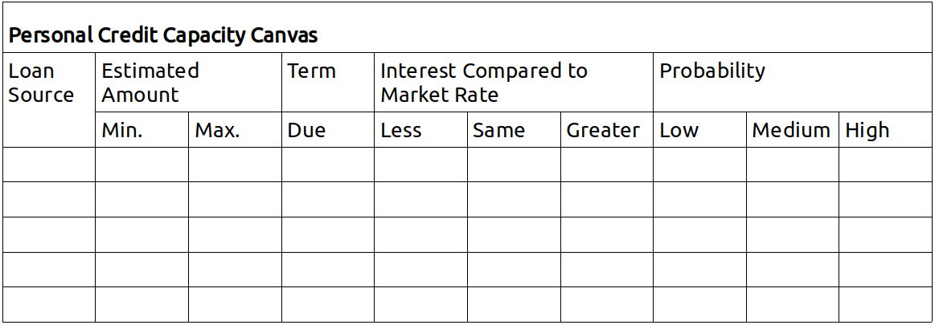

Session 10
Plan
- Gather, welcome, thematic game, form a circle, choose a moderator for the meeting.
- Reading and commentary on the answers to Questions for Review and Discussion #5. (If the group is large, each participant will read only one or two responses.)
- Exercise #9: Exploring Possible Donations.
- Break, snack.
- Exercise #10: Exploring Opportunities for Reciprocity, Barter, commensality, and Cooperation with Third Parties.
- Assignment of Individual Task.
- Reading and Organization of Jornada #5: “Costs and Financing Budget.”
Exercise #9
Exploring Possible Donations
Explanation
The purpose of this group exercise is to examine the possible sources of donations the solidarity group might be able to obtain in order to carry out its project of creating a solidarity enterprise. In many countries there are non-governmental organizations that fund initiatives of self-help organization and make donations on the basis of proposals that groups submit to them. Some public agencies – municipal, state, or federal – also have resources that can be used to support initiatives that create employment or address certain social problems. In addition to these institutional sources of donations, one should consider the possibility of securing private donations through enterprises, organizations, or people who might have a reason to support this solidarity enterprise project and be willing to collaborate by making a donation.
In this exercise the idea is to find and share information and ideas, and analyze in realistic terms the value of contacting particular potential sources of donations for a solidarity enterprise, sources that the group could at some point approach with a request for support.
The Flow
The flow of this exercise depends on whether the group has already established contact with institutions or organizations that make donations, whether the criteria applied by the funders and the requirements the group must meet are already known, and if there is already some kind of relation to the potential funder. Depending on the answers to those questions, the exercise can be carried out with more or less realism and specificity. In any case the steps to be taken are the same:
- Sharing information. Taking turns, group members share what they know about possible sources of donations, the conditions on which they are made, the requirements, if the group has contacts or relationships or possible ways to approach the potential funders.
- Reflection and analysis. The group reflects on the the appropriateness, viability, and necessity of seeking donations from these sources in order to finance the creation of the enterprise.
- Action planning. The group discusses actions they might take that would increase the possibility of obtaining donations on the most favorable terms. This could imply searching for information, establishing relations and contacts, preparation of proposals to be submitted to funders, etc.
Exercise #10
Exploring Opportunities for Reciprocity, Barter, Commensality, and Cooperation with Third Parties
Explanation
Without a doubt the members of the solidarity group are surrounded by other people, social organizations, associations, NGOs, public and private institutions of various types, etc., with which their nascent solidarity enterprise can establish relations of reciprocity, barter, commensality, and cooperation, for mutual benefit and utility.
Identifying these people and organized subjects, discovering what they can contribute to the solidarity enterprise, and, simultaneously, analyzing what the solidarity group and the enterprise we are creating can contribute to them, is a process of exploration of possible sources of resources that many groups fail to seek out or approach appropriately, simply because they are not aware of their existence. There are always more factors and resources surrounding the enterprise, accessible to the group, than we imagine. Here the slogan fits: “only the person who strongly desires something will identify the necessary means to make it happen.” Only when the project is clear does one begin to discover the means to make it a reality.
The Flow
In this exercise there are three aspects to consider:
  - Possible counterparts in the area, people and organizations with which you might be able to establish relations of reciprocity, barter, commensality, and cooperation.
  - What these counterparts could contribute to your solidarity enterprise. In order to avoid missing any possibility it is best to go through each of the six productive factors.
  - What your solidarity group and the enterprise you are creating could contribute to your counterparts. Go through each of the six factors in the same way.
For each organization or subject, examine ways in which mutual support could be established: reciprocity, barter, commensality, and cooperation.
In this exercise you use a canvas and cards of four different colors, arranged in four columns:
  - Cards of the first color are for writing the identities of possible counterparts.
  - The second color is for noting the possible factors that each counterpart could contribute to the group.
  - The third color is for contributions that the solidarity group could make to each counterpart.
  - Finally, the fourth color is for noting the types of relations (reciprocity, barter, commensality, cooperation) through which mutual collaboration can be organized.

Jornada #5
“Cost Budget and Financing Plan”

What is this practical activity about?
The objective of this Jornada is to calculate the financial needs implied by the creation of the enterprise and its initial operations, that is, first to make a Cost Budget for the project and then to determine the ways in which the necessary finances will be procured and integrated into the project, i.e. to make a Financing Plan. The Jornada concludes with organizing the group so as to merit the required finances.

Which aspects should be taken into account when budgeting for financial needs?
We have seen that before seeking funds and other factors of production outside of the solidarity group, it is essential to explore in depth all that the group members can contribute and the group can create for itself. The more of the necessary factors the group and its members are able to generate, the less will be the enterprise’s financial need. Once all the internal contributions have been considered, one should consider the factors that can be obtained without money through solidarity relationships established by the enterprise: donations, barter, reciprocity, comensality, and cooperation. Only after having specified everything that can be obtained without incurring financial costs should the group estimate and calculate the amount of money from external sources that will be needed, that is, prepare a Costs and Financing Budget.
When making estimates and calculations, the group should consider all the needed factors but keep focused on the essential points. The budget does not need to include items which could be left out without affecting the operation of the enterprise and its productive, commercial, and administrative functions. In any enterprise there are many elements that may be useful but are not indispensable, at least at the beginning, and for a while. The moment will come to invest in them, according to the possibilities that the enterprise creates as a result of generating surplus.
When elaborating the Cost Budget, the following aspects should be distinguished and taken into account:
a) Costs of investing in fixed or durable assets (equipment, machinery, etc.),
b) Operating costs for the establishment and initial phase of operation of the enterprise. (Inputs and raw materials, rent for a workplace/store, advertising, payments or anticipated earnings for labor, cash on hand, etc.) The amount of time for which you should budget is determined by the length of time during which you will be waiting for income from sales. In effect, the budget to be elaborated in this Jornada is incomplete, limited to calculating the costs of creation, establishment, and initial operations of the enterprise, because our goal right now is to identify only the amount of initial financing required, before the enterprise begins to generate income.
Once the budget has been prepared, the next step is to analyze and choose the forms by which to obtain the necessary financing: contributions from members? Group activities to generate income? Donations from third parties? Grants? Loans?
Finally, the solidarity group should determine how to prove itself worthy of the trust and belief of the potential external funders, how to motivate and convince them to contribute (in whatever form, as donation, grant, or loan) the finances that the group cannot otherwise obtain.
What are the activities to be done in this Jornada?
There are four steps:
  - Preparation and planning.
  - Doing the assigned individual task.
  - A day (Jornada) of group work.
  - Carrying out the activities decided upon during the day of group work.
How to prepare and organize the Jornada
Just as in previous Jornadas the preparation and organization is done in the previous Session (#10), where the explanation is read, individual tasks are assigned, and the day of group work is organized following the instructions given below. As the group has done several Jornadas already and is capable of proceeding efficiently, they will know how to carry out this one, which is more complex than the others, with a variety of preliminary activities to be done individually and in groups, and which imply the performance of tasks that will be decided upon in the course of the Jornada.
In the preparation meeting, the group should have on hand the results of Jornadas 3 (“The Theorem”) and 4 (“Deciding to Contribute Factors”). Using the information gathered in those activities the group should be able to develop a list of the elements needed to create an enterprise that the group does not have and can not create on its own. This list of “missing factors” is the basis for doing the individual and group preparatory tasks.
What are the preparatory tasks? (group and individual)
Each member of the group should come to the Jornada with all the necessary information regarding two elements:
a) The prices at which the missing factors can be purchased on the market, whether as an initial investment (tools, machinery, equipment, etc.) or as inputs to be used in the initial operation of the enterprise (locale, raw material, supplies, production costs, publicity, payment for work by people outside the group, consulting, etc.).
Based on this, the group should assign specific members, individually or in teams of two or three, to study the market and ask various providers for “quotes” (prices and payment terms). Getting quotes is an activity that the enterprise will do regularly and members should learn how to do it in the right way, in order to obtain the best possible prices and terms. The creators of any enterprise need to learn how to negotiate prices, which requires a kind of apprenticeship in which nothing is better than the experience that is shared peer to peer. In any case, there will be various quotes for all of the elements that need to be purchased on the market, never just one, and the variations found in the market can be significant.
In order to get the most from these tasks, the elements for which quotes are needed should be carefully noted by the group members who take responsibility for them.
b) Interest rates, terms, and conditions that banks, credit unions, rotating funds, and other financial entities and institutions, place on loans that they offer to individuals and to micro-enterprises or solidarity enterprises (e.g. cooperatives).
What should members bring to the Jornada?
Each person or team will bring the information they have obtained in their research about quotes and loans and be prepared to share with the group.
- The group symbol, logo design, and business idea.
- All the materials from Exercises 9 and 10.
- All the materials and information from Jornadas 3 (“The Theorem”) and 4 (“Deciding to Contribute Factors”).
- A flipchart.
- A large blackboard or other board.
- Plenty of index cards (10cm x 20cm) in six colors.
- Updated account information (personal and group).
How should the Jornada be done? What is the plan for the day of group work?
This Jornada is essentially a work session that can be done in about four hours, though the group may decide to add other activities that they think would be good to include.
The Jornada follows this plan:
- Gathering, welcome, thematic game. Installation of the group symbol in an appropriate place. Selection of a moderator for the meeting, as well as a “canvas manager” (person who manages the canvas used in the activities), and a note-taker.
- Set up the materials from Exercises 9 and 10, as well as Jornadas 3 and 4.
- Preparation of the canvas, using this layout:
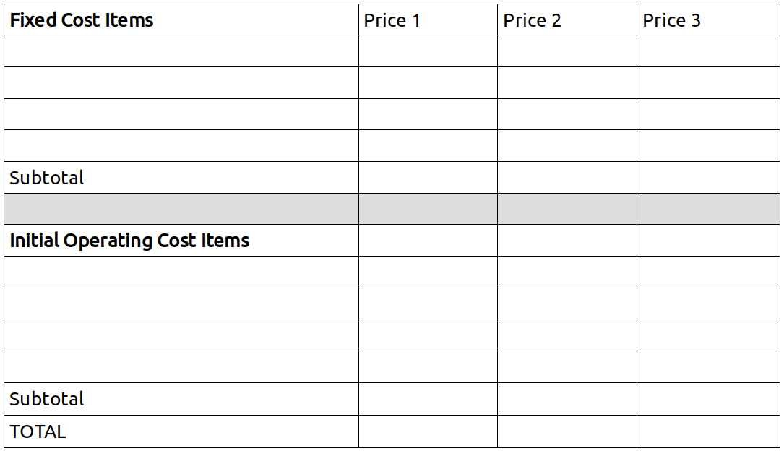
- COST BUDGET
- Activity 1. Calculating the Cost Budget.
- Break and Snacks
- Activity 2. Defining Sources of Financing.
- Activity 3. Organizing the Group so that it Merits Financing.

Activity 1: Calculating the Cost Budget
In this activity members prepare a Cost Budget that includes the costs involved in the creation of the enterprise, estimating the costs of all the elements that it will be necessary for the group to buy. To prepare this budget, the solidarity group will identify all the necessary elements that are not provided by members, created by the group, or obtained through solidarity means (donation, reciprocity, barter, etc.) using information from previous activities, exercises, and Jornadas. (In some cases a needed element can be created or produced by the group itself but at some expense. Those costs would be included in the budget.)
In this activity the canvas is used for recording information (by posting index cards) in the following order:
First, all the foreseeable items that will cost money should be noted. This information should be placed on the canvas in the corresponding table:
Fixed Cost Items are equipment, machinery, and other durable implements that will be used in the enterprise for a prolonged period.
Initial Operating Costs are raw materials and inputs, locale, initial payments for labor, cash on hand, etc., items that are indispensable in the initial period when the enterprise is just starting up. These are costs that should be covered ahead of time, knowing that the enterprise will not generate sufficient revenue to finance them until sales have reached a certain level.
Later, for each item, the corresponding price quotes should be noted, based on the research done in preparation for the Jornada. Based on data collected by individuals and teams for prices, quality, and conditions, the group chooses the best option and the price in the corresponding column is circled.

Activity 2: Defining Sources of Financing
Once the needs for external financing have been identified, as well as the amount of money needed by the enterprise during its startup and initial phase (that is, until it begins to generate enough revenue to become self-financing), the group should analyze how it might obtain the necessary finances.
Using the following tables for this activity, record the information on a flip chart or a second canvas. The goals is to identify possible sources of financing.

FINANCING PLAN
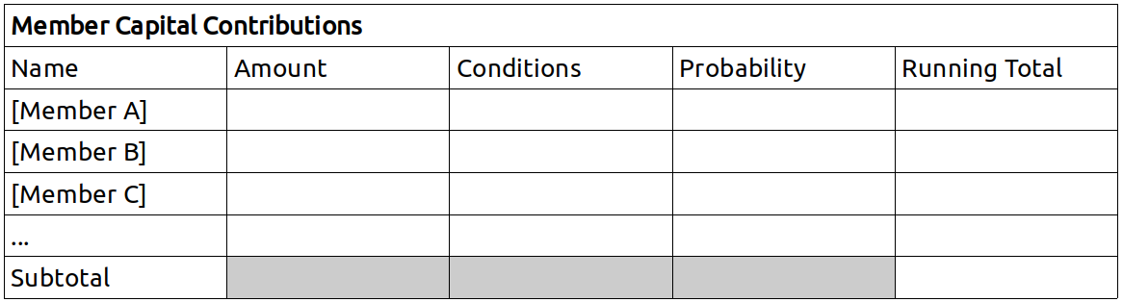

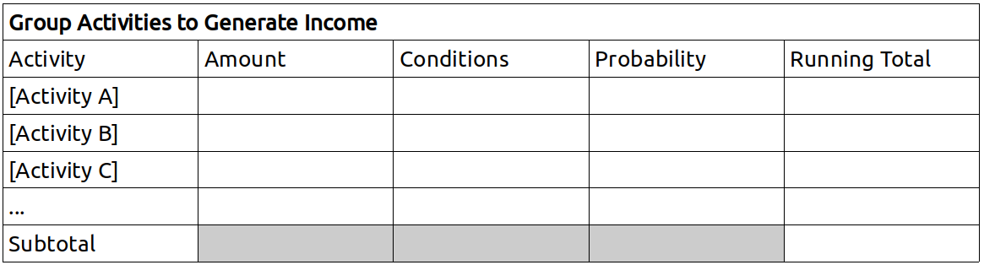

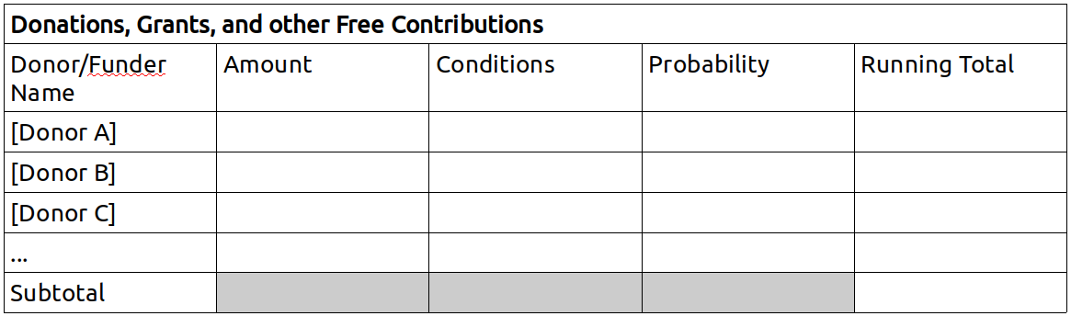

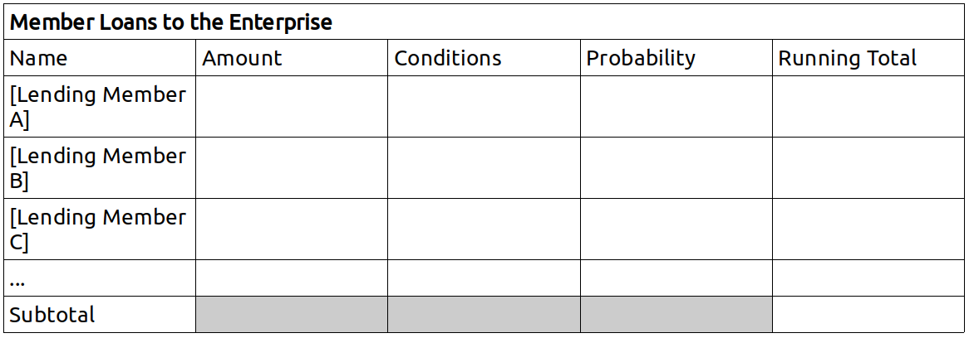

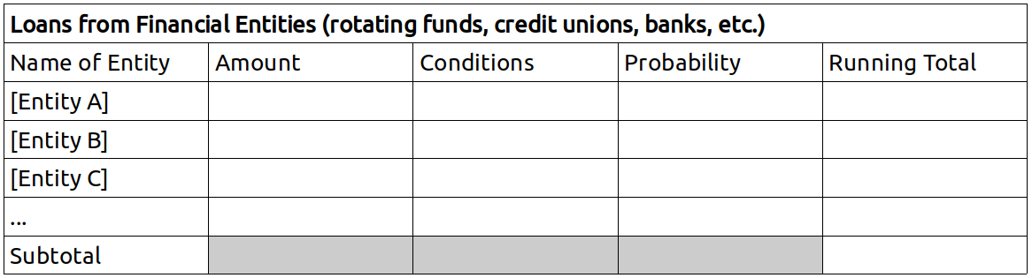

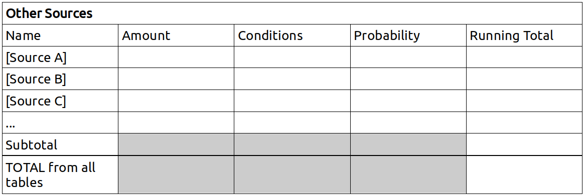

The group listens to the information provided by fellow group members, based on the information obtained in the previous exercises and activities, and, if it is accepted, it is added to the tables.
The amount to be noted is that which members believe it is possible to obtain from the source, and that the group is prepared to accept.
The conditions are things like the interest rate, the term of a loan, or other conditions.
The probability refers to the likelihood that the contribution can be obtained, according to the assessment of the member(s) who did the research, or the group as a whole. It can be expressed as a percentage.
In the column titled “running total” the group keeps a running tally of the amounts they can obtain from each source, adding the results of each row. Note: it is not simply the total of the amounts in the second column, but each amount adjusted to reflect the conditions and probability scores. For example, if under Activity 1, in the Group Activities table above, the amount is $1,000 but the probability of obtaining it is 50%, only $500 is added to the running total. If, in addition, there are conditions that make it difficult to obtain funds from the given source, the members make a subjective estimate of the degree of difficulty, and further reduce the amount. Let’s take another example:
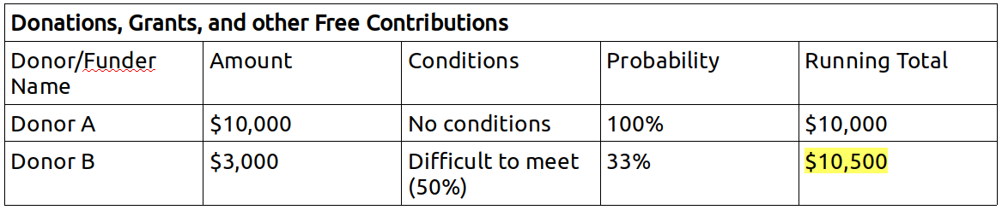
Only $500 is added to the running total in the second row because there is only a 50% chance the enterprise can meet the conditions (reducing the amount to $1,500) and the probability of getting the donation, even if the group can meet the conditions, is only 33% ($1,500 x 33% ≈ $500).
The logic of keeping a running total is that some probabilities balance out others.
The idea is to have a realistic appreciation of the possibility of obtaining the finances necessary for the creation of the enterprise, following the order in which it is best to seek money from different sources: first from member contributions, then from group activity, then from donations, and so on.
Activity 3: Organizing the Group so that it Merits Financing
In Activity 1 the group could see how much financing is needed in order to create and begin operating the enterprise. Activity 2 asks the group to identify the ways the funds might be obtained. Now it is time to think about what it means to “merit the financing” the group hopes to obtain. How to make the group trustworthy, credible, capable of proving themselves reliable to those who would trust the group with their resources. If the sum of the subtotals in each table is not sufficient to meet the needs, the group will need to do more work to show itself “deserving” of support than if the sum is greater than the total amount needed. In any case, in this activity, the group should apply the criteria studied in Reading 5, and organize itself accordingly such that the group can proceed rapidly once it has completed the Readings, Activities, Exercises, and Jornadas, and is prepared to assume the commitments implied in accepting financing.
We should note that we called this activity “Organizing the Group so that it Merits Financing” and not “Finding Financing” because the group is not yet ready for the final decision to create an enterprise: the group is not yet adequately organized and still needs a Business Plan. These will demonstrate the viability of the enterprise.

UNIT 5 GLOSSARY
Bankruptcy
The failure of an enterprise caused by its insolvency or incapacity to meet its obligations to repay loans, bonds, or other financial debts.
Barter
A relation of exchange between two subjects who exchange goods or services of the same estimated value, without use of money. The goods or services are directly exchanged without a calculation of monetary price, but simply on the basis of mutual satisfaction, which implies an agreement about what is to be offered and received by each party.
Bonds (issuance of bonds)
Bonds are documents issued by enterprises that commit the enterprise to paying on a specified future date (three years, five years, etc.) a certain quantity of money, which is stipulated in the documents. Bonds are purchased by investors at a discounted price, such that their purchase represents a gain for the investor (a future profit) that can be calculated as the equivalent of interest on the money spent when purchasing the bond.
Commensality (or sharing)
A form of economic relationship between various subjects who are part of a group, community, or organization in which goods and services are contributed by each according to their means and transferred to others according to their needs. It is most often seen in families or communities where economic relations are determined by the varying capacities and needs of the members.
Compound Interest
The increment in a given sum of money when the interest earned in a certain period is added to the original amount of money saved (or borrowed), and, in the following period, the established interest rate is applied to the sum of the initial money and the interest from the first period. Over the course of successive periods of time, the amount saved (or owed) increases exponentially.
Cooperation
Cooperation is an economic relation between subjects who are part of a collectively managed association or organization to which members pay dues and make contributions in the form of money, work, or other factors, generating a surplus or profits that are distributed among the members according to the contributions each has made.
Corporation
A corporation is an economic unit in which ownership is divided into shares of stock. The liability of the shareholders is limited to the value of the shares they hold; their personal assets being protected.
Financial Entities
Banks, Finance Companies, Credit Unions, Cooperative Banks, and all other institutions that play an intermediating role, collecting savings and providing loans, connecting the supply and demand of money in the market.
Guarantees
Commitments that financial entities require of those who seek credit, with which the former seek to ensure that the latter can meet their promises to pay. There are various types of guarantees such as mortgages on property and real estate, collateral in the form of furniture, documents like checks and promissory notes, and other economic assets with which the creditors be compensated in the event that the borrower can not pay the principal and interest to which the parties agreed.
Interest Rate
We commonly say that the “interest rate” represents the value of money, that is, the price you have to pay to borrow money from others on the market. The interest rate represents a percentage of the amount of money transferred. The “deposit interest rate” refers to the interest paid by the financial entity to the depositor, and the “loan interest rate” refers to the interest the financial entity charges a borrower.
Non-Profit Organizations
Non-profit organizations are economic units that organize individuals or collectives to support some process, resolve certain problems, or contribute to the satisfaction of specific social needs without the expectation of making a profit or economic gain from their activities. These economic units are dedicated to social ends and not to the personal benefit of their organizers and owners.
Reciprocity
Reciprocity is a transfer of goods or services between two subjects (individuals or collectives) in a particular moment or period of time, without calculating the price of the goods or services transferred, but with the commitment that the value received will be compensated at some point. These transfers are only possible on the basis of mutual trust between the two parties.
Shares (of stock)
Shares are units of value representing the capital invested in an enterprise that is organized as a corporation. Shares represent first of all a quantity of money invested, which is represented by the “face” (or nominal) value. But shares also represent a percentage of the total equity of the enterprise which can rise or fall in value as a result of profits, losses, reinvestment, debt, etc., leading to a rise or fall in the value of the shares. The “book value” of shares is determined by the ratio of equity to the number of shares. Stocks are traded on the market, where they acquire a “share price” based on future expectations of the enterprise’s profits or losses and supply and demand for the stock. This is the market value of the shares, the price at which they trade on the stock market.
Transfer of Assets
Any movement of assets with economic value from one person or social subject to another. It can take the form of donations, exchanges, taxes, allocations, subsidies, etc.

EVALUATION OF UNIT V
This evaluation is to be done both individually and as a group.
Individual Evaluation
Each participant should answer the following questions in their notebook:

A. Circle the answer that best matches your experience.
- My understanding of the contents covered in this Unit is:
Weak – Good – Excellent
- My performance of the individual assignments in this Unit was:
Weak – Satisfactory – Very good
- I consider my contributions to the group exercises to be:
Poor – Adequate – Outstanding
- My participation in the organization and execution of the practical activity (Jornada) was:
Passive – Relatively active – Very active
- I think my overall contribution to the group was:
Very little – Could have been better – Ample
B. Reflect on the following questions and summarize your answers in writing.
- Was the analysis I did of my personal capacity to obtain credit for our solidarity enterprise rigorous enough? Did it help me discover and appreciate my economic credibility among those who know me? What was the effect of this personal assessment on my self-esteem?
- How much faith do I have in the solidarity enterprise in which I am participating? Am I giving it all the credit that I think it deserves, or do I still have doubts, suspicions, worries? Is it possible that I am expecting a lot from the group and the project but still not fully committed to making it happen?
- Do the forecasts we made as a group with respect to the possibilities of securing donations and obtaining factors for the enterprise through other relations of solidarity, seem realistic?
Group Evaluation (to be done in the next session)
Seated in a circle, the whole group discusses the following questions.
- Have we created a good Cost Budget for the enterprise we hope to create? With a little distance from it already, do we think we got carried away by our enthusiasm, or, on the contrary, were we too pessimistic?
- Were we realistic in our projection of our ability to secure financial resources from ourselves, the solidarity sector, and the financial market?
- Based on the Cost Budget and Financing Plan, are we really ready to start our project, or do we need to rethink it, reducing our plans to match our capacity, or, on the contrary, expanding them to take better advantage of all the capacities and resources we might be able to obtain?

Unit VI
ECONOMIC ORGANIZATION OF THE ENTERPRISE (1)
Forms of property, admission of members, management structure
Session 11
Plan
- Gather, welcome, ice-breaker, form a circle, choose a moderator for the meeting.
- Evaluation of Unit V.
  - Each participant reads aloud their answers to the individual evaluation form from Unit V.
  - Carry out the group evaluation as described in the group evaluation form from Unit V.
- Break, snack.
- “Reading Six.” (One or two people read out loud as others follow along in the text.)
- Questions for review and discussion. (Participants volunteer to answer one question each, raising their hands to speak. Other participants can add to their answers but it is best if nobody speaks twice before others have had a chance to speak.)
- Questions for the facilitator, exchange of ideas and free conversation on the theme.
- Suggestions for the Individual Task. (The facilitator will explain the content and purpose of the individual task, clarifying any issues and answering questions that come up.)
READING SIX
At this point we have identified all the economic factors needed for the enterprise we wish to create; we know which ones we have and how to get the ones we lack. The time has come to think about the form of economic organization we will use to integrate the various factors in our enterprise.
The enterprise is, as we have seen, an economic organization of productive factors created according to a specific rationality in order to reach certain ends. The question, then, is how can we organize an enterprise according to the criteria of solidarity economy and achieve the greatest efficiency at the same time?
This is a step of great importance. A great deal hinges on the type of economic organization we create starting from all of the decisions already made about contributions and the procurement of factors from members and third parties (i.e., internally and externally). We have decided which factors each member will contribute and which will be created by the group, but now we have to carry out those decisions, that is, make the actual contributions.
The contribution of economic factors becomes real and effective when they are incorporated into an organization.
Economic organization is above all the process through which the contributions on which the enterprise or organization is based are made real. The enterprise is separate from each member and the group of people who create it. In other words, through the contributions of factors and their economic organization, a new reality is created, which we call an enterprise, which begins to have its own life, under the control of the group and its members of course, but different from them.
However, before bringing external factors into the enterprise – factors contributed by people who are neither members nor owners of the enterprise – through contracts and agreements that define and regulate their respective rights and obligations, it is also indispensable to have in place a clear and consistent management structure.
To integrate factors obtained externally you need an existing organization. This means that the initial organization of the enterprise is carried out only with internal factors. As the name suggests, external factors are external to the economic organization, even though they will be incorporated into its functioning and operation.
Moreover, the procurement of external factors implies making commitments to third parties, which can only be done if the group already has a definite form of economic organization in which the responsibilities of members in regards to those commitments are clearly defined. Yes, the commitments are made by the enterprise itself and the solidarity group that sustains it, but that does not dilute the responsibility of individuals, in the same way that the profits generated by the enterprise are distributed and accorded to the individual members.
Commitments, profits, costs, risks, in the final analysis all of them are assumed by the members of the group, in precise and definite terms, based on criteria of justice and solidarity. These criteria and the way they are applied and operate in the enterprise are the subject of this sixth unit of the manual, to be studied in theoretical terms and put into practice.
Economic organization of the enterprise consists of establishing the criteria and norms that regulate a series of basic aspects of its structure and functioning.
The fundamental aspects to be regulated in the organization of an enterprise are the following:
- The form and structure of property,
- The treatment of labor power,
- The distribution of surplus and profits,
- The recruitment and withdrawal or expulsion of members,
- The management and decision-making systems.
These five aspects are closely related and the criterion used to establish one affects the others, which must be coherent with it. Lack of coherence between aspects will cause organizational deficiencies that will soon manifest themselves in the form of various problems.
It is good to keep in mind that whether the organization is just or unjust, characterized by solidarity or not, efficient or inefficient, all depend on how the enterprise is organized, or how the five aspects above are structured. There is a lot at stake so we need to carefully address each of these aspects of economic organization.
But the first question to be asked is:
Who defines the criteria and norms that regulate these different aspects of the enterprise?
The answer is obvious: the organizers of the enterprise, in our case, the solidarity group. But the question is worth asking because the answer is not always obvious. Some people believe, for example, that all of the aspects are regulated and decided by law. Others believe that they are purely technical questions, the answers to which one simply has to understand and obey. Still others may believe that there is one efficient organizational model, or perhaps a few among which one has to choose.
Each of these beliefs is in part correct: the laws of each country (or state) establish certain criteria and norms that have to be followed; there are aspects that are strictly technical and need to be taken seriously; and they are organizational models, some more efficient than others, among which you can choose.
Nonetheless, none of these three elements, nor all of them together, can resolve by themselves the question of economic organization of the enterprise. Legal norms, technical criteria, and models of efficiency must be taken into account, but in the final analysis the type of organization created in the enterprise depends only on the people or group that create and organize it.
By organizing the enterprise the solidarity group is defining the way it will be directed and led. The criteria of organization determine the criteria for management and decision-making. Naturally, in order for the decision-making to be fluid, transparent, natural and without unnecessary complication, the group needs criteria that are not only known by all members of the group but seen as their own, suited to their ways of thinking, their values, and their normal criteria for behavior. If not, when they face a decision, they will become rigid, won’t know which criteria to apply, or if they do, will have difficulty sticking to them, or to do so will feel artificial, imposed. This is another important reason why the enterprise’s organizational criteria, which are freely decided by the solidarity group itself, should be suited to the members’ ways of thinking, feeling, behaving, and relating to each other. For this reason:
The organizational forms of the enterprise should be adopted by consensus of all the members of the solidarity group.
Keeping this in mind, we will now look at different criteria of organization that the group could adopt. These criteria, which are offered as alternatives among which the group can choose, take into account technical aspects related to organizational efficiency as well as elements of justice and solidarity that correspond to the economic logic of solidarity, with which the group needs to stay aligned in order to be successful in its entrepreneurial project.
Let’s look, then, at possible criteria to be applied in relation to the five fundamental aspects that should be regulated in the organization of an enterprise: a) the form and structure of property; b) the regulation of admission and withdrawal of members; c) the system of management and decision-making; d) the remuneration of labor; and e) the distribution of surplus or profits. In this Unit we will look at the first two, leaving the other three for Unit VII.
Forms and Structures of Property in the Enterprise
The question of property is important in any enterprise including solidarity enterprises. Experience shows that the form of property should be established according to precise criteria, on which members have reached consensus, that are applied from the moment the enterprise is created. Any ambiguity or lack of clarity regarding property will be the source of inevitable future conflicts and produce permanent economic inefficiencies.
There is no one form of property that corresponds to the logic of solidarity, but several. Which is best for a given project depends on four aspects:
- The objective of the solidarity group, that is, the relative importance it attributes to generating monetary profits or achieving social, cultural, or other goals.
- The composition of the solidarity group, its size (number of members) and the strength of the bonds among members.
- The economic value of the goods and factors that make up the equity of the enterprise, the sum of value (the size of the capital owned) and the impact it has on the generation of profits (its productivity or contribution to production).
- The origin of the goods and the factors that make up the equity, the degree to which they are contributed by members, created by joint work, received in the form of donations, loans, or reinvested profits.
As we saw in Unit Four, contributions can take various forms and the equity of the enterprise can be formed in various ways. With respect to the factors of production, members can contribute through: donations, valorized equity contributions, non-equity contributions of rights to use and usufruct, compensated contributions, and paid contributions of external factors. The distinct forms in which contributions are made determine the type of property to be established in the enterprise.
The basic alternatives are as follows:
Alternative 1 – Property in Common
In this case all the assets (goods and factors) that form the capital or equity of the enterprise belong to the solidarity group as a collective. Nobody can claim personal ownership of any asset, nor of any part or percentage of the common equity. If a member leaves the group, all that they have contributed remains with the group and when a new member joins they become a member on the same terms as all of the existing members. This form of common property implies that contributions to the enterprise are essentially donations: members donate to the group the factors that they contribute. Since they have donated them, they have no grounds on which to later demand restitution.
This form of property is only recommended when at least one of the following conditions applies:
a) The objectives of the solidarity group are of a social, cultural, or shared character with little emphasis on generating monetary profits for redistribution to the members.
b) The group has a high level of cohesion, like a family or an intentional community, with many common activities, extensive sharing of goods and services, and the common satisfaction of many needs.
c) The total value of the goods and factors that make up the equity of the enterprise is very small, or not very important for each individual member, and the role of assets in the generation of profits is of little importance (depending more on labor than on physical capital, for example).
d) The origin of the equity is largely or entirely social. In other words, the equity does not come from the individual contributions of members but from their joint work, or received as a donation intended to benefit the group as such, or generated by reinvestment of profits generated by the enterprise or through amortization of a loan taken by the collective.
When one of these conditions clearly applies, and if all members of the solidarity group are in agreement, property in common and without distinction among members may be the most appropriate form because it simplifies procedures and prevents problems from arising. But if none of these conditions is present, holding property in common will probably prove to be inefficient and unfair, and give rise to frustration and conflict. Inefficient because there will be little incentive for the enterprise to grow, either in terms of equity or members. Unfair because the specific contributions of members are not recognized and every contribution they make goes to the common fund benefiting those who contribute less at the expense of those who contribute more. Even when the equity of the enterprise comes from equal contributions from each member and grows through equal contributions (e.g. of labor), property in common will be unfair to those who later leave the group having made many contributions that they can not take with them. (In such a case, the group might benefit from the departure, voluntary or forced, of its senior members who leave their contributions behind.) Frustration and conflict because these are the inevitable result of inefficiencies and injustices.
Alternative 2 – Individual ownership of goods or assets which are used in common
In this case the ownership of goods and factors with which the enterprise operates is held by the individuals who contribute them. Members of the solidarity group contribute to the enterprise by providing goods and factors that are used by the group as a whole and serve their common objectives, but they do not transfer ownership of these assets to the enterprise. This form of individual property in assets that are used in common implies that factors are contributed to the enterprise in the form of non-equity contributions of the right to use and usufruct.
This form of property is used in some informal solidarity organizations, and in some types of cooperatives. In each case the modalities are different.
In informal solidarity enterprises, which are typically very small (micro-enterprises), all the members contribute something: a room in a member’s house to be used as a workspace, a piece of furniture, a machine, tools, dues, supplies, etc. The enterprise is assembled in this way and managed by the group as if every asset belonged to all. What matters most to the members is not the property, or the enterprise as equity, but the possibility of working together and obtaining income as a result of their joint work and management.
The informal character of these economic units, which typically do not involve large amounts of equity, and the strong sense of solidarity among their members, permit them to function in this way without difficulties, knowing that each member has the right to take with them what they have contributed if for any reason they decide to leave the group.
Some formal cooperatives adopt forms of property that, while different in their mode of constitution, also match the criterion of individual ownership of assets used in common. Each member contributes, for example, by paying dues and all the dues collected (and the assets bought with them) are managed in common; but each member maintains an individual account of their contributions, which they own and which they have the right to withdraw when they decide to leave the cooperative. This type of organization operates more as a unit of collective management of individual assets than an enterprise independent of its members. An example of this type of enterprise is the housing cooperative, in which each member contributes money that, managed together with the money paid by other members of the cooperative, enables them to buy their own homes. Certain producers’ cooperatives, or energy or utilities cooperatives, or taxi or transportation cooperatives, use this form of individual ownership of goods used in common.
Alternative 3 – Cooperative ownership through shares
In this case the equity of the enterprise is formed by contributions from members who transfer ownership, legally and de facto, to the juridical person that organizes, manages, and sustains it. But while the contributions are transferred to the enterprise, each member acquires at the moment of transfer a certain quantity of units of value (typically called shares or stocks) representing a percentage of the value of the total equity of the enterprise, equivalent to the proportion of their contributions. This form of cooperative stock ownership is established when the members make (at least some) contribution of factors to the enterprise in the form of valorized equity contributions.
The criterion is similar to that of capitalist corporations, but with substantial differences corresponding specifically to the distinctive rationality of the solidarity economy: to be a “shareholder” you have to be a member of the solidarity group and work at the enterprise, the valorized equity contributions are not only financial, and the property rights of the solidarity group as such are also recognized with respect to a portion of the equity. (If more coherence with the logic of solidarity is desired, the value of shares can be measure by labor time and not monetary units; but we will not explore this option in this manual because it involves complex elements and a level of development of solidarity enterprises that does not correspond to the situations for which this manual is intended.)
Let us see how cooperative share ownership is configured.
The equity of the enterprise – on the basis of which the proportions of property represented by shares are allocated to each member – is formed in two moments and thus has two parts: a) the initial equity, the equity formed when the enterprise is created through the contributions of its members, their common work, and whatever donations they may receive; and b) the increments of equity that result from the reinvestment of profits, new contributions from members, amortization of debt, or new donations.
For both initial and incremental equity, in both moments, a certain proportion of the equity may be personal property and the rest group or common property.
The essential criterion for establishing this form of property is that each person be assigned a percentage of ownership corresponding to their portion of the total member contributions. That is, to each according to their contribution. The proportion of the equity which is individual property and that which is social property is determined by the person who made the contribution.
With this criterion, the initial equity, made up of factors that become property of the enterprise when it is created, will be allocated – in shares – in part to the various members, in part to the solidarity group as such. The group will be assigned that portion of the value of total equity that comprises donations from members or third parties and the joint labor of the members. Each member will be assigned that proportion of the value of the total equity that is comprised by their respective valorized equity contributions.
As for increases in equity corresponding to growth measured at the end of every annual period, the same criterion is used. The gains in equity from donations made to the group, the reinvested profits, and the amortization of debt are allocated to the group, while the gains due to new individual contributions and the profits distributed to members that they reinvest in the enterprise are assigned to each member. (We will examine later the criteria for distribution of surplus.)
These are the criteria. The forms in which values are quantified and the modes of issuance and assignation of shares will be examined more concretely in the exercises and Jornada for this Unit.
Let us now look at a second aspect of the economic organization of the enterprise:
Regulation of the Admission and Withdrawal of Members
This aspect of the organization is very important because in the life of an enterprise there will certainly be members who were there at the start but later wish or are obliged to withdraw, as well as people who join the group after it starts. It is important for the admission and withdrawal of members to be clearly regulated from the start and to clarify if members can withdraw what they have contributed when they leave, or in the event they are expelled. In the case of the death of a member, it is important to have a clear policy regarding the rights of their inheritors.
People place in the enterprise not only their labor power but also financial and material contributions and technological and administrative resources, and commit as well an important part of their values, expectations, hopes and efforts. Having placed so much in the enterprise it is difficult to leave, and if the enterprise is efficient it should have a very stable human composition. But, in life, situations arise that can oblige or lead one to withdraw, and what becomes of all that the member has contributed to the enterprise must be made clear. If not, members may become reticent, unwilling to fully commit.
On the other hand, when a new member joins all the contributions already made come to be shared with them. It is necessary then to know under what conditions the previous contributions are shared with the new members and what is demanded of the new member by way of compensation for what they receive from the group. In synthesis, it is necessary for the enterprise to have clear forms and procedures regulating the entrance and departure of members.
The entrance of new members should respond to the functional needs of the enterprise, which should be technically evaluated, and/or the belief of the group that the new member will contribute in a clear way to the achievement of the group’s objectives. In saying this, we are warning the reader that, generally speaking, and excepting some particular types of enterprise, it is not good to keep the doors too open. It is an almost biological principle of organization that excessive willingness to accept new members tends to reduce group identity and members’ sense of belonging, as well as weakens internal structures, elements that are very relevant for solidarity enterprises.
In the selection of applicants for membership it is necessary to make sure that they know, share, and adhere to the group’s objectives, understand its mode of organization and operation, share its criteria with respect to the various aspects of the organization; and moreover that they meet the minimal requirements established when the group was originally formed, and contribute in some way the same amount as those who created it. All of this is indispensable in order to maintain unity, coherence, and homogeneity of the group, and to preserve the C Factor which is so important as a foundation on which a solidarity enterprise is formed. For this reason many enterprises establish a probation period, which should not be very long (so as not to fall into unjust and discriminatory practices), and at the end of the set period the group makes a definitive decision to admit the member, or asks them to leave.
Now, the admission of a new member means that they will make contributions to the enterprise in the form of labor, finance, materials, technology, etc. It also means that the new member will participate as part owner of the enterprise’s equity and in the distribution of surplus. Obviously, this should be done each time a new member joins and it should be done in the way established by the founders of the enterprise, according to the type of property they adopted. If they chose the joint-stock system they should re-apportion the percentages of ownership among all the members, in proportion to the shares issued and allocated to the new member.
The withdrawal of a member is a possibility that must always remain open. There is no justification for rules that would deny members the freedom to withdraw, whatever their reason for doing so.
In order for this right to be effective and not merely formal, it is essential that when a member leaves the enterprise they be able to recover the percentage of the property or equity that they have accumulated in it and that corresponds to them. Naturally, we are talking about those contributions that are credited to individual members, not the contributions they make to the common property.
Now, as the withdrawal of a member with all of their contributed assets could pose operational and financial problems for the enterprise, it is appropriate for the organization to establish clear norms and procedures that protect it. For example, it is reasonable to require members to give one month’s notice before leaving work, or to establish a time period (six months or more) or a progressive mechanism (monthly payments) over which the enterprise can pay down that which the departing member is owed.
The withdrawal of a member, like the admission of a new member, also poses the problem of recalculating the percentages of ownership among the remaining members. This can be done by simply eliminating the departing member’s shares in the enterprise, or reassigning them to the remaining members, in proportions that do not alter the given property structure.
It can be seen that with respect to the entrance or withdrawal of members the criteria adopted must be strictly consonant with the organization’s ownership structure. A similar coherence should exist with respect to the following:
The System of Management and Governance
Any enterprise needs a clear and effective system for management and decision-making. The experience of solidarity enterprises teaches that there are different possible management systems that are both efficient and compatible with the criteria of a solidarity economy. But there is one basic criterion that underlies any concrete form of management:
The governance or general management of the enterprise is an inalienable right of the solidarity group, that is, of the members who own and control the enterprise.
There nonetheless exist different modes of organization of management and governance depending on various conditions and circumstances: the number of members, the form of property used, and members’ skills and capacities for administration and management. We will consider some of the principal alternatives, without forgetting that it is the solidarity group itself that decides which approach seems best suited to their own ways of thinking and organizing.
First of all, it is necessary to distinguish between two questions which need to be resolved according to their corresponding criteria which guarantee coherence, solidarity, and efficiency. The first has to do with the composition of the solidarity group as an organ of general governance of the enterprise, which alludes to the form and proportion in which each member participates in the power of governance and management. The second question has to do with the relationship between governance and management.
The Member Assembly as an organ of general management or governance of the enterprise
With respect to the composition of the solidarity group as an organ of governance, there are basically two options:
Option 1. Collective or Shared Governance
In collective or shared governance the solidarity group constituted as a Membership Assembly makes decisions, with all members participating on an equal basis. Decisions are made by the Assembly as a whole, that is collectively, and each member has a vote. When a decision is supported by a majority of those present it expresses the common will of the solidarity group. In order for the Assembly to be considered legitimate, a quorum of members is needed, that is, a certain number of members (established in the bylaws).
Collective governance seems best suited to enterprises in which property is shared, or in those where ownership is individual but assets are used in common.

Option 2. Associative governance with differentiated participation
In enterprises with joint-stock ownership, the criterion of “one member, one vote,” which suits collective governance and is traditionally accepted by cooperatives, may not be suitable. Because collective governance is a criterion generally applied in social organizations and consistently adopted because of its intrinsic democratic content, there exists a strong tendency to apply it in associative and solidarity enterprises. But it is not always the reasonable choice, especially when a joint-stock system has been adopted.
In effect, due to differential contributions made by members, the difference in time served in the enterprise (old vs new members), and the different levels of participation in activities and operations, members have different degrees of responsibility and commitment to the enterprise. The criterion, “one member, one vote” which is suited to situations when members’ participation is equal or similar, and when the equity is held in common, can be unjust and inefficient when applied to enterprises where members have made very different contributions and if the ownership of assets is distributed in the form of shares. In these latter cases, each time that important decisions are made in the enterprise some members run much larger risks than others, due to the differences in personal investment.
Thus the form of participation of members in governance that may be adopted in such cases is that of a Membership Assembly in which the criterion is one “unit of contribution, one vote,” or in enterprises with stock ownership, “one share, one vote.” Although it may seem very similar to the governance system that exists in capitalist businesses, in contradiction with certain democratic convictions, it is perfectly compatible with the special rationality of the solidarity economy if the contributions that are recognized have been made in accordance with the criteria of cooperative stock property that that we indicated above (see Alternative 3 above). From an ethical point of view, in this system of governance each member manages their work in proportion to the contributions they have made to the enterprise.
The Relationship between Governance and Executive Management
With respect to the form of the relationship between governance and executive management, there are basically three options:
Option 1. Collective Management
Here operational decisions are made by all members of the solidarity group, gathered in a permanent assembly that takes responsibility for management of the enterprise. This form of governance is possible when the group is small – fewer than twelve members – and highly cohesive and there are present clear and expeditious mechanisms for resolving differences of opinion, for example by simple majority vote.
In any case, and though the group may make decisions on a collective basis, there will always be a need for someone to preside over meetings and serve as the enterprise’s legal representative, acting as coordinator and facilitator of meetings and assuring that decisions made are carried out; as well as a secretary to take minutes and notes, and other roles that it may be best to assign to specific individuals.
Option 2. Delegated Individual Management
In this case one member of the solidarity group is chosen to be its head and takes responsibility for management of the enterprise. This form of executive management is possible when certain conditions are met. First, there must be an individual who is clearly better suited to the position, has better skills, than the rest. It is necessary as well that the group be unanimous in its support of the person, or that they be chosen by consensus. But it is not enough to elect them once, it is necessary that the individual selected be controlled by the Assembly, that their mandate be periodically reviewed with the individual subject to recall. It is also essential that they exercise leadership in a democratic manner, that is, in consultation with others, encouraging participation, respecting people in their work, informing the group of the activities and daily condition of the enterprise, teaching and training others so that they can, in the future, assume management responsibilities, and accepting collective control over decisions. On top of all this, it is necessary that the individual’s decisions be respected and obeyed, each worker or member submitting to their authority in their own area of operations or work.
Option 3. Delegated Management in a Governance Body
In this case, the members in their Assembly have the final word when it comes to the overall operation of the enterprise; but they have delegated leadership and management of the enterprise to a small group of people who form a leadership body (administrative counsel, executive committee, board, steering committee or what have you), with specific tasks and responsibilities assigned to the group and to specific members, according to the needs of the enterprise. The leaders may be accountable to the Assembly and periodically renewed. It is important to have rotation of members and tasks, and to ensure that everyone has the real possibility of being elected and of participating in the governance body. This system is best suited to very large solidarity groups (more than twelve members), and situations when it is useful to delegate management functions to people recognized as particularly suited and competent.
We have specified the general criteria of organization and the possible options with respect to three of the five aspects that need to be defined before creating an enterprise. In the exercises and the Jornada for this Unit we will have the chance to apply these criteria and opt for one of the proposed options, moving forward in the concrete organization of our enterprise. In the next Unit we will examine the two remaining aspects – the remuneration of labor and the distribution of surplus or profits – and all of these elements will become part of the Bylaws and Internal Rules of the enterprise that we create in the first of two Final Assignments.
Questions for Review and Discussion #6
The following questions should be answered individually, in writing. Each participant will later share their answers during the group work, allowing for evaluation and correction of the answers by comparing them with the answers of other members and ensuing discussion.
- Why does the sum of factors contributed, whether by members or third parties, depend on the form of economic organization of the enterprise?
- What does it mean to give economic organization to an enterprise?
- What are the five fundamental aspects that need regulation in the organization of an enterprise?
- Why do the organizational criteria of a solidarity enterprise have to be defined by the members by consensus? Which elements that affect these criteria have to be taken into account?
- What are the basic alternatives with respect to the ownership structure of a solidarity enterprise?
- Which elements determine which of the alternatives is best suited to a particular enterprise?
- What does cooperative ownership consist of and how is a joint-stock cooperative (or association) organized?
- Which criteria need to be taken into account when bringing a new member into a solidarity enterprise? What requirements should be met by the person seeking membership?
- Why is it so important, in a solidarity enterprise, to clearly define the criteria and conditions that regulate the withdrawal of members?
- Keeping in mind that governance of the enterprise is an inalienable right of the solidarity group that organizes it, what are the different organizational forms that the group can adopt for its governance and management while maintaining the logic of solidarity?
- What is associative governance with differentiated participation and how does it work?
- What are the different ways in which the relation between governance and management can be set up?
INDIVIDUAL TASK #6
To be done after the eleventh session
- Study the Glossary at the end of Unit VI.
- Answer the “Questions for Review and Discussion #6” in writing in your notebook.
- Individual Activity: Proposal for Organizational Criteria (I).

Individual Activity:
Proposal for Organizational Criteria (I)
In this activity, each group member, having studied the different criteria and options for economic organization with respect to the first three aspects that should structure the enterprise, reflects on a series of questions and prepares answers to share with the whole group. It is important to do this because the form of organization adopted by the enterprise will only be adequate and efficient if it responds to the ways of thinking and feeling of its members, those who should specify their points of view and share them with total liberty and personal judgment. This will allow us, later, to develop shared criteria that will be defined in Jornada #6.
To facilitate this activity, people can use the following handout, circling the option they favor for each theme and arguing in favor of their choices, or explaining their reasons, in the space provided.
HANDOUT
A. I believe the best form of ownership for our enterprise is:
- Shared ownership.
- Individual ownership of goods or assets that are used in common.
- Associated (or cooperative) ownership of shares of stock.
- Other:
Why?
B. I think that when a member leaves the enterprise they should:
- Leave everything they have contributed with the enterprise.
- Recover their contributions in the amounts in which they made them.
- Recover from the equity of the enterprise a value proportionate to the amount of shares they own.
- Other:
Why?
C. I think that new members should:
- Make a contribution equal to those made by the existing members when they created the enterprise.
- Make a contribution equal to those made by the existing members up to the point when the new member enters.
- Make a contribution previously determined by the solidarity group, which entitles the new member to a proportionate share of the assets of the enterprise.
- Other:
Why?

Session 12
Plan
- Gather, welcome, thematic game, form a circle, choose a moderator for the meeting.
- Reading and commentary on the answers to Questions for Review and Discussion #6. (If the group is large, each participant will read only one or two responses.)
- Exercise #11. Defining the Criteria of Ownership.
- Break, snack.
- Exercise #12. Defining the Mechanisms of Admission and Withdrawal of Members.
- Assignment of Individual Task.
- Reading and Organization of Jornada #6: “Organizing the Enterprise. (I)”

Exercise #11
Defining the Criteria of Ownership
Explanation
We now understand the importance of the system of ownership that the enterprise adopts. We know the various alternatives and options and the aspects that need to be taken into account when choosing between them. When it comes to actually choosing, it is good to keep in mind that when defining the ownership structure, just as when defining other aspects of the economic organization of the enterprise, you have to look to the future and think about the long run. Although the factors that constitute the enterprise’s assets are few and of little value at the start, and the members few in number, the enterprise and its assets will grow, the number of members will increase and conflicts may arise. It is in the future, then, that we will appreciate the importance of having clearly defined these organizational aspects of the enterprise.
But the enterprise is formed by its creators and the task of determining the organizing criteria falls to them: establishing the forms of ownership, admission and withdrawal of members, management systems, schemes for remuneration of labor and distribution of profits. The members of the solidarity group should be in agreement about the form of organization they want for their enterprise, which presumes that they all participate and contribute to the decision. It is possible that not everyone will think alike and that there will be different criteria, which will become apparent in the group discussion. Here it is not about making an easy decision, or hastily applying the criterion of “majority rule.” What is at stake is the destiny of the enterprise, the achievement of the objectives the group has worked to hard to reach, and the hopes of each member.
So each person should express their point of view with complete liberty, and each should respect criteria that differ from their own. But the organization of the enterprise can not remain undefined. The group must come to agreement, as a result of in depth analysis of each theme and proposal. Above all, the arguments and reasons behind each member’s choices of options must be taken into account. By examining each aspect on its merits and always keeping in mind the objective of the enterprise and the benefit of the solidarity group, it is clear that the group will come to the best decisions.
The Flow
Prepare the white board or flip charts with the three alternative forms of ownership structure as presented in Individual Activity 11, leaving space to record participants’ preferences (with a check mark), and take notes summarizing their arguments and reasons. Leave a space for the final decision, too.
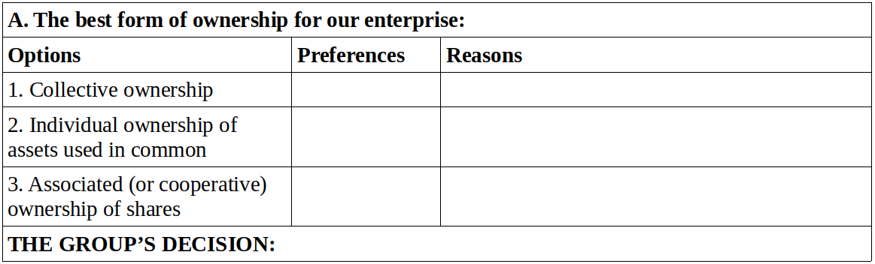
1. Taking turns, each participant shares their answers to Individual Activity 11, stating which option they think is best and giving their arguments and reasons. The moderator takes notes on the white board/flip chart, marking the preferences with a check and summarizing the arguments in the space provided.
2. Once all participants have shared their answers, there is a round of free discussion in which participants are encouraged to exchange opinions with the goal of arriving at a shared understanding of the theme. Once the group has reached consensus, the moderator records the group’s decision on the table noting the main arguments in favor.
Exercise #12
Defining the Criteria for Admission and Withdrawal of Members
Explanation
The criteria with respect to the contributions new members are required to make, and with respect to the rights of members to take their contributions with them when they withdraw should be coherent with the criteria related to the form of ownership. The adoption of criteria for admission and withdrawal of members is an important test of the validity and coherence of the criteria of ownership. Since the ownership criteria have been defined, it should be easier to establish the membership criteria; still it is important to make them explicit and to verify their coherence, or not, with the form of ownership.
The Flow
As in the previous exercise, tables are drawn on the white board or a flip chart.

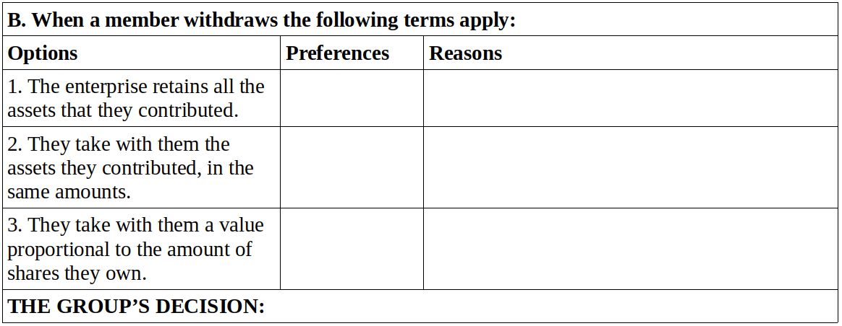
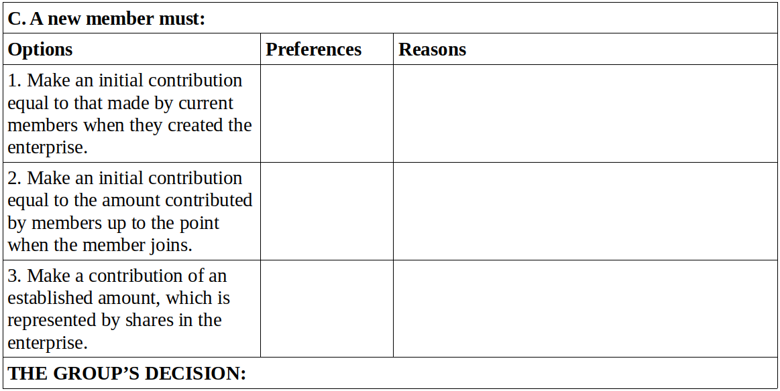
- Begin with the question of withdrawal of members. Taking turns each participant shares their answers from Individual Activity 11, stating which option they think is best and presenting their arguments and reasons. The moderator takes notes on the white board/flip chart, marking the preferences with a check and summarizing the arguments in the space provided.
- Once all participants have shared their answers, there is a round of free discussion in which participants are encouraged to exchange opinions with the goal of arriving at a shared understanding of the theme. Once the group has reached consensus, the moderator records the group’s decision on the table noting the main arguments in favor.
- Repeat the process for the question of admission of new members.

Individual Activity 12
Proposal for Organizational Criteria (II)
(to be done after completing Unit 12)
Do the preparatory task for Jornada #6, as indicated in the instructions.
Individual Activity:
This activity is similar to the one you did after the Eleventh Session, but in this case it is about the Management System and the relation between Governance and Management.
Each member of the group should reflect personally on the possible forms of organization with respect to governance and management and prepare their thoughts for presentation to the whole group. This will help the group develop its shared criteria which will be defined in Jornada #6.
To facilitate the Individual Activity people can use the following template, noting their preference with respect to each theme and option and noting their arguments and reasons in the space provided.
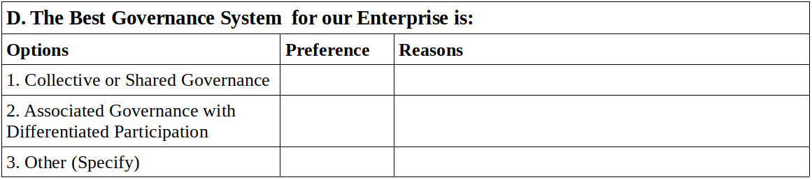
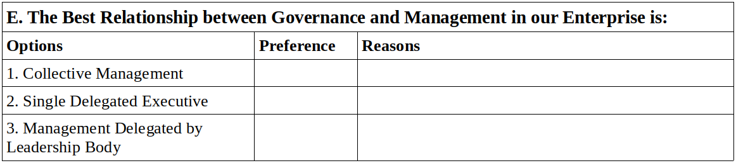

Jornada #6
Organizing the Enterprise (I)
What is this practical activity about?
In this Jornada the solidarity group begins the real process of organizing their enterprise. This means that what has up to now been only a Solidarity Group becomes a “Cooperative,” that is a collective subject constituting the owner of an enterprise in formation. As for the people, they go from being simple members of a group that is following a manual and pursuing a business project, to being members of an entrepreneurial project that they have decided to create together, each one making a series of economic contributions. But this status of “member” is still informal, not acquiring its full meaning until the group is legally established as a cooperative or association with its own legal identity.
The organization of the enterprise, as we have seen, includes five principal aspects. In this Jornada we will organize three key elements: the ownership structure; the admission and withdrawal of members; and the system of governance and management. The other aspects of organization will be studied in the next Unit.
Which aspects should be taken into account in carrying out this Jornada?
The concrete goal of this Jornada is to establish the structure of participation of members in:
a) ownership of the solidarity enterprise and its assets,
b) governance and management of the enterprise.
How this Jornada is executed and the degree of complexity involved depends on the decisions the group has made in Exercises 11 and 12, regarding the criteria to used in determining the ownership structure and the admission and withdrawal of members.
The explanation and planning of this Jornada proposed here corresponds to those cases in which the group has decided to adopt the criterion of Associated (or cooperative) ownership of shares of stock, which implies that the members who withdraw will have the right to take with them a value proportionate to the value of their shares, and that new members will make a contribution for which they receive a proportionate share of ownership of the enterprise in the form of shares.
NOTE: If the group has instead adopted Collective Ownership or Individual Ownership of Assets Used in Common, the process of organization is very simple, and the Jornada can be limited to specifying the implications of the chosen criteria and focussing on the question of governance and management.
What are the activities to be done in this Jornada?
There are three steps:
  - Preparation and planning.
  - Doing the assigned individual tasks.
  - A day (Jornada) of group work.
How to prepare and organize the Jornada
Just as in previous Jornadas the preparation and organization is done in the previous Session (#12), where the explanation is read, individual tasks are assigned, and the day of group work is organized following the instructions given below.
As the group has done several Jornadas already and is capable of proceeding efficiently, it is not necessary to go into too much detail. But this Jornada is different: here the group starts making binding decisions, that is people make commitments to shared projects, in accordance with the chosen form of organization. For this reason it is crucial that all the members who are involved in the creation of the enterprise be present and contribute to the decision-making process. Members who choose not to become members of the enterprise can still participate in the Jornada but should not participate in any decision-making by the people who will be the founding members of the cooperative.
What are the preparatory tasks? (group and individual)
The group should prepare well so that they can come to the Jornada with all the necessary information and clear ideas, prepared not only to make decisions as a group, but also to make personal commitments. The latter are made in the Individual Task which consists of completing the form Pledge of Personal Contributions to the Solidarity Association for the Creation of [name] Enterprise.
To complete the form, the following information should be available:
- Cost and Financing Budget
- Schedule of Possible Personal Loans
- Information collected in Jornada #4 “Deciding to Contribute”
- Each member’s “Personal Balance Sheet”
- Account of expenditures during this course.

What should members bring to the Jornada?
Each person or small group should bring a) a completed Pledge of Personal Contributions to the Solidarity Enterprise, with relevant supporting documentation, b) their answers to Individual Activity #12 on the forms of Governance and Management.
In addition:
- The group symbol, logo design, and business idea.
- All the materials from Exercises 11 and 12.
- All the materials and information from Jornadas 4 (“Deciding to Contribute Factors”) and 5 (“Cost and Financing Budget”).
- A flipchart.
- A large blackboard or other board.
- Plenty of index cards (10cm x 20cm) in six colors.
- Updated account information (personal and group).
How should the Jornada be done? What is the plan for the day of group work?
This Jornada is essentially a work session that can be done in about four hours, though the group may decide to add other activities that they think would be good to include.
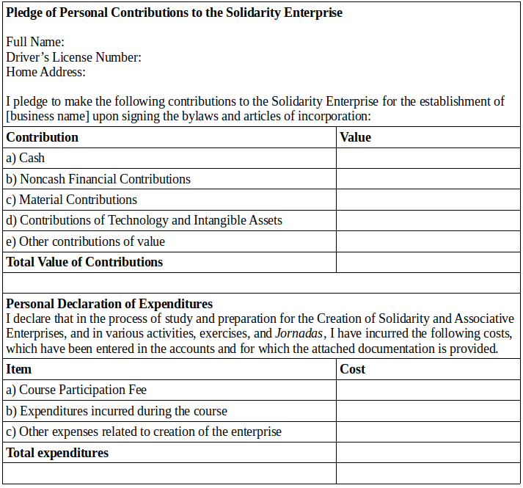
The Jornada follows this plan:
- Gathering, welcome, thematic game. Installation of the group symbol in an appropriate place. Selection of a moderator for the meeting, as well as a “canvas manager” (person who manages the bulletin board or display used in the activities), and a note-taker.
- Set up the materials from Exercises 11 and 120, as well as Jornadas 4 and 5.
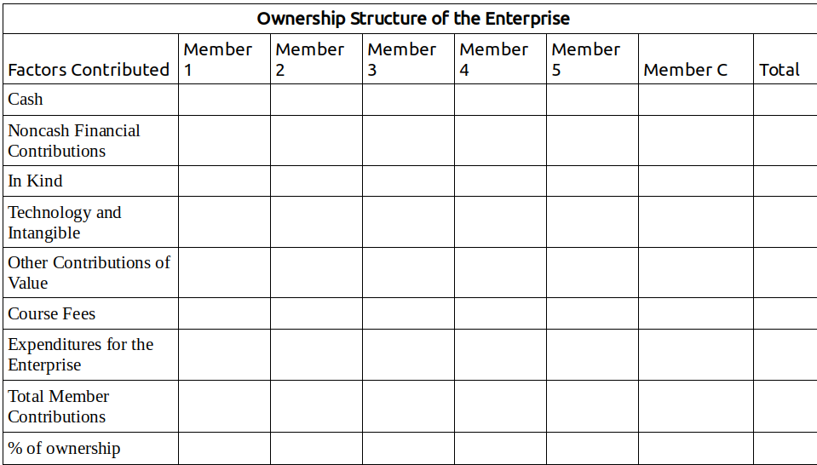
- Preparation of the canvas, using this layout:
- Activity 1. Determining Ownership of Enterprise Equity.
- Break and Snacks
- Activity 2. Defining the Criteria of Member Participation in Governance and Management of the Enterprise.
- Activity 3. Creating the Member Assembly.
- Activity 4. Assigning Responsibilities and Positions to Members of the Management Team.
Contents of Activity 1: Determining Ownership of Enterprise Equity
In this activity members define the ownership of the enterprise and its equity, specifying the percentage of ownership that each member will receive in the form of shares.
It is necessary to determine the total contribution each member will make to the establishment of the Solidarity Enterprise.
In addition to the contributions that each member pledges to make when the enterprise is formally established, the contributions they have made and expenses incurred up to this point, should also be considered and, where agreed by the group, included in the calculation of their contributions of value.
Note: in carrying out this activity there is a very special element, characteristic of the solidarity economy, which we represent in the form of a new member, a special member we can call “Member C.”
Member C is none other than the solidarity group as a group, that is the collective, the community, the source of the C Factor. The contributions of this member should also be recognized.
To determine the ownership share of each future member in the solidarity enterprise we need to quantify in money terms each person’s contribution, including that of Member C, and calculate what percent of the total contributions will be attributed to each person and to the collective person “C”.
Concretely, this is accomplished in five steps:
Step One: Estimating the contributions of “Member C”
As a contribution made by the solidarity group as such, we must account for and specify the contributions of Member C in each of the cells of the table above, first using colored index cards:
- The costs involved in carrying out this course (How to Create a Solidarity Enterprise) that the group ascribes to the collective itself and not to an individual member. Here it is important to recall that the value of the course and all the contributions made by members in relatively equal conditions throughout the course, can all be attributed to Member C. This is fair since the people who made those contributions did so with no expectation of recompense for their individual contribution but as a group effort with a profound solidarity content.
- The value of all the assets (materials, financing, tangible and intangible technology) that have been or will be received by the enterprise in the form of donations.
- All of the contributions of value received through relations of solidarity – barter, commensality, and cooperation.
- All assets that the group feels should be recognized as group property, over which no withdrawing member should have any right to compensation and which, for the same reason, should be shared with new members when they join the group.
Step Two: Information provided by each member regarding their respective contributions
Using index cards, the data for each member are collected, based on their Pledges of Personal Contributions.
Step Three: Recognition by the group of the value of the contributions made
The group analyzes the information provided by each member and proceeds to recognize the contributions already made and the value of the pledged contributions. Where information needs to be corrected, either because a member has over or understated the value of a contribution, the corrected numbers will be recorded on cards that will replace the originals. Naturally, the group will base their assessment of the value of each contribution on one set of criteria applied with the maximum of fairness and balance.
Step Four: Calculation of Percentages
The corrected and agreed upon numbers on the chart will be totaled, vertically and horizontally, in order to obtain the corresponding totals. The percentages will then be calculated, dividing the total contributions by the total value contributed by each member. The sum of percentages should equal 100% and the total value contributed should match the total value of the initial equity of the enterprise.

Step Five: Analysis and Validation of the Results
The result of the exercise may come as a surprise to some members, or to all. Most likely, the percentages of ownership will be very similar, with no major differences. Moreover, the contributions made by Member “C” will be a good reminder of their shared participation in the enterprise. But, in a given group, the differences between members may turn out to be bigger than expected.
Whatever the result, it should be analyzed, reflected upon, and finally validated by the group, with each member affirming their agreement with the result.
If not all members agree, the group should go back to the calculation of each member’s contributions to see if there are any errors. If there are none, members should be able to agree on the percentages of ownership. If the estimations of value and calculations are well done, the result should be transparent and just: each member’s contributions and corresponding share in ownership should be recognized by all. Nobody wins or loses at the cost or benefit of another member and all contributions made on a basis of equality, those attributed to Member “C”, have also been carefully calculated and recognized.
If, in spite of this, the group fails to achieve consensus, it will be because of a problem that lies somewhere else, that is, in the preliminary discussion of the criteria to be used in choosing a form of ownership. Perhaps the form chosen by the group was not actually embraced by all members. In that case, the group should re-do Exercise 11.
Contents of Activity 2: Defining the Criteria of Member Participation in Governance and Management of the Enterprise
Once the ownership shares in the enterprise have been determined and validated, it is time to take the next step and define the governance bodies that will run and enterprise and its general management. Activities 2, 3, and 4 are designed for that purpose.
In Activity 2 members define the criteria for participation of members in governance of the enterprise, following the same basic procedure as in Exercises 11 and 12:
a) Tables are drawn on a white board or a flip chart showing the three possible systems of governance and management of the enterprise as explained in Individual Activity #12. The moderator will record the preferences of each member and their reasons and arguments.
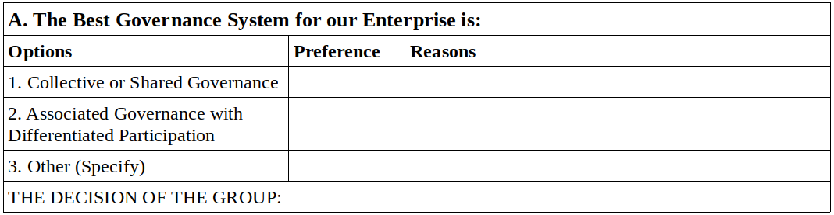

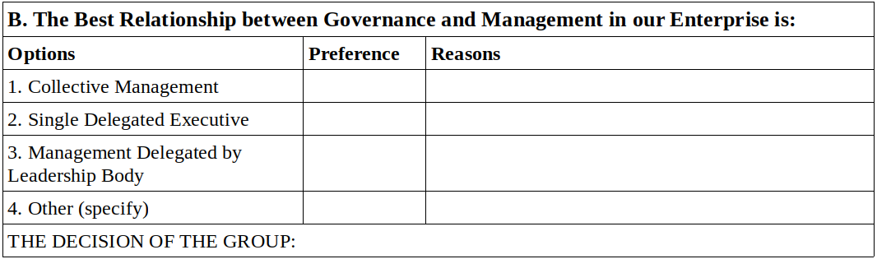
b) Taking turns, each participant shares their answers from Individual Activity 12, stating which option they think is best and giving their arguments and reasons. The moderator takes notes on the white board/flip chart, marking the preferences with a check and summarizing the arguments in the space provided.
c) Once all participants have shared their answers on the theme of Governance, there is a round of free discussion in which participants are encouraged to exchange opinions with the goal of arriving at a shared understanding of the theme. Once the group has reached consensus, the moderator records the group’s decision on the table, noting the main arguments in favor.
d) Repeat the process for the question on the best Relationship between Governance and Management.

Contents of Activity 3: Creating the Member Assembly
In this activity the group begins to form the Member Assembly according to the criteria and system chosen in the previous activity. At this point, the Assembly is still informal and provisional. Later on, when the Enterprise is established and the bylaws have been adopted the Member Assembly will need to be formally established in accordance with the specific procedures defined by the group. The fact that the Member Assembly is first formed as a provisional body will enable the group to begin functioning in a way that matches the type of organization chosen, and, based on the experience they acquire by doing so, make changes or amendments to the procedures and definitions when the time comes to formalize them.
If the group has chosen Collective Governance, the Assembly is formed with the equal participation of all members (“one member, one vote”), and the only thing to determine is if the Assembly will have a President, Coordinator, or other figure, and if other roles are necessary, such as Secretary, Treasurer, etc.
If the group has chosen the system of Associative Governance with Differentiated Participation, the Assembly is formed with each member having a weighted vote, proportional to their share of ownership of the enterprise. In this case, it is best to proceed based on the information obtained in Activity 1 of this Jornada, specifying the weight of each member’s vote . Based on this the group can then establish the roles deemed necessary, with each member voting. The decision is considered valid when a proposal receives more than 50% of the total votes cast.
As there is a wide variety of experiences of participation in Assemblies, in this activity the group should proceed according to the customs and procedures that seem most comfortable to them. What is important is that the activity conclude with a Members Assembly that is capable of functioning as the group goes ahead with the process of creating the solidarity enterprise up to the point when the bylaws have been adopted and the Members Assembly is officially constituted.
Contents of Activity 4: Assigning Responsibilities and Positions to Members of the Management Team
Once the Members Assembly has been created, its first task is to determine the form of management to be adopted by the enterprise, defining roles and positions with their respective responsibilities and powers. Finally, the Assembly will choose the individuals to fill those positions.
The Assembly proceeds according to the option chosen: collective management, delegated individual, delegated group.
It is important that the agreements reached in this activity regarding positions, powers, and the individuals named to positions be completely clear so that each member understands the implications and consequences of the decisions made and all members support the system chosen going forward.
It may be useful to record the decisions on a flip chart and have each member record them in their Course Notebook.
At the end of this Activity, the solidarity group may want to conduct some kind of collective celebration of the first Member Assembly (provisional) and the selection of representatives. This is a good occasion to have each member sign on to the commitments made and express to the group their feelings about the moment and their will to fulfill them.

UNIT 6 GLOSSARY
Distribution of Surplus
We understand “surplus” to mean the sum of monetary value available to the members after having subtracted total costs from the total revenue generated by the enterprise. The “distribution of surplus” refers to the use that is made of this money, whether it is paid out to members, reinvested in the enterprise, or held in a reserve fund of some kind, etc.
Economic Organization
The economic organization of an enterprise consists of the criteria and norms regulating a series of basic aspects of its structure and functioning: a) the form and structure of ownership, b) the treatment of the workforce, c) distribution of surplus, profits, or gains, d) regulation of the admission and withdrawal of members, e) the system of management and decision-making. It is through its economic organization that an enterprise constitutes itself as an association, in that participants become members who contribute factors, assume responsibilities among themselves and with third parties, establish systems and procedures of governance and management, and decide how surplus and profits are to be distributed.
Governance
The system and process by which the most important decisions are made with respect to the structural, strategic, and fundamental aspects of the enterprise in its organization and operation, and which assures that the enterprise functions in accordance with the criteria and in pursuit of the objectives that its owners, organizers, or members desire. Normally, the governance of a solidarity enterprise is exercised by its organizers and owners, united in a General Assembly, which is the highest body of the organization.
Increase in Equity
Any increase in the total value of the factors belonging to the enterprise, verified after the enterprise has been established and begun to function. Increases in equity can derive from new contributions by members, reinvestment of profits, donations received, amortization of debt, etc.
Initial Equity
The combined factors owned by an enterprise when it begins to operate, including the recognized value contributed by each member.
Juridical Person
A collective entity officially recognized according to the laws of the country or jurisdiction, made up of the members who organize the enterprise and, as a group and a collective, exercise rights of ownership and governance over it.
Management
The operational leadership of the enterprise, in its internal functioning and its relations with third parties and the market, aiming to achieve in the most efficient way possible the objectives previously defined by the owners or the organization that controls the enterprise. Normally in solidarity enterprises, management is exercised by members elected by the Members Assembly, to serve as executives or board members. These individuals hold powers that have been delegated to them by the Members Assembly and must periodically report to them on their success or failure in the achievement of the members’ objectives.

Organizing Model
An organizing model is a rational and coherent combination of criteria, norms, and procedures that that regulate the economic organization of an enterprise with regards to its ownership structure, governance and management systems, distribution of profits and losses, admission and withdrawal of members, and treatment of the workforce.
Ownership Structure
The form in which the members who create the enterprise establish their individual and collective rights over its equity. The ownership structure depends on how the members have made their contributions of factors, which make up the initial equity of the enterprise. If those contributions were made as donations or in the form of commensality, conferring no individual right to a percentage of ownership of equity, and renouncing any right to recover the value of the factor(s) contributed, the ownership structure has the character of collective or common property. If, on the other hand, member contributions take the form of valued equity contributions the corresponding form of ownership is associative or cooperative joint-stock.
Reinvestment of Profits
The reinvestment of profits consists of directing part of the enterprise’s profits to the purchase of new factors of production which become part of its equity.
Remuneration of Labor
All of the income (monetary and non-monetary) that people who work in an enterprise obtain in a given time, whether in the form of salary, wages, advances on expected profits, distribution of surplus, or other types of benefits, given in return for labor performed in the enterprise.
Valued Contributions to Equity
Those contributions of factors that members make to the enterprise, the values or market prices of which are attributed to the member as a percentage of ownership of the enterprise, expressed in units of value known as “shares.”

EVALUATION OF UNIT SIX
This evaluation is to be done both individually and as a group.
Individual Evaluation
Each participant should answer the following questions in their notebook:

A. Circle the answer that best matches your experience.
- My understanding of the contents covered in Unit 6 is:
Weak – Good – Excellent
- My performance of the individual assignments in this Unit was:
Weak – Satisfactory – Very good
- I consider my contributions to the group exercises to be:
Poor – Adequate – Outstanding
- My participation in the organization and execution of the Jornada was:
Passive – Relatively active – Very active
- I think my overall contribution to the group was:
Very little – Could have been better – Ample
B. Reflect on the following questions and summarize your answers in writing.
- Do I believe that the criteria of economic organization that we agreed on with respect to the ownership structure, the admission and withdrawal of members, and the systems of governance and management are the best ones for our enterprise?
- Am I satisfied with the decisions we made as a group with respect to the percentage of my share in the ownership of the enterprise? What about the ownership shares of the other members?
- Do I believe that we organized the Members Assembly correctly? Did we make good decisions regarding the positions and powers of representatives? Did we choose the right people for the positions?
Group Evaluation (to be done in the next session)
Seated in a circle, the whole group discusses the following questions.
- Did we create a good organization in terms of the ownership structure of the enterprise? Were our valuation of members’ contributions fair? Did anyone benefit or loose unfairly?
- Did we organize ourselves in the best way for governing and managing our future enterprise? Is the Members Assembly properly organized? Did we efficiently establish the positions and powers?
- If serious doubts arise in response to the first two questions, the group should ask itself: are there aspects of the decisions we have made regarding the organization of our enterprise that we should improve, correct, or even change?

UNIT VII
ECONOMIC ORGANIZATION OF THE ENTERPRISE (2)
Remuneration of labor and distribution of surplus
Session 13
Plan
- Gather, welcome, ice-breaker, form a circle, choose a moderator for the meeting.
- Evaluation of Unit VI.
  - Each participant reads aloud their answers to the individual evaluation form from Unit VI.
  - Carry out the group evaluation as described in the group evaluation form from Unit VI.
- Break, snack.
- “Reading Seven.” (One or two people read out loud as others follow along in the text.)
- Questions for review and discussion. (Participants volunteer to answer one question each, raising their hands to speak. Other participants can add to their answers but it is best if nobody speaks twice before others have had a chance to speak.)
- Questions for the facilitator, exchange of ideas and free conversation on the theme.
- Suggestions for the Individual Task. (The facilitator will explain the content and purpose of the individual task, clarifying any issues and answering questions that come up.)
READING SEVEN
Having considered what the group members bring to the enterprise, the factors of production they contribute, their effort, labor, varied understandings and creativity, we now arrive, finally, at the question of their compensation for the contributions they have made and the work they have done: how will the enterprise compensate its workers and members? The last two elements of the economic organization of an enterprise are the ones we mentioned in the previous reading: Remuneration of Labor and Distribution of Surplus. Our task now is to determine, theoretically, which criteria are best suited to a solidarity enterprise and later resolve the practical questions regarding the application of these criteria to the enterprise, adapting them to the concrete conditions of the Solidarity Group.
The Remuneration of Labor
This is a decisive question for a solidarity enterprise because labor is the principal factor that its creators and members invest.
Now, when we analyzed the factors of production we saw that in solidarity enterprises the labor factor should be treated as an internal, not external, factor, to be remunerated not through a contractual set salary or wage but through the distribution of surplus or profits generated by the enterprise. Based on this criterion, remuneration of labor is not established as a fixed amount, but as a percentage of the surplus generated. If the enterprise earns more revenue, the payment to labor is greater, and if its revenue declines, workers have to make do with what they have managed to produce.
We said that the problem this system presents – the fact that workers need income on a regular and more frequent, typically monthly, basis (distribution of surplus is often done at the end of the year) – can be resolved by establishing monthly payments to workers known as anticipated distributions of the surplus reflected in the annual financial statement.
But the principal problem when it comes to remuneration of labor is not the way it is conceptualized (in reality, if set salaries were established they would have to be deducted from the earnings and the end result would be the same, the only difference being a greater uncertainty for the enterprise and more difficult accounting). The most important thing is to establish how much of the total surplus to distribute, based on the work each worker has done for the enterprise.
There are three possible criteria:
Option 1: “everyone is paid the same.”
Option 2: “to each according to their needs.”
Option 3: “to each according to their work.”
Which is most just? Which expresses the deepest solidarity? Which is most efficient? Let us see.
Option 1
In this case all members receive the same payment for their work, even if some work more than others, and even if members have different needs. “All members are equal” seems to be a criterion of justice and solidarity, but in fact it is not. How can it be just that all receive the same amount with no consideration of the needs of each individual or the work that they contribute? Should a dedicated worker with a large family to support get the same amount as a lazy worker who lives alone? Is that solidarity? A system in which all workers receive the same pay would only make sense if all workers did the exact same work, or, if not, if they rotated positions frequently; but it is easy to see that in this case the actual principle at work would be “to each according to their labor,” resulting in equal pay for all.
Option 2
In this case, payment varies with the greater or lesser needs of each worker and not the amount of effort each makes. “To each according to their needs” seems clearly to reflect a spirit of solidarity, but in reality it is unjust and, if we examine it closely, lacking in solidarity as well. Moreover, it is inefficient because it removes a stimulus for doing work of high quality and efficiency. On the contrary, this criterion stimulates the expansion of needs regardless of what the worker does to meet them. Nonetheless, this criterion can be applied in some cases in which the group bond is so strong that each member feels the needs of the other as their own, and the well-being of the group depends directly on the satisfaction of each member’s needs. In a family, for example, or an intentional community in which many goods and services are shared and many needs are met in common. It may also be suited to situations where the principle objectives of the solidarity group are social, cultural, or of shared utility, and the generation of profits to be distributed among the worker members is of little importance.
Option 3
To each according to their work signifies that payments are based on the quality and time of the labor each member performs, in other words, productivity: payment depends directly on the contribution made by each worker to the generation of surplus. This criterion is efficient, since it stimulates each worker to make a greater effort. It is also fair, in that each is paid based on their contribution. But does it meet the criterion of solidarity?
This is an interesting point because it raises another very important question: what is the relation between justice and solidarity? A full treatment of this would require a long exposition. We will limit ourselves to making three assertions, which we offer up for the group’s reflection.
First assertion: something can be just but not have the character of solidarity.
Second assertion: that which is unjust can not make for true solidarity.
Third assertion: it is the role of solidarity to correct injustice and make justice more perfect.
If we apply these three assertions, the first step would be to establish a system of payment that is just. In a spirit of solidarity, we can not accept that which is unjust, and have to correct any injustice. So, the first principle is “to each according to their labor” recognizing the productivity of each person, their effort and skill, and the contributions they make to the generation of profits for the enterprise.
But while this is a necessary condition for a solidarity enterprise, it is not sufficient. Though it might be just, does it amount to solidarity in remuneration of labor? It could lead, for example, to excessive differences between members, based on opportunities for professional training that some had but not others, or a situation in which privileges matter more than the will and effort of each person. The members need, then, to find a way to use solidarity to correct that which remains unjust and perfect that which is just, without negating the principle of paying each worker according to their performance and productivity.
Can the enterprise provide training opportunities to less qualified workers, in order for them to gain skills and thus raise their productivity and earnings? This would be an application of solidarity to the problem of unjust socio-economic differences.
Can the enterprise establish a solidarity fund, with proportional contributions from all members, with which to meet certain needs for which the income some workers earn is insufficient? This would be a case of perfecting a just payment system by infusing it with solidarity.
Each group has to think about how to resolve this equation, establishing a form of labor payment that is just, efficient, and demonstrates solidarity. We will come back to this theme; and later, in the exercises for this Unit, we will see how to apply these general criteria in practice.
But first we need to consider a more general question that arises from what we have said so far: if labor payments should be considered distributions of surplus, what is this surplus? How much of it should be used to remunerate labor? How much should go to other factors or to reinvestment in the enterprise for growth or improvement?
What is surplus and how is it calculated in a solidarity enterprise? Is it the same as profits?
We need to make a conceptual distinction between “surplus” and “profits.” Until now we have used the terms interchangeably but at this point we need to specify, based on our understanding of the nature of solidarity enterprises.
In solidarity enterprises, the concept of surplus is used to describe the result of the total revenues in a given period (usually a year), minus the total costs paid to third parties (outside the enterprise), such as fixed costs, rents, financing costs, raw materials, salaries for workers who are not members of the enterprise, payment of debts, taxes, etc. Surplus refers to the value left over, which belongs to the enterprise and its members and can be used to compensate the internal factors of production and for growth of the enterprise’s equity.
To calculate the surplus one simply subtracts from the total annual revenues all costs paid for external factors and any expenses that represent transfer of money to entities outside the enterprise. Thus surplus includes payments for labor done by members, whether paid as anticipated distributions or in fact paid at the end of the year. It also includes the money dedicated to reinvestment in the enterprise such as purchase of machinery, technological improvements, amortization of debt, inventory of supplies and products, etc., anything that implies an increase in equity for the enterprise. This also includes the payments to members as recompense for their contributions of capital or other factors.
In practice, in a solidarity enterprise, surplus is not so different from profits but we will use the term profit only for current accounts as normally calculated, which is also the basis on which taxes are calculated. The main difference between profits and surplus, understood this way, is that to calculate profits one must also subtract labor payments and distributions to members. This concept of profit is useful for comparing the efficiency of a solidarity enterprise to that of capitalist enterprises which, obviously, do not include labor costs as part of profit.
Having defined surplus and profit in this way, the question is how to distribute surplus among the members of a solidarity enterprise.
Distribution of Surplus
This is the final and most complex aspect of the economic organization of an enterprise. We need to apply here the criteria of justice, solidarity, and efficiency and adapt them to the characteristics of the enterprise we are creating.
We have already taken a big step, defining the key criterion for payment of labor as “to each according to their work.” This criterion gives us the general pattern for distribution of surplus which is distribution to each in proportion to their contributions to the enterprise.
All factors contributed by members should be remunerated, not just labor, but financial contributions, materials, technology, management, and also the C Factor. Surplus should be used to recompense all factors and each member will receive a percentage of the surplus corresponding to the percentage of the factors they have each contributed to the enterprise.
The issue is determining the proportions in which each factor will be remunerated and then to see how much surplus goes to each member, according to the contributions they have made. Although it is not easy to understand and apply, it is fundamental that we understand this approach clearly and apply it rigorously: what is at stake is as much the special logic of the solidarity economy (the character of the solidarity enterprise) as the efficiency of operations, which depend on these criteria.
Remember, first of all, that each enterprise has its “theorem of defined proportions,” a particular combination of the six productive factors. This is important because the surplus generated by the enterprise should be distributed to each factor according to the specific proportions in each enterprise, according to its “theorem.”
We have already defined the “theorem” of our enterprise, not just in general or theoretical terms, but concretely: we know the quantity of each of the six factors to be employed. To determine the proportion of the surplus to be used to compensate each factor we need to know their productivity. This theme raises tricky theoretical questions that we will not address here, instead we will approach the question simply and pragmatically based on signals and indicators that we receive from the market. In effect, the market assigns prices to each factor based on its average productivity, the contribution that factor can be expected to make to enterprises. While such prices can be distorted, in practice they are the prices at which members of the solidarity enterprise can obtain or sell factors to other enterprises.
So, to determine the proportion of surplus going to each factor, we sum the market prices of each factor, then divide the price of each factor by that sum, giving the proportion in which each factor should be remunerated in the distribution of surplus.
But as the market does not operate according to the logic of solidarity economy, we need to make two adjustments:
1) We need to adapt to the market by simplifying the information about the value of factors, reducing them to two basic factors for which the market sets clear prices: labor power and capital.
2) At the same time we need to correct the market, adding a special remuneration for the C Factor, which the market ignores and does not value, but we know to be essential to the success of a solidarity enterprise.3
So we have to resolve three things:
1) How much of the surplus should go to compensate labor?
2) How much of the surplus should go to compensate capital?
3) How much of the surplus should go to compensate the C Factor?
The Remuneration of Labor According To Professional Qualifications And Management Roles
We begin by returning to the remuneration of labor, which we have partially addressed, adding a question: is the labor of an engineer more productive than that of an unskilled worker and should it be better paid? If so, why? Why is the labor of a department head considered more productive and better paid than that of a worker in the same department? In general, why are the contributions of workers with professional training considered more productive than those made by less skilled workers?
These questions may seem obvious but they point to a reality with which is familiar but should be questioned.
The labor power that an engineer or department head (more generally a professional and highly skilled worker) brings to the enterprise incorporates important elements of other factors, mixed together in the same person: in this case elements of technology and management. Said differently, three factors are present in the contribution that each person makes to the enterprise: labor power, technology, and management, and they are exercised simultaneously. The productivity of a member, or their contribution to the enterprise, is determined not just by their labor power but by the technology and management their work includes as well. So the different rates of pay or salary that workers typically receive in an enterprise, based on their skill levels and the degrees of management responsibility they take on, reflect in fact their contributions of three combined factors.
Based on the information we get from the market regarding the remuneration of labor power (which in fact includes elements of technology and management), we can determine jointly the proportions of surplus that go to each member based on their contributions of labor, technology, and management. Jobs with a higher technological content, or positions with greater management responsibility, will be recognized for their greater contribution to the enterprise and obtain a higher percentage of the surplus. We will do the specific calculations in the Exercises and the Jornada for this Unit. For now, on the level of theory, the key is to understand that we will determine the contributions of these three factors jointly based on the information provided by the market as to the normal levels of remuneration assigned to people based on skills, training, and the roles and responsibilities they assume.
The Remuneration of Capital According to the Amount Contributed by Each Member
As for the remuneration of capital, we use the same criterion: the information provided by the market. But we need to understand clearly what we are doing and why; it is crucial that we be convinced and sure that what we are doing is just and done in a spirit of solidarity and is not used as a cover for any form of capitalist exploitation.
First of all, we need to be clear about what capital it is that we are talking about. We are not referring to external financing that we obtained through borrowing. The payment of that debt is a cost for our enterprise and has to be paid as agreed with the agreed rate of interest and timeline. When paying these costs we are not distributing surplus but bearing the costs of borrowing, even if the loans were made by friends, family members, or even a member of the enterprise.
When we talk about remuneration of capital we are talking about the enterprise’s own capital, members’ financial contributions and the monetary value of the materials of production and other factors they contributed, individually or as a group, that are now property of the enterprise. We calculated the monetary value of the factor contributions made by each member so we know the total amount of this capital as well as the amount contributed by each member. What we need to specify now is what portion of the surplus generated by the enterprise will go to remunerate these capital contributions.
You may have heard of the old principle of cooperativism “limited interest on capital.” This principle signifies the intention to pay capital as little as possible. We reject this principle. We will forget it, ignore it, and not apply it, for two reasons: 1) because it is unjust, and 2) because it is inefficient.
The idea of paying capital as little as possible comes from the notion of capital as an external, hostile, force which threatens to subordinate and oppress us.5 This is true of capitalist firms but not solidarity enterprises. In a solidarity enterprise the members of the solidarity group themselves contribute capital which remains under their collective control. Their capital is the result of the effort and sacrifice made by members of the solidarity group on behalf of their enterprise. When a member contributes capital to the enterprise they are sacrificing other needs that could be satisfied with those resources or that money. They are contributing savings accumulated from their previous labor, not alienated labor they accumulated by exploiting others. The contributions of capital made by members deserve fair compensation. Above all they need to be properly valued: not only are they contributing their own accumulated labor and sacrificing other consumption and satisfaction of needs, but they are doing this for the benefit of the solidarity enterprise for which they are taking a risk. In effect, if the enterprise fails to generate the expected surplus, or is inefficient, the members risk losing everything they worked so hard to have. For this reason, it is right to provide fair compensation for these contributions of capital.
Moreover, if we do not compensate this capital fairly it will be more difficult to obtain. Our enterprise will never have much capital, our labor will not bear the expected fruit, and the operation will be inefficient. It is just to provide members fair compensation for the capital that they contribute. It is evidence of solidarity and it is efficient. The question is: how much of the surplus should go to compensate members for their capital contributions?
Again we can use the criteria of the market: what is the cost of capital in the market?
In the market, capital has two prices, the acquisition price and the borrowing price. The acquisition price is the interest rate that banks pay depositors. The borrowing price is the interest rate that banks charge borrowers. Which price should we consider when calculating the value of the capital contributed to the enterprise by members? The answer depends on how we look at it, from the standpoint of the member or from the standpoint of the enterprise. In one case, the member benefits at the expense of the enterprise, in the other, the opposite occurs. The simplest solution, and the fairest, is to take the average of the two prices. If the rate of acquisition (interest paid by a bank for deposits), is 1% and the lending rate (interest charged on loans, is 2%), a fair rate would be 1.5%. This is good for the member since they are earning more than they would have had they deposited the money and for the enterprise since they are paying less for capital than they would if they borrowed the money from a bank.
But watch out! We are not assigning fixed values, payments of predetermined sums, any more than when we set the payment for labor by the standard salaries set by the market. In both cases, the criteria we take from the market are only used to establish proportions of the surplus to be distributed to labor and capital.
We will learn how to calculate these proportions in practice in the Exercises and the Jornada for this Unit. For the moment what matters is just to understand the problem theoretically. And it is fairly simple:
1. You add up the values of the monthly payments that members would be paid in the market for the jobs that they do in the enterprise, resulting in a monthly total payment to labor.
2. You add up the value of all the valorized equity contributions made by the members, which constitute the capital belonging to the enterprise, and apply to that amount the monthly interest rate obtained by averaging the acquisition price and the borrowing price, which gives you a monthly payment for capital.
3. You add the two monthly payment amounts and calculate the percentages of the total for each amount which correspond to the proportions of the surplus that go to labor and capital, respectively. (Remember that both the labor and the capital we are discussing here are contributed by members.)
4. You then calculate the percentage of surplus distribution that goes to each member, according to their particular contributions of labor and capital.
What about remuneration of the C Factor?
We already know that in addition to the factors that we gathered under the main categories Capital and Labor, in a solidarity enterprise a third main factor is at work, making a relevant and indispensable contribution to production: the C Factor. In capitalist enterprises, too, the C Factor is present and contributes to production, but it goes unrecognized not to mention uncompensated.
In the solidarity economy, on the other hand, we recognize the C Factor as an essential factor that needs to be stimulated, kept alive, cultivated, and always maintained for its contribution of solidarity. It is often said that over time solidarity enterprises lose their initial mystique, the power of unity and solidarity that they had at the start. I believe this is closely related to the lack of recognition and compensation of the C Factor and failure to constantly stimulate its development. This is why we call attention to the C Factor, so often forgotten, even in the solidarity economy. We also include it in the calculation of the distribution of surplus in our solidarity enterprise.
So, if the C Factor is entitled to a portion of the surplus to be distributed, how much should it receive?
Here the market is of no help, because this factor is not valued or paid for on the market. We have no choice but to determine its price in our group, using our own criteria. The proportion of the surplus that we assign to the C Factor will vary with our appreciation of its importance in our enterprise relative to capital and labor. If the investment in capital and labor is very slight, we will assign a greater proportion of the surplus to the C Factor. If, on the contrary, the enterprise operates with a lot of capital and many workers, it may be appropriate to reduce the percentage of the surplus going to the C Factor.
The most important consideration is the quality of the C Factor. When we introduced it in Unit One, we noted that various studies of capitalist enterprises had shown that productivity could be raised up to 30% by improving internal relations, and that in solidarity enterprises it could be raised even higher, the C Factor being the principal factor determining the success or failure of an enterprise. As there can be wide variations in the strength of internal cohesion in a group, resulting in greater or lesser productivity of the C Factor, we urge each group to assign a percentage that takes into account as much the quantity of capital invested and the number of workers in the enterprise as the degree of unity of will and commitment to shared objectives. In any case, as a suggestion, and basing ourselves on the old cooperative practice of reserving 20% of the surplus for cooperative education and the cultivation of participation, we believe it is reasonable to assign to the C Factor between 20% and 30% of the surplus generated by the enterprise (no less than 10% and no more than 40%). Less than 10% and you run the risk of weakening the logic of solidarity, over 40% risks harming the efficiency of the enterprise in the market, by undervaluing the productivity of labor and invested capital.
Obviously, having determined the percentage of surplus to dedicate to the C Factor, the remaining surplus should be divided between the other factors, in proportions we have already shown how to determine. In other words, 100% of the surplus goes to these three factors: Capital, Labor, the C Factor.
Naturally, the portion of surplus going to the C Factor is not distributed directly to individual members but to the solidarity group, the collective of worker-members. It can be used to develop group activities, recreation, education, communication, etc., anything that helps increase and improve the group’s sense of solidarity. Part of the money can be used for solidarity by covering needs in case of health emergencies or other crises that can affect members, or to reward and encourage certain behaviors and qualities in members (a prize for the best member, bonuses for commitment to the enterprise, etc.). Finally, the money could also be reinvested in the enterprise, increasing the portion of equity owned by the group, assigning the group corresponding shares in the enterprise.
Having defined in this way the percentages to be distributed among the members and to the solidarity group as a collective, for their contributions of labor, capital, and the C Factor, we need to address a final question concerning the assignment and use of surplus:
How is the distribution carried out, given that it may be in the interests of the enterprise and the group to re-invest some of the surplus in the enterprise?
The question arises because we calculated the surplus by taking the total annual revenues and deducting only payments made or owing to third parties for external factors, based on the concept of surplus we have defined as proper to solidarity organizations. Thus, the surplus includes payments to members for their labor, whether paid monthly as anticipated distributions or distributed at the end of the year. It also includes money which is to be reinvested in the enterprise, for example by purchasing new machinery, technological improvements, amortization of debt, inventories of supplies or finished products, etc., which imply some increase in the equity of the enterprise or the factors in its possession. The question, then, is how to assign to individual members and to the collective that part of the surplus to which they are entitled but can’t be distributed in money form since it has already been reinvested in the enterprise or will soon be?
We need to be clear that, in the first place, the decision about how much to distribute to members in money, how much to invest in the enterprise, and how much to spend on activities that benefit the group, has to be made by the Member Assembly. This decision is made, definitively, when the Assembly approves the balance sheet and the income statement for the year and the budget for the next year. The only criterion here is what makes sense for the enterprise, the interests of the members, the needs they face from the market. Nonetheless, as a kind of guideline for evaluating the health and equilibrium of the enterprise and the decisions to be made, it may be helpful to think in terms of a certain balance between the product of each factor and that which the factor is due, based on its remuneration, i.e.:
- The money which is distributed to members should not differ too much from the amount that is assigned to remunerate the labor factor.
- The money invested in the enterprise should not differ too much from the amount assigned as remuneration to capital.
- The money spent for the benefit of the group and on solidarity activities, internal and external, should not be too different from the amount dedicated to remuneration of the C Factor.
As to the mode of distribution, based on the criteria we have examined, it is clear that all the money reinvested in the enterprise, and thus implying an increase in the equity, should be reflected in the ownership structure. Members will see their shares rise or fall at the end of each year according to the amount that they are due to receive (in accordance with the factor contributions they have made). Concretely this is expressed in the issuance of shares and their assignment to individual members. We will see how this is done in the Exercises and the Jornada of this last Unit of the Manual.
So we reach the end of the manual which has led us to the understanding that in solidarity enterprises every contribution and every remuneration is proportional. Economic justice is found in this proportionality, as is the great efficiency of this type of enterprise. It is due to this principle of proportionality that solidarity enterprises are so resilient in times of crisis, automatically adjusting when surplus falls and never taking on losses that lead to bankruptcy.
We have also understood that it is due to the application of this same criterion of proportionality that solidarity enterprises stimulate to the maximum the factor contributions of members and increase their productivity. Remuneration is proportional to contributions: every new contribution, every effort, every innovation is soon recompensed, and there is no fear that one’s contributions and the good they do to the members and the solidarity group will go unrecognized or that someone else will unjustly appropriate that which one has contributed.
In this way we conclude the theoretical part of this manual much as we started it. We began by showing how the principle of solidarity which takes material form in the C Factor is the great force of efficiency that drives solidarity enterprises. And we end by showing how the principle of justice translated into criteria of proportionality is the other great force for efficiency that makes the solidarity enterprise grow and develop. Solidarity, efficiency, and justice are the three pillars of solidarity economy, upon which successful solidarity enterprises are built.
So we have completed our study of the concepts and theoretical criteria that need to be kept in mind and applied to the creation, organization, and operation of a solidarity enterprise. If we understand it well, and if we carefully apply what we know, we can rest assured that we are constructing our enterprise on firm ground and not shifting sands.
Questions for Review and Discussion #7
The following questions should be answered individually, in writing. Each participant will later share their answers during the group work, allowing for evaluation and correction of the answers by comparing them with the answers of other members followed by discussion.
- Why, in solidarity enterprises, are members paid a proportion of surplus for their labor instead of fixed salary?
- How should the enterprise resolve the problem that members need to be paid regularly, at least monthly, but the surplus is only calculated at the end of the year?
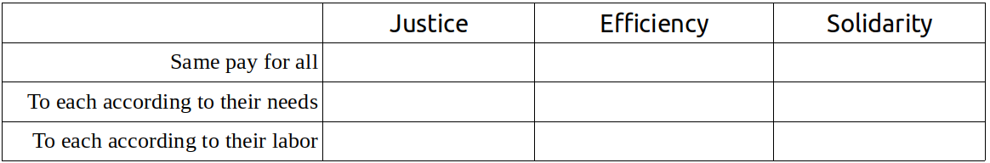
- Check the box for each criterion that applies to the three remuneration systems that can be used in a solidarity enterprise:
- Why do we say that something unjust can not have the character of solidarity? How does solidarity correct injustice and improve justice?
- What is surplus in a solidarity enterprise? How is it calculated? Is surplus the same as profit?
- What is the main criterion that defines the general pattern of distribution of surplus in a solidarity enterprise?
- Why, in a solidarity enterprise, should capital be remunerated according to the same principle as applied to labor? Why is providing adequate compensation for capital an expression of justice and solidarity?
- How do you we explain the fact that the labor of an engineer is more productive and better paid than that of an unskilled laborer? Why is the labor of a department head more productive and better paid than a regular employee in the same department?
- Why do we use market prices of capital and labor as a reference when determining the proportions in which each factor should be remunerated in a solidarity enterprise?
- Why do solidarity enterprises also remunerate the C Factor? How do you determine the proportion of surplus that should go to remunerate the C Factor? Who receives the share of surplus assigned to the C Factor?
- How, in what form, do members receive their share of the value of the surplus that is reinvested in the enterprise?
- Who decides, and at what moment, how much of the surplus is distributed in money form to members, how much is reinvested, and how much is spent by the group?
- What criterion can we use to evaluate if we are wisely balancing our distributions of surplus between these three uses? (see prior question)
INDIVIDUAL TASK #13
To be done after the thirteenth session
- Study the Glossary at the end of Unit VII.
- Answer the “Questions for Review and Discussion #7” in writing in your notebook.
- Individual or Small Group Activity: Exploring Pay Structures in the Labor Market.
Individual or Small Group Activity:
Exploring Pay Structures in the Labor Market
In this activity, group members collect information about salaries and other remuneration for labor in enterprises of a similar size and type to their own, including differences in pay based on professional level, skill, and roles and responsibilities. This information will be used as a reference for determining the percentages of surplus to be distributed to members of the solidarity enterprise based on their different jobs and positions of responsibility. Members of the group should obtain as much information as possible, according to the type of enterprise and its area of activity. To the degree possible they should obtain complete pay schedules from businesses to the one they want to create, or businesses that are different but can still serve as a reference for the solidarity enterprise. It should be remembered that proportions are more important than amounts, so it is important to collect complete data about the whole pay structure in a given enterprise and not just data about particular jobs.
Each person or small group will organize the information collected in their notebooks such that it will be easy to share and analyze with the group.

Session 14
Plan
- Gather, welcome, thematic game, form a circle, choose a moderator for the meeting.
- Reading and commentary on the answers to Questions for Review and Discussion #7. (If the group is large, each participant will read only one or two responses.)
- Exercise #13. Determining the Pay Schedule.
- Break, snack.
- Exercise #14. Calculating Percentages of Surplus to be Distributed to Members for their Labor.
- Assignment of Individual Task.
- Reading and Organization of Jornada #7: “Organizing the Enterprise (II)”

Exercise #13
Determining the Pay Scale
Explanation
The worker-members of the enterprise carry out different jobs, each requiring specific skills and varying degrees of management and leadership responsibility. Because each job makes a different contribution to the enterprise they deserve different levels of remuneration. So it is necessary to determine the percentages of the surplus to be distributed to the different members as workers (that is, according to the work they do in the solidarity enterprise). Following the criteria we described above, they should take as a reference the rates of pay (salaries and wages) that apply to similar jobs in the market. We need, then, to create a pay scale for the various jobs that will be done in our enterprise. In this exercise, we will stick to establishing a pay scale for the different jobs and positions, assuming that each is done full time, without yet considering who will do the job nor how much time will be dedicated to each one.

The Flow
1. Prepare the white board or flip charts with this table:
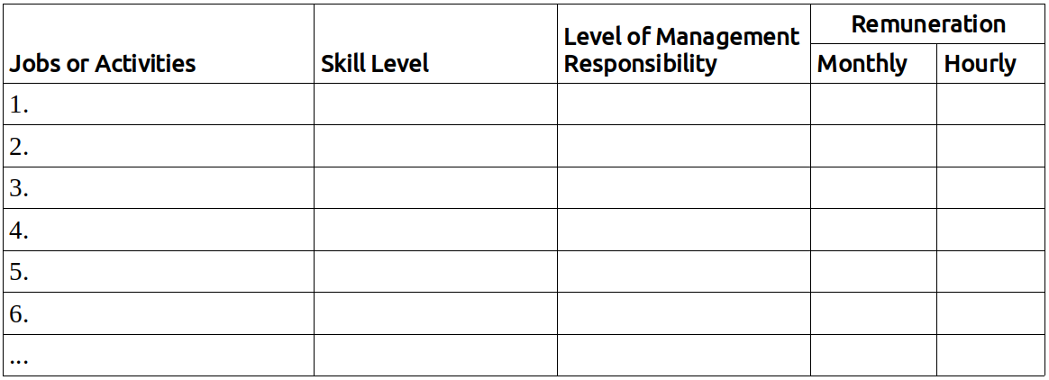
2. In the column, “Jobs and Activities” write the different jobs and/or labor activities that need to be done in the enterprise and will be done by members.
3. In the column, “Skill Level” there are three levels:
a) Unskilled (not requiring special study or training)
b) Technical (requiring technical study or specialized experience)
c) Professional (requiring university study or higher education)
4. In the column “Level of Management Responsibility” there are also three levels:
a) No management responsibility
b) Medium responsibility
c) High responsibility
5. In the column “Monthly Remuneration” note the salary or wage paid for each type of work or activity in businesses of similar size and type, as well as the levels of skill and responsibility. Base these figures on the research done in the previous Individual or Small Group Activity.
6. In the column “Hourly Remuneration” note the hourly pay rate, which can be obtained by dividing the monthly figure by 200 (the approximate number of hours worked in a month).

Exercise #14
Calculating the Percentage of Surplus to be Distributed to Members for their Labor
Explanation
In this exercise the remuneration to be received by each worker-member will be established, based on the prevailing pay rates in businesses of similar size and type. Later, based on these figures, we will calculate the percentages (%) of surplus to be distributed to each member in accordance with their contributions of labor. As each worker-member may do more than one job, or may hold more than one position of management or leadership responsibility, the numbers of hours (per week) dedicated to each job or position need to be estimated. Later we will convert them into percentages of a full work day (based on a 48 hour work week). It is clear that later, in the exercise in which we calculate the percentage of remuneration for each worker-member, we will discount days and hours not worked.

The Flow
1. As in the previous exercise, a canvas is drawn on the white board or a flip chart:
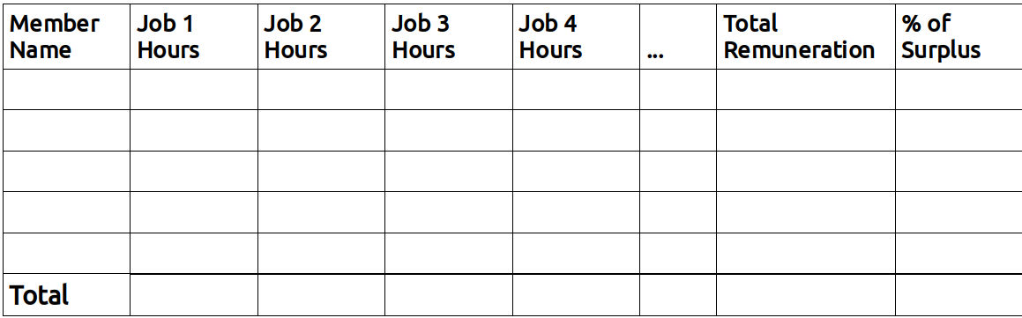
2. Write the names of the worker-members and note the hours worked by each person in the various jobs defined in the previous exercise.
3. Multiplying the hourly value for each job by the number of hours worked, determine the amount of money that would be paid to each worker based on the standard market value.
4. Based on the total value of remuneration owed each worker, calculate the percentages of distribution of surplus to which each member is entitled, given their labor contributions.

Individual Activity #14
Research on Interest Rates Charged in the Financial Market
(to be done after completing Unit 12)

Do this as preparation for Jornada #7, as indicated in the instructions.
In this activity members visit banks to inquire about the interest paid on deposits and the loans, pretending to be potential customers. The amount to be borrowed or deposited is the total value of the capital owned by the enterprise, as calculated in Jornada #6. The members should organize themselves, dividing up the various banks to be visited, such that different members will visit each bank, one pretending to be a potential borrower, another a potential depositor. The information can usually be obtained by reading leaflets or displays in the bank, or on the bank website, but it is important that the members do this in person, especially those members who have never sought business loans, learning in this way not just the interest rates but the conditions required of borrowers. On top of the experience to be gained, it may turn out to be useful for future negotiations they do on behalf of the enterprise, enabling them to obtain more precise information, since the interest rates can be personally negotiated depending on the amount of money involved.

Jornada #7
Organizing the Enterprise (II)
What is this practical activity about?
This is the final Jornada to be done as part of this course on creating solidarity enterprises. There are three tasks:
a) Organize the system of distribution of surplus.
b) Do an individual and group evaluation of the seventh Unit.
c) Understand the Final Projects of the course and prepare to carry them out.
How to prepare and organize the Jornada
Just as in previous Jornadas the preparation and organization is done in the previous Session (#13), where the explanation is read, individual tasks are assigned, and the day of group work is organized following the instructions given below.
As the group has done several Jornadas already and is capable of proceeding efficiently, it is not necessary to go into too much detail. As in Jornada #6, the solidarity group will make binding decisions of great importance for each worker-member of the enterprise that you are creating. For this reason it is crucial that all the members who are involved in the creation of the enterprise be present and contribute to the decision-making process. As in the previous Jornada, members who choose not to become members of the enterprise can still participate in the Jornada but should not participate in any decision-making by the people who will be the founding members of the cooperative or association.
What should members bring to the Jornada?
- Each person or small group should bring the information gathered in the Individual Activity on Researching Interest Rates for Borrowing/Saving.
- A pocket calculator (or phone app) for calculating percentages and other simple operations.
- All the materials from Exercises #11 and #12.
- All the materials and information from Jornada #6 “Organizing the Enterprise (I)”, and Exercises #13 (“Determining the Pay Scale”) and #14 (“Calculating the Percentage of Surplus to be Distributed to Members for their Labor”).
- The group symbol, logo design, and business idea.
- A flipchart.
- A large blackboard or other board.
- Plenty of index cards (10cm x 20cm) in six colors.
- Updated account information (personal and group).
- Handouts for each member:
  - Individual and group evaluation forms for Unit VII
  - Handouts for the final projects: “Creating Bylaws and Rules for the Solidarity Enterprise” and “Creating a Business Plan for the Solidarity Enterprise”
- All the information collected during the course, in the Exercises, Activities and Jornadas.
How should the jornada be carried out, what is the plan for the day of group work?
This jornada is essentially a work session that can be done in about four hours, though the group may decide to add other activities that they think would be good to include.
The jornada follows this plan:
- Gathering, welcome, thematic game. Installation of the group symbol in an appropriate place. Selection of a moderator for the meeting, as well as a “canvas manager” (person who manages the bulletin board or display used in the activities), and a note-taker.
- Set up the materials from Exercises #13 and #14, as well as Jornada #6.
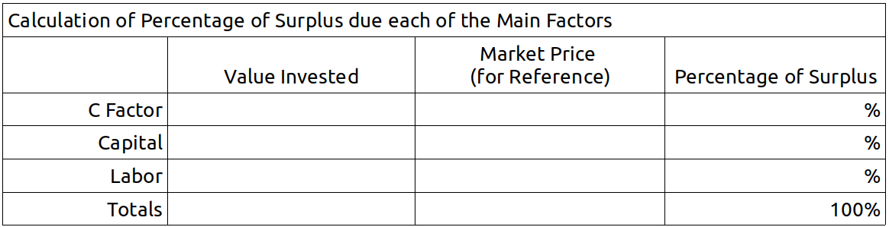
- Preparation of the canvas for calculating the percentages of surplus going to the C Factor, Capital, and Labor, using this layout:
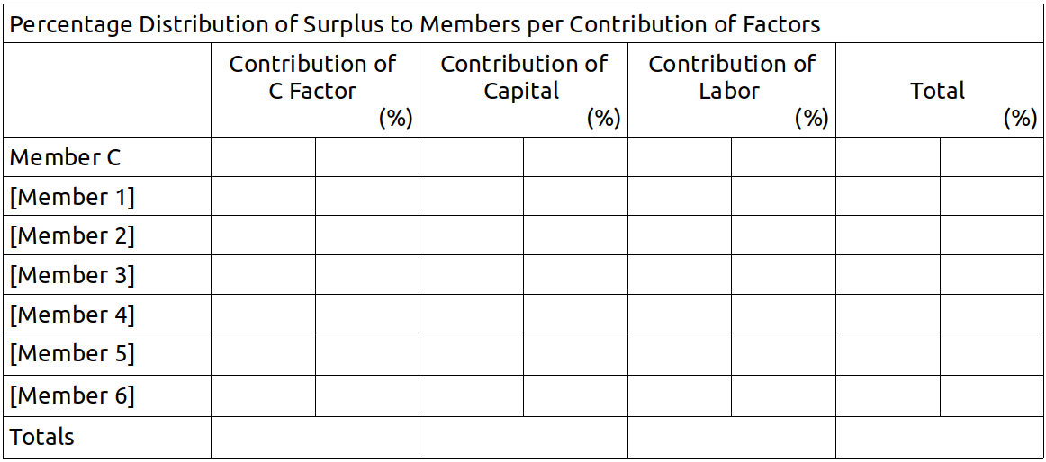
- Preparation of the canvas for calculating the percentages of surplus going to each worker-member, using this layout:
- Activity 1. Determining the percentage of surplus that corresponds to each factor.
- Activity 2. Determining the percentage of surplus that should go to the members.
- Break and Snacks
- Activity 3. Preparation for Final Project #1: Writing the Bylaws and Rules of the Enterprise.
- Activity 4. Preparation for Final Project #2: Creating a Business Plan for the Enterprise.
- Evaluation of Unit VII

Contents of Activity 1
The calculation of the percentages of the surplus that will be distributed in accordance with the contributions of each of the main factors (Labor, Capital, C Factor) is based on information already in the group’s possession. This information will be gathered and processed in the canvas prepared as described above (Calculation of Percentage of Surplus due each of the Main Factors).
We proceed by the following steps:
First, fix the percentage of the surplus that should stay with the solidarity group as such, as remuneration for the C Factor. In the reading we already noted that this percentage needs to be established by the group itself between a minimum value of 10% and a maximum of 40%. Between these extremes, the percentage can rise if the cohesion and unity of the group is especially high and strong and the investments of capital and labor are not very high. If, on the contrary, those investments are large and the group does not have many aspects of shared life, the percentage going to the C Factor can approach the lower limit. Once the percentage has been decided, note it in the first line of the fourth column.
a) Continue by noting in the second line of the second column the value of the capital invested.
b) Calculate the percentage of surplus to be dedicated to capital, based on the average of the rates of interests offered/charged by the banks for one year, based on the information gathered in the Individual Activity, and, summing and dividing, find the average annual interest rate.
c) Apply the average annual interest rate to the total amount of capital invested and note the result in column two, line two.
d) Calculate the total annual amount of labor remuneration, multiplying by twelve the monthly amount of remuneration to worker-members calculated in Exercise #14.
e) With this data you can now calculate the corresponding percentages of capital and labor, which, added to the C Factor, amount to 100% of the surplus. Note the percentages in the second and third lines of the third column.
Contents of Activity 2
The calculation of percentages of surplus that will go to individual members should be a simple mathematical calculation, since you have all the information you need. But it is best to do the calculation together, as a group (or by one member in the presence of the group), so that all the members can clearly see how the percentages were determined and understand the theoretical basis on which the profits of the enterprise are to be distributed to members. (We say “theoretically” because in reality the contributions that each member makes can vary: the actual contributions of factors may be different from what they pledged. In particular, remuneration for labor is calculated on the assumption of no loss of labor time, for example due to absences from work. Obviously, at the moment of calculating each person’s share of the surplus absences and other gaps in factor contributions will be discounted proportionally.)
The calculation of percentages of surplus going to each member is done on the canvas, following these steps:
a) The percentage going to the C Factor is noted on the first line of column one (assigned to Member C, or the group itself) and in the total (last row of column one).
b) The totals corresponding to the capital and labor factors are noted on the last line of columns two and three and should add up to 100%.
c) Note in the corresponding cells the data for the labor and capital contributions of each member, using the data collected in previous Exercises and Jornadas.
d) Calculate the corresponding percentages and verify the result, summing each column and the final total of member contributions, both of which should total 100%.
In this way the group has completed the calculations with regards to the main aspects of organization of the enterprise and each member knows the exact value of the contributions they will make and the corresponding remuneration they might obtain from the surplus generated by the enterprise.
Thus concludes the process of economic organization of the solidarity enterprise. Members can now proceed to the writing of the Bylaws, the norms that institutionalize and guarantee the operation of the enterprise. As we will see, elaborating the Bylaws consists of giving the enterprise a legal form corresponding to its economic organization. In other words, the “criteria” used to resolve the five aspects of economic organization are converted into “norms” in the Bylaws that define its juridical organization.
Contents of Activity 3
All that remain to be done are the two final projects: writing the Bylaws and creating the Business Plan. These final projects require the group to continue meeting until they are finished, at which point the enterprise can be launched.
The two final projects should be planned and prepared during this Jornada, following these three steps:
a) Read the material in the manual about how to write the Bylaws.
b) Discuss and assign tasks.
c) Set the date and place of the meeting where the Bylaws will be completed and adopted.

Contents of Activity 4
Having prepared and planned the writing of the Bylaws, the group should prepare the Business Plan for the enterprise, following the same steps:
a) Read the material in the manual about how to create the Business Plan.
b) Discuss and assign tasks.
c) Set the date and place of the meeting where the Business Plan will be completed and adopted.
Once this activity is completed, the group should proceed to the Evaluation of Unit VII, in the same manner as at the end of other Jornadas. This time, however, time should be allowed for each member to respond to the Individual Evaluation Form. Then, conclude with the group Evaluation.

UNIT 7 GLOSSARY
Balance Sheet
A tool for general information that reflects the situation of an enterprise in a given moment, typically at the end of a year. Using the Balance Sheet we gather and share information about the Enterprise’s Assets (all the goods possessed by the enterprise), its Debts, and its Equity (the capital remaining after subtracting debts from assets).
Budget
An estimation or calculation of the expected expenses and revenue for a period of time (generally a year). The Budget is an important tool for planning, scheduling, control and evaluation of the operations of an enterprise. Normally the Budget is approved by the Member Assembly at the beginning of the year and its fulfillment is evaluated by the Assembly on a monthly or quarterly basis.
Distribution of Surplus
The distribution at the end of an accounting period of surplus generated in an enterprise during that period. In solidarity enterprises, the distribution of surplus is the means by which members are compensated for their contributions of productive factors, including remuneration for Labor, Capital and the C Factor.
Income Statement (Profit and Loss Statement)
A tool for accounting and information sharing that summarizes the operations of an enterprise in a given period (typically one year). It includes: revenues (the result of sales); expenses (costs incurred for production, administration, and sale of good and/or services), depreciation (the loss of value of assets over the period, counted as a cost); other income and expenditures; monetary corrections (gains or losses in value dues to inflation or deflation); and profits.
Interest Rate (on deposits)
The rate of interest paid by the bank or other financial institution on money the depositor makes available to the bank for a set period of time.
... (on loans)
The rate of interest paid by a borrower to a bank or financial institution for money borrowed for a set period of time.
Labor Management Responsibilities
The organizing and leadership activities and roles played by workers in a solidarity enterprise, implying certain special responsibilities that flow from the impact that their decisions can have on the operations of the enterprise and its efficiency. These management tasks and responsibilities imply a greater productivity that deserves recognition for the workers who do them, which should be reflected in their shares of surplus.
Profits
In standard economic terminology, profits, gains, earnings, and surplus are all essentially the same, expressing the positive difference between total revenues and total costs in a given period of time. In our understanding of solidarity enterprises, surplus and profits are different. We use the term profits for current accounts, as it is commonly used for calculating taxes. The main difference between profits in this sense and surplus is that calculations of profit are made by subtracting from revenues not just the payments to third parties but also compensation paid to members for their labor. This concept of profit is useful for comparing the solidarity enterprise to capitalist enterprises which, obviously, do not include remunerations for labor as part of their profit.
Remuneration of Capital
In solidarity enterprises, that portion of the surplus used to compensate members for their individual or collective contributions of capital. This remuneration is not a fixed rate paid on the amount contributed but is rather a “share of surplus” obtained in each period.
Remuneration of the C Factor
In solidarity enterprises part of the surplus is used to compensate or develop the C Factor for the important contribution it makes to the enterprise and its productivity. The rate of remuneration of the C Factor is determined by the members according to their own criteria and in the proportions they think best. The key criterion is that the remuneration be sufficient to stimulate the collective to maintain and improve its internal cohesion, that unity of consciences, wills, and feelings among the members of the solidarity group (members of the enterprise), which is the base of its creation and its special mode of being and operating.
Remuneration of Labor
In solidarity enterprises that part of the surplus that is used to remunerate members for their labor contributions. Remuneration of labor is not accomplished by paying a pre-determined fixed salary but as a share of surplus obtained in each period (year). Nonetheless, solidarity enterprises often pay anticipated distributions on a monthly basis (similar to salary, but the content is different), which is nothing other than a determinate quantity of money which can vary depending on the performance of the enterprise. At the end of the year, in light of the actual results the anticipated distributions are balanced against the shares of surplus going to each member.
Share of Surplus
The proportion of the surplus that goes to a member or factor of production as compensation for their contributions. The basic criterion of distribution is that the surplus goes to those who contributed to its generation, in proportion to their contributions.
Surplus
We use this term as a synonym for “gains” in the largest sense and distinguish it from “profits” which we use in a narrower sense. In solidarity enterprises, surplus is the final positive result that the enterprise obtains for the benefit of its members, normally calculated at the end of the fiscal year. This result is determined by the difference between the total revenues over the period and the total of payments made to third parties (external to the enterprise), such as rents, fixed costs, financial costs, purchases of raw materials, salaries paid to employees who are not part of the enterprise, payment of debts, taxes, etc. The surplus is used to remunerate and compensate members for their contributions of factors and to build the equity of the enterprise through reinvestment. Surplus includes remuneration for the labor performed by members, whether paid at the end of the fiscal year, or on a monthly basis in the form of anticipated distributions. It also includes money spent on investment in the enterprise, such as purchase of machinery, technological improvements, amortization of debt, inventories of supplies or products, etc. that imply an expansion of equity or of the enterprise’s productive factors. Surplus also includes the profits that are divided among the members in return for their contributions of capital or for any other ownership title.

Technological Content of Labor
The knowledge, information, skill, and special capacity that characterizes a particular labor activity and that when applied increases the productivity of that labor. More concretely, this refers to the technical and professional skills required for the performance of certain specialized jobs.

EVALUATION OF UNIT VII
This evaluation is to be done both individually and as a group.
Individual Evaluation
Each participant should answer the following questions in their notebook:
A. Circle the answer that best matches your experience.
- My understanding of the content covered in Unit VII is:
Weak – Good – Excellent
- My performance of the individual assignments in this Unit was:
Weak – Satisfactory – Very good
- I consider my contributions to the group exercises to be:
Poor – Adequate – Outstanding
- My participation in the organization and execution of the Jornada was:
Passive – Relatively active – Very active
- I think my overall contribution to the group was:
Very little – Could have been better – Ample
B. Reflect on the following questions and summarize your answers in writing.
- Do I believe that the pay schedule we established for the different worker-members in our enterprise is just? Is it fair for each person, or have any members been harmed or others unfairly rewarded?
- Do I believe that the system of distribution of surplus that we have adopted is just and has the character of solidarity? Do I feel that all of us in the group are convinced that this is the right way to distribute surplus?
- We have now completed all seven Units of this manual: do I believe we are ready to make real everything we have learned? Are we ready to give our enterprise an official legal form and Business Plan?
Group Evaluation
Seated in a circle, the whole group discusses the following questions.
- Have we created a fair pay schedule for the different worker-members in our enterprise, that has the character of solidarity? Are we sure that we have not harmed or unfairly rewarded any member?
- Have we established specific criteria for determining the distribution of surplus? Do all members understand exactly how the enterprise will function in this respect? Are we all in agreement and convinced that this is the best system for distribution of surplus?
- Are we ready to formalize the legal structure of our enterprise, applying the criteria we defined in the course? Are we ready to elaborate our Business Plan?
- What is the state of our C Factor? Has it grown as we worked our way through the course, or has it stagnated or declined for some reason? Do we need to organize another Mitote?

Final Project #1
Elaboration of the Bylaws and Internal Regulations of the Solidarity Enterprise

WARNING: The following is a guide to elaborating the bylaws or internal regulations for a solidarity enterprise. This guide was prepared to help enterprises in the process of formation think about which of a variety of legal forms that are available in the country in which the enterprise is being created might be best suited to their size and characteristics.
Each country has its own laws regulating the formation of societies, cooperatives, and businesses. For this reason, this guide does not pretend to offer legal advice; it is only an instrument designed to help you gather and organize all the information normally required in order to acquire legal status for a society or economic organization.
The information you gather here should be delivered to an attorney or specialist who can guide the group with respect to the juridical form best suited to the enterprise, according to the laws of the particular country and the characteristics of the particular solidarity group.
We recommend that group members, having compiled the data required by this guide, seek the help of an attorney or legal expert who can help them determine whether it is best to create a legal entity or not and if it is, which of the available forms would be best suited to their purposes.
In any case, the form to be chosen remains the group’s decision, not the attorney’s. The attorney is there to assist the group, provide necessary information, answer questions and clarify confusing points. If the group chooses, the attorney can be tasked with drafting and editing the bylaws and carrying out the procedures for establishing the enterprise in conformity with the laws and procedures of the given country/state.

Enterprise Bylaws Structure
Article 1 About the Enterprise
Article 2 Objectives and Purpose
Article 3 Members
Article 4 Governance and Management Bodies
Article 5 Leadership Positions
Article 6 Ownership
Article 7 Changes to the Bylaws, Dissolution of the Enterprise, Conflicts among Members
Article 8 Internal Regulations
Article 1 About the Enterprise
- Date and location of the enterprise’s establishment.
- Full legal name of the enterprise, for government records.
- Common name or trademark to be used in promotion, etc..
- Legal form (workers co-operative, LLC, partnership, non-profit organization, etc.).
- Address for official correspondence.
- Duration of the enterprise (indefinite, or limited duration).
- Founding members of the enterprise. The following information should be provided for each member: full name, nationality, profession or title, marriage status, identification document, address.
- Official representative of the enterprise, member(s) of the enterprise with the right to represent the enterprise in negotiations, administration, and legal matters, and the right to use the official name.
Article 2 Objectives and Purpose
- General objectives of the enterprise as established by the founding members.
- Purpose of the enterprise: the economic activities to be carried out by the enterprise (detailed description of all the economic activities, production, sales, services, investment, etc. that the society can legally perform).
Article 3 Members
- Who can become a member.
- Requirements for membership.
- How to become a member.
- Obligations and responsibilities of members.
- Rights and powers of members.
- Revocation/withdrawal of membership.
- Penalties that members may suffer for failure to meet obligations.
Article 4 Governance and Management
- Governance and management bodies (for example, Member Assembly, Governing Council, Audit Committee, Management Council, etc.)
- For each body specify:
  - Who will be on it.
  - How members are selected/removed.
  - What tasks the body performs.
  - What are its specific powers and exclusive responsibilities.
  - What powers the body can delegate and to whom.
  - How often it will meet and how meetings will be announced, how members will be notified.
  - Who can call a special meeting, how to call a special meeting.
  - How voting will be done and the basic criterion (for example, one person one vote, percentage of ownership, etc.).
  - Quorum for meetings and votes.
Article 5 Leadership Positions
- Positions held by one person (e.g., president, treasurer, general secretary, manager, etc.).
- How people are selected for each position (election, appointment, sortition, etc.).
- Powers and responsibilities of each position.
- Duration of the positions and how people holding them are replaced or removed.
Article 6 Ownership
- Sources of equity for the enterprise (e.g., dues and contributions from members, reinvestment of earnings, donations received, etc.).
- The amount of capital with which the enterprise is established (the amount of money to be used for initiating the enterprise and carrying out its activities).
- The percentage of the initial capital to be contributed by each member (the percentage of the total initial capital contributed by each member).
- The percentage of the surplus generated by the enterprise to be distributed to each member.
Article 7 Changes to the Bylaws, Dissolution of the Enterprise, Conflicts among Members
- The leadership body that can change or amend the bylaws;
  - the procedures to be followed;
  - the quorum needed.
- Circumstances under which the enterprise can be dissolved;
  - who can make the decision;
  - the procedures to be followed;
  - the quorum needed.
- Continuation of the enterprise in the case of the death of a member. (E.g., the enterprise continues with the remaining members plus a representative chosen by the heirs or successors of the deceased member, who will only act to represent them in relation to matters such as distribution of surplus but without any administrative or other governance role.)
- Conflict between members regarding interpretation of the bylaws, their validity, the performance or non-performance by each member of their obligations under the bylaws, accountability of officers or representatives, etc.. (Use of an outside professional arbitrator, chosen by the members, some other mediation services, or the legal system.)
Article 8 Internal Regulations
- Identification of other aspects of group and enterprise functioning needing regulation.
- Organization of labor, assignment of tasks, hours of work, norms for performance of work, bonuses, incentives, penalties, etc.
- Other.

Final Project #2
Creation of a Business Plan for the Solidarity Enterprise

WARNING: The following is a guide to creating a business plan. It was designed to be useful for a wide variety of enterprises, from production to services, of different sizes and characteristics. Each solidarity group should adapt the outline presented here to their particular project, keeping what is useful and changing what is not.

Structure of the Business Plan
1) Presentation of the group and the enterprise.
2) Description of the products and/or services to be offered, specifying their unique qualities and values.
3) Description of the potential market.
4) Marketing and sales strategy.
5) Business model and finance plan.
6) Organization of production.
7) Organization of sales.
8) Organization of management.
9) Partners and strategic alliances.

- Presentation
(Used to present the business plan to potential investors. It is also useful for explaining the enterprise to potential providers and clients. It provides a basic definition that can be used in leaflets, websites, or other promotional materials. It should include the following elements:)
  - Name of the enterprise.
  - Legal form.
  - Legal representative.
  - Date of establishment.
  - About us (brief description of the members).
  - Location (address and access).
  - Our Mission (brief summary of the goals of the enterprise).
  - Business Idea (brief summary)
- Our Products and Services
  - What we produce (enumeration and basic description of the products and/or services the enterprise can offer).
  - Current stage of development (specify what remains to be done to be ready to offer products and services).
  - Production capacity (current possible monthly volume of production for each product or service)
  - Quality of services and products (characteristics, functionality, technical specifications of products or services).
  - Unique value proposition (needs met by the products, distinctive features or values, other details which explain how they differ from others offered on the market).
  - Prices and conditions (list of prices, purchase conditions, guarantees, after-sales services, etc.)
- Potential Market
  - Target markets for our products and/or services (identify customer segments by age, gender, geographic location, socio-economic level, etc.; or the enterprises, organizations, or other clients that might be interested in our products and/or services).
    - Customer segments (make lists based on objective criteria for segmentation)
    - Market size for each customer type or segment.
    - Principal factors determining growth of demand for each segment.
    - Most attractive market segment.
  - Size of potential market (quantity of prospective customers and volume of demand).
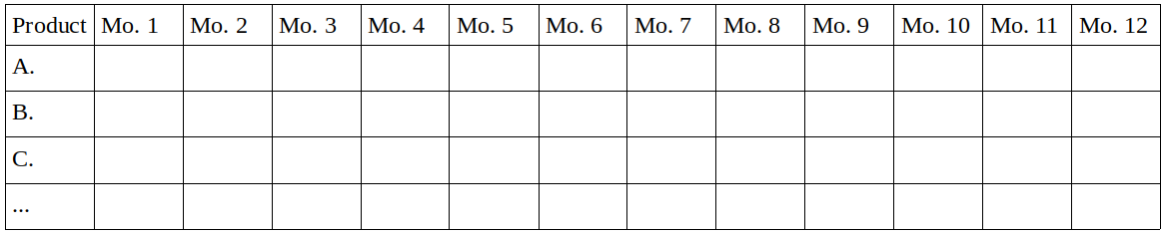
  - Expected volume of sales (for each product or service estimate the quantities to be sold each month over the course of the first year).
- Marketing and sales strategy
  - Positioning of the enterprise and its products (specify how your enterprise and its products and/or services will be made known to potential customers. Describe in detail the plan for a launching campaign, identifying all means to be used.).
  - Advertising and publicity to maintain and expand the customer base and the demand for your products and/or services. Specify the strategy to be followed for recruiting the desired number of customers and the cost involved:
    - Channels for communication with potential customers
    - Providers of publicity or advertising with whom you intend to work.
  - Price policy (specify the price policy to be used in order to position your products in the market and expand demand, guaranteeing the expected profits).
- Business model and financing plan
  - Revenue streams (it is not only necessary to have a unique value proposition for your products and/or services, you also have to specify the various sources of revenue, detailing each expected source and stream of revenue).
  - Expected revenues (calculate the monthly revenues based on the volume of sales defined above (3c) and the other sources of revenue).
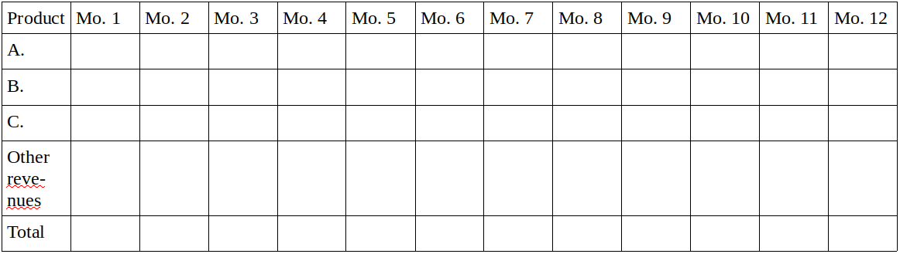
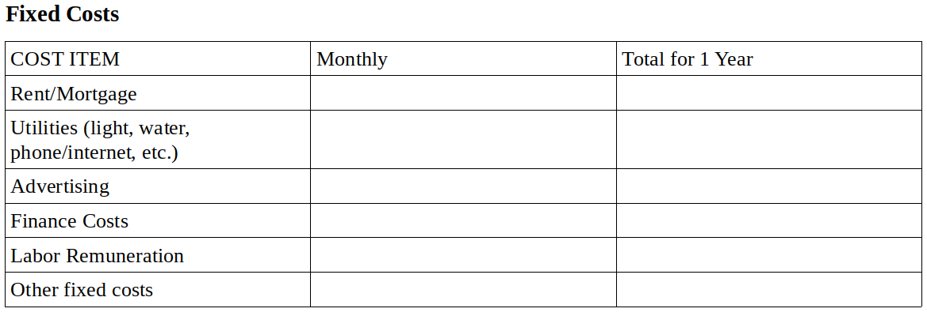
  - Cost items (specify all the fixed costs to be incurred by the enterprise in its regular operation and all the variable costs that depend on the level of production needed to satisfy the demand calculated in (3c) above).

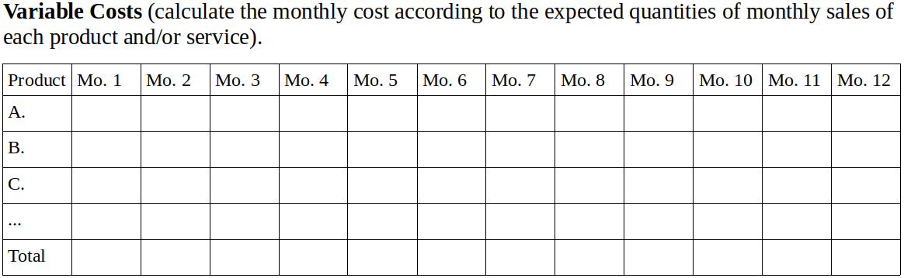
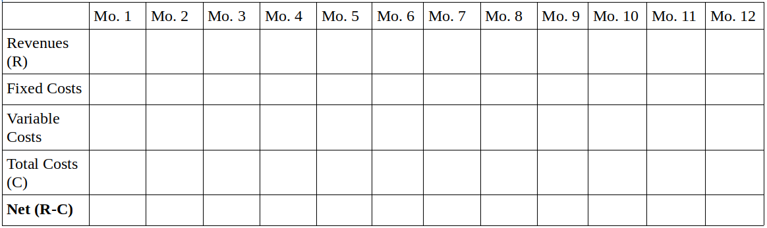
  - Expected Income.

- Organization of Production
  - Current state of development of the products and/or services (prototypes of products, previous provision of services, completed models and designs, necessary tools, sufficient workforce, sufficient supply of inputs or identified supply chains, etc.)
  - Physical organization of the enterprise.
  - Scheduling of production.
  - Launching plan (specify all the activities necessary in order to launch the enterprise, including a calendar, principal activities and people responsible, landmarks and deadlines, linkages between activities).
- Organization of Sales and Commercial Relations
  - Current customers and contacts (elaborate a list of potential customers, analyzing in each case the status of the commercial relationship and the modes of establishing and enhancing it).
  - Organization of advertising and sales.
  - Scheduling of sales and commercial activities.
  - Plan for implementation (make a plan that includes all the necessary activities for improving sales, including a calendar, principal activities and people responsible, landmarks and deadlines, linkages between activities).
- Organization of Management
  - Design the Enterprise’s Organizational Chart
    - Describe the principal leadership functions and positions.
    - List the people responsible for each function and how they are assigned.
  - Organizational Structure
Complete the following table of responsibilities and activities for each member of the enterprise.
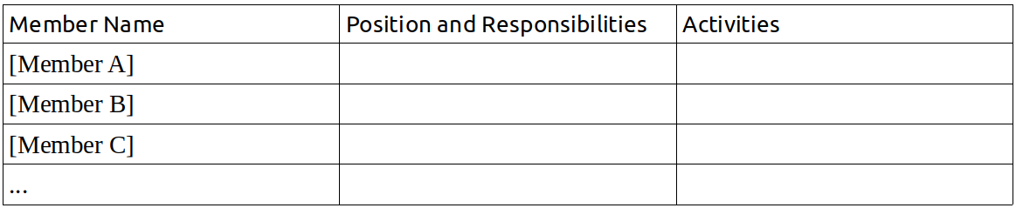
- Partnerships and Strategic Alliances
It is important to identify all the contacts and relations that will be useful for the functioning and development of the enterprise, in both its commercial (suppliers, distributors, related enterprises, etc.) and social-institutional (public entities, non-profit organizations, community organizations, etc.) aspects. These relations need to be cultivated so it is useful to define the networks, coalitions, associations in which the enterprise will participate, as well as the opportunity to implement strategic alliances that will be most helpful to the enterprise and the people who make it up.

Razeto uses the terms “solidarity enterprise” and “associative and solidarity enterprise” interchangeably, in most cases I have used the simpler term. -MN
Solidarity Economy Roads. Luis Razeto Migliaro. Grassroots Economic Organizing (GEO.coop). 2019 -MN
Two of my favorites are Técnicas Participativas para la Educación Popular, by Laura Vargas Vargas et al., Centro De Estudios y Publicaciones, San Jose, Costa Rica, 1992, and Educating for a Change by Bev Burke et al., Between the Lines, Ontario, Canada, 1991. -MN
“Cooperatives can be thought of as businesses with an important educational element; it is just as accurate to think of them as educational projects with an important business element.” Jose Maria Arizmendiarrieta, in Azurmendi, El Hombre Cooperativo, Mondragon, 1991. -MN
See the website of Grassroots Economic Organizing (GEO.coop) for some of this discussion.
See How can we begin to create a new civilization? Luis Razeto Migliaro. Translated by Lafayette Claud Eaton Henderson. Universitas Nueva Civilización, Santiago de Chile, 2013.
I will use the Spanish word “Jornada” in the text, rather than the more academic “practicum.” - MN
It may be useful for the group to keep a “living” glossary to which they can add terms and explanations. - MN
Another useful rule of thumb is no one speaks twice until all have had the chance to speak once. If people are reluctant to speak in front of the whole group, the moderator may want to include some paired discussion. - MN
“Ice-breakers” have a bad reputation in the United States where they are often used in a way that is instrumental and patronizing. In popular education, “dinámicas de animación,” which are perhaps better described as thematic games, are often used to create space for creativity, friendship, mutual recognition, inventiveness, and solidarity. It is important to be clear about the intent of any “ice-breaker” and to carefully consider whether/how it should be used in a given context and with a given group. - MN
The facilitators should consult with participants ahead of time about getting a space that will work for group work in various formats and is accessible to all participants. - MN
Razeto is not explicit about the optimal number of participants, but many activities are designed for groups of eight to twelve people. If there are more than twelve participants, it makes sense to form two groups for most activities. Where it is important for the whole group to participate, other techniques may be needed to ensure that all can participate equally. - MN
Reading out loud is useful in two ways – it ensures that everyone is familiar with the reading and it is helpful for people with limited eyesight or literacy. It also encourages participants to verify their mutual understanding with reference to a shared text. (See Jacques Rancière, The Ignorant Schoolmaster) - MN
After the first session, the group should decide who will provide snacks next time. - MN
Razeto uses the terms “solidarity economy” and “solidarity and labor economy” interchangeably, reflecting the centrality of labor in his conception. - MN
In general, I have translated empresa as enterprise, using business to refer to capitalist enterprises. - MN
Remuneration, money payment in return for some contribution, is a key term in this manual. - MN
Even more so in Spanish where many words use this prefix, including trust (confianza) and sharing (compartir). - MN
Hirschman, Albert O. 1984. Getting Ahead Collectively: Grassroots Experiences in Latin America. Pergamon Press. - MN
“It is as though the protagonists’ earlier aspirations for social change, their bent for collective action, had not really left them even though the movements in which they had participated may have been aborted or petered out. Later on, this “social energy” becomes active again but it is likely to take some very different form. ...we have here a special kind of sequence, a renewal of energy rather than a wholly new outbreak.” Hirschman 1984, p43 - MN
See the work of Richard D. Bartlett and others from Enspiral for recent reflections on group formation. https://www.microsolidarity.cc/ - MN
See Acts 2:44-45, 4:32-35 -MN
See George Cheney’s Values at Work: Employee Participation Meets Market Pressure at Mondragón, ILR Press 2002, for a study of developments in this social energy. - MN
This could be in pairs or small groups, depending on the size of the whole group. - MN
The freedom to “pass” is important to building trust. Maybe that person’s yesterday was especially difficult or traumatic in some way. If a person passes repeatedly, a facilitator or other group member should check-in with them. - MN
The first person to speak gives the final response. - MN
In recent years, graphic recording has become widely used in companies, organizations, and schools. - MN
All drawings should be saved for future reference. - MN
“Mitote” has additional meanings, including problem or trouble. - MN
Two useful sources of group activities: Técnicas Participativas Para la Educación Popular, by Laura Vargas Vargas et al., and Educating for a Change, by Bev Burke et al. - MN
Theater improvisation games can be good for this. - MN
Again, it is important to permit people to decline to share their evaluation, but, since evaluation is a key tool for building trust and accountability, an alternative way to do that will need to be put in place. - MN
To this could be added organic, regenerative, locally grown and produced foods and drinks, preferably from a cooperative or other solidarity enterprise. The standards should be determined by the group. - MN
Types of cooperatives include: workers, producers, consumers, credit, housing, and platform cooperatives. - MN
See the International Cooperative Association Principles https://www.ica.coop/en/cooperatives/cooperative-identity. An analysis of alternative cooperative coordinates can be found in Noyes, 2017 https://geo.coop/sites/default/files/mnoyes.article_a_on_solidarity_economy.final-1.pdf - MN
In this manual the word “enterprise” is used as a general category which can include cooperatives, non-profits, collectives, as well as social enterprises. “Business” is used primarily for private, capitalist companies. - MN
In a capitalist business the organizing factor is capital, in a solidarity enterprise it is the C Factor. – MN
Most famously analyzed by Karl Marx, in Capital, Volume One, Part Eight “The So-Called Primitive Accumulation of Capital” (Vintage, 1977).
For more on popular economic organizations in Latin America, see Chapter 2 of Solidarity Economy Roads: https://www.geo.coop/story/solidarity-economy-roads-chapter-2 - MN
See Razeto’s Solidarity Economy Roads (GEO, 2019) for a thorough explanation of solidarity economy. – MN
In the basic principles of the Mondragón cooperative group, capital is categorized as “instrumental and subordinated” while labor is “sovereign.” – MN
Translator's note: In this Unit the solidarity group is asked to deepen their understanding and commitment by identifying and prioritizing their objectives as individuals and as a group. The process of creating a solidarity enterprise advances as group members brainstorm ideas for the enterprise they wish to create, and identify the group’s comparative advantages with respect to each idea. Unit II includes field research of existing enterprises/businesses and the community in which the solidarity group wishes to establish its enterprise. The Unit culminates in a day-long meeting (jornada) in which members discuss, evaluate, and make decisions about their objectives and business idea, leading to an important Go/No Go decision for the group and individual members. - Matt Noyes
“Was in die Erscheinung tritt, muß sich trennen, um nur zu erscheinen.” Goethe, Sammliche Werke, Band XVI, Naturwissenschaftliche Schriften Band I. Pp. 96. – MN
A volunteer can do the first reorganization, asking the group to suggest changes, until the group is satisfied with the organization. It is important, especially at this early stage, to ensure equity in participation and consent in decision-making. - MN
There are various possible measures, for example the Bureau of Labor Statistics classifies firms by number of employees: 1-49 (small); 50-249 (medium); 250 and over (large). https://www.bls.gov/ Turnover, assets, and market share are other possible measures. - MN
Max-Neef, Manfred. “Development and Human Needs.” http://3awww.alastairmcintosh.com/general/resources/2007-Manfred-Max-Neef-Fundamental-Human-Needs.pdf - MN
In Unit II, the solidarity group defined its objectives, its business idea, and the potential market for its goods and/or services. The group also assessed the positive and negative externalities that the enterprise might produce for the surrounding community as well as the comparative advantages the group and its enterprise might have in relation to existing businesses. In Unit III, the group becomes a functioning work unit and turns to the various factors of production – labor power, technology, management, materials, financing, and the C Factor – that will be needed in their enterprise. What role does each factor play in the production process? How can they be combined? In what proportions? Can one factor be substituted for another? To what extent can members themselves provide the factors needed? Where can external factors be obtained? – Matt Noyes
Razeto’s concept corresponds to Marx’s definition of “living labor,” labor power as a use-value, but does not assume that labor power is bought and sold as a commodity (See Marx, Capital, Chapter 7).
“Management” here (gestión) is not limited to the roles played by managers. As we will see, in a solidarity enterprise, management – coordination, direction, short-term decision-making – can be organized in different forms and the associated tasks distributed in various ways. -MN
Nati Lombardo and Richard Bartlett have helpful materials on decision protocols for decentralized organizations and corresponding decision-making methods. https://www.thehum.org/ -MN
It is worth taking some time to reflect as a group on the differences between a C.V. prepared for capitalist enterprises and one prepared for a solidarity enterprise. For example, parenting and other non-wage care work may have special relevance in a solidarity enterprise. See, for example, Distributed Cooperative Enterprises https://disco.coop/2019/08/last-night-a-distributed-cooperative-organization-saved-my-life-a-brief-introduction-to-discos/ [-MN]
All charts should be photographed and kept as a reference. -MN
In Unit III, the solidarity group began to operate as a work unit, considering the various factors of production – labor power, technology, management, materials, financing, and the C Factor – that will be needed in their enterprise and in what combination and proportion. Each member wrote a C.V. appropriate to the proposed solidarity enterprise and the group created a detailed Factor Canvas. In Unit IV, members determine which of the factors needed they can contribute to the group, creating a personal balance sheet and making a proposal to the group. Having considered which factors it can develop through its own activity, the group reaches agreements with individual members about the factor contributions each will make and the terms on which the enterprise will accept them, an important step in the creation of their solidarity enterprise. – Matt Noyes
See Razeto’s Solidarity Economy Roads, Chapter 3, for an analysis of the “economy of donations.” https://geo.coop/story/solidarity-economy-roads-chapter-3 -MN
Timebanking would be another example. -MN
Members of workers collectives in Japan call this “tomoiku” 共育 or mutual education; it is a key element of the process they use to develop new collectives. -MN
The solidarity group may want to revise the information requested to suit its context and needs. -MN
It might be wise to have a “vibe checker” who can keep an eye on how people are feeling and intervene if necessary to address personal conflicts. - MN
Translator's note: In the previous Unit the solidarity group did the crucial but sometimes neglected work of analyzing the productive factors that each member can contribute to the solidarity enterprise. Whereas in capitalist firms productive factors are typically bought on the market, in solidarity enterprises the members themselves are the first source of factors, not just labor, but materials, technology, management, and of course solidarity, the C Factor. What about financing, “the most scarce of the factors of production, and usually the most difficult to obtain?" In this Unit the solidarity group tackles this common problem for cooperatives, breaking down and researching the various possible sources of external financing: loans, investments, donations, and solidarity funding. Which are most efficient? Which are most aligned with the logic of solidarity economy? The Unit ends with the solidarity group preparing a Cost Budget and making a Financial Plan which details the types of financing to be sought and on what terms. – Matt Noyes
Razeto does not discuss venture capital as such, but the analysis of loans and the logic of solidarity economy clearly applies. -MN
See Chapter 3 of Razeto’s Solidarity Economy Roads for a detailed analysis of the economy of donations. https://geo.coop/story/solidarity-economy-roads-chapter-3 -MN
Matthew 13, New International Version -MN
Literally “accompanying” accompañamiento. For more on this concept, see Staughton Lynd’s Accompanying: Pathways to Social Change PM Press 2012. -MN
Commensality is similar to the practice of commoning, which implies a larger strategic framework for social-economic change, akin to solidarity economy. See David Bollier’s “Commoning as a Transformative Social Paradigm.” http://www.bollier.org/blog/commoning-transformative-social-paradigm -MN
In these tables, write the names of members, activities, donors, etc. Clearly, in many cases there will be more than three items. - MN
The concept was made famous by Marx in his “Critique of the Gotha Program,” though he did not use the term. “Commensality” is not widely used in English, where it usually refers to the act of eating together or sharing a meal. In biology, it is a form of symbiosis in which one organism benefits without harming the other. – MN
The International Cooperative Association’s seven cooperative principles are a common reference point: Open and Voluntary Membership; Democratic Member Control; Members’ Economic Participation; Autonomy and Independence; Education, Training and Information; Cooperation among Cooperatives; and Concern for Community. Cooperatives sometimes add/change principles, for example the principles of the Mondragon Corporation include “Sovereignty of Labor” and “The Instrumental and Subordinated Role of Capital.” – MN
Translator's note: After careful organizing, study, and preparation we have now reached the point where many groups try to begin, defining the economic organization of the enterprise. How will ownership be organized? How will members join and withdraw? How will decisions large and small be made? How will members be paid, and how much? What will they do with the profits (or losses)? It is time to “establish the criteria and norms that regulate [these] basic aspects of structure and functioning.” Having built a strong, cohesive group with a well-defined business idea and a clear understanding of the factors required to make it real and how to obtain them, the Solidarity Group is now in the position to create a viable solidarity enterprise. In the previous Unit the Solidarity Group completed their analysis of the factors needed to create their solidarity enterprise, considering various sources of financing, determining which were most aligned with their values and goals, and creating a costs budget and financial plan. Now, in Unit VI, the Solidarity Group considers the form and structure of property, the regulation of admission and withdrawal of members, and the system of governance and management. (In Unit VII they will take up the treatment of labor power and the distribution of surplus and profits.) Razeto also introduces a new member only found in solidarity enterprises – “Member C” – whose contributions must also be recognized and compensated. Unit VI ends with the creation of a provisional Members Assembly, the definition of a governance and management structure, and the initial selection of representatives. – Matt Noyes
Razeto does not address expulsion of members for violation of the bylaws or some other offense, for example a violation of the law, e.g. theft. The Solidarity Group may want to establish a code of conduct and a conflict resolution procedure that provides the member due process. – MN
While these roles can be rotated among members it is important that they be clearly assigned. – MN
It is also wise to establish a periodic (annual?) review and, if necessary, revision of these basic agreements. This is especially helpful for integrating new members.–MN
This can be done by taking the average share ownership as 1 and calculating the percentages of ownership in relation to this amount, e.g. 50%, 90%, 150%. More simply, members can “vote their shares” on a one share, one vote basis. –MN
Translator's note: Just how different a solidarity enterprise is from a capitalist business becomes completely clear in this final chapter. Labor, Profit, Surplus, Capital, the C Factor: the terms and framework are not the same. Likewise, the final tasks, writing a business plan and bylaws (which Razeto has pushed to the end of the course) appear to be conventional but embody the principles and practical applications of solidarity, “the great force of efficiency that drives solidarity enterprises.” In Unit I, the emphasis was on the C Factor and the need to build a solidarity group capable of creating a successful enterprise, “on firm ground and not shifting sands.” In the journey through Units II to V the solidarity group continued exploring the C Factor and strengthening the group, as they analyzed and defined their business idea and goals, the factors of production needed and in what proportions, where and how factors could be obtained, and finally the possible sources of external financing. In Unit VI the group began to establish the economic organization of the enterprise: choosing and defining forms of property, admission of members, and governance and management. In the final Unit they complete that process, determining how they will remunerate labor, capital, and the C Factor and distribute surplus. The emphasis is on proportionality, which Razeto calls the second “great force for efficiency that makes the solidarity enterprise grow and develop.” The goal is to establish a system that is “just, efficient, and demonstrates solidarity.” Participants will appreciate the manual’s methodical approach when they write their bylaws and business plan grounded in a robust collective process and a deep understanding of the theory and practice of solidarity at work. Any manual is limited; a manual that took into account every problem and possibility would be like Borges’ 1:1 scale map, as large as the terrain it charted. (“On Exactitude in Science.” Borges, Jorge Luis. https://www.openculture.com/on-exactitude-in-science-by-jorge-luis-borges) Still, it would be interesting to extend the analysis here to new examples of solidarity enterprise: platform cooperatives, Distributed Cooperative Organizations, multi-stakeholder cooperatives, and commoning. (See the Platform Cooperative Consortium https://platform.coop/, DisCO.Coop https://disco.coop/, Multi-stakeholder Cooperatives (article) https://thenextsystem.org/learn/stories/multi-stakeholder-cooperative, and FemProcomuns https://femprocomuns.coop/.) Moreover, this manual is designed to help a group create a solidarity enterprise, so it ends at the beginning of the journey. Many questions will arise, along with new problems and challenges. But founded in solidarity and collective thought and action, the group should be well prepared to find its path. – Matt Noyes
Readers familiar with the “DisCO Manifesto” in which three categories of labor are recognized and remunerated – Livelihood, Love (Pro Bono), and Care – can see how the same purposes can be achieved in Razeto’s framework by treating Love and Care work as C Factor activities. https://disco.coop/manifesto/ -MN
One of the original Rochdale principles. –MN
Razeto’s language echoes the Mondragon principles which insist on the “instrumental and subordinated character of capital” and the “sovereignty of labor.” –MN
Elements 2 - 9 should be subject to periodic assessment and revision by all the members as part of an ongoing strategic planning process. –MN

